Examples of mixed/mixing methods

Table of Contents

Some useful studies 1

(Gallaher et al. 2016) Effective Use of Mixed Methods in African Livelihoods Research 1

(Hockett and Richardson 2016) Examining the Drivers of Agricultural Experimentation 3

(Isaacs et al. 2016) Assessing the Value of Diverse Cropping Systems 6

(Bennett et al. 2014) The capacity to adapt? 8

(Tumuhairwe 2003) Agrobiodiversity potential of smallholder farms 11

(Mikhailovich 2016) Exploring the Lives of Women Smallholder Farmers in Papua New Guinea 12

(Limon et al. 2014) Using Mixed Methods to Investigate Factors Influencing Reporting of Livestock Diseases 13

(Santiago-Brown et al. 2014) What Does Sustainability Mean? 14

Other studies 17

(Lacoste et al. 2016) Comparative Agriculture Methods Capture Distinct Production Practices 17

(Murgue et al. 2016) Hybridizing Local and Generic Information to Model Cropping System 18

(Bezner Kerr et al. 2016) Food Sovereignty, Agroecology and Resilience: Competing or Complementary Frames? 21

# Some useful studies

## (Gallaher et al. 2016) Effective Use of Mixed Methods in African Livelihoods Research, African Geographical Review, 35(1), pp. 83–93.

Case study of mixed-methods research on livelihoods and urban agriculture in Nairobi, Kenya.

**Methods:**

Qualitative interviews, household surveys, focus groups, bio-physical sampling, and feedback workshops [integration of social and biophysical data]

‘**Mixed’** as opposed to ‘multiple’ (parallel) methods by using of triangulation to assess multiple data sources, and through attention to issues at multiple scales.

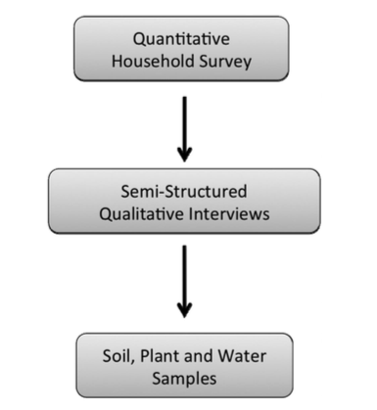

**Original design: linear research design**

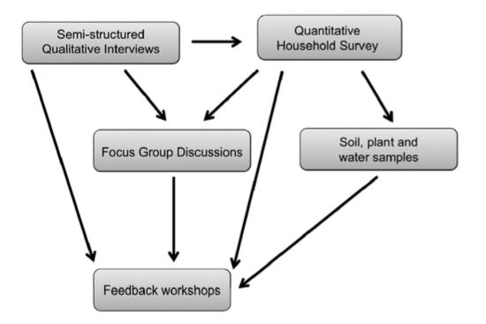

**Final design: iterative process**

1. Semi-structured qualitative interviews: 31 qualitative semi-structured interviews with farmers from two neighborhoods, or villages, in Kibera.

2. Quantitative Household Survey: farmers and non-farmers (n = 306) in nine villages in Kibera. Focus on basic demographic data, as well as farmer’s livelihood strategies, the impact of sack gardening on household food security, and people’s understanding of environmental risk. Data used to triangulate/confirm data from qualitative interviews.

3. Plant, soil, and water samples: collected from subset of farmers (n = 50) to be analyzed for heavy metal contamination and total coliform bacterial counts.

4. Focus group discussions + Feedback workshops.

“By using qualitative interviews first to inform the construction of a quantitative survey instrument, our survey was more targeted and better reflected the reality of urban agriculture in Kibera as described by the farmers we interviewed”

**Mixed methods research needs to be iterative, where qualitative and quantitative tools inform each other and help to confirm/complement each other.**

## (Hockett and Richardson 2016) Examining the Drivers of Agricultural Experimentation among Smallholder Farmers in Malawi, Experimental Agriculture, pp. 1–21.

Objective: to examine the decision-making processes, motivations (attitudes and perceptions), and drivers (physical and economic) of Malawian smallholder farmers who are experimenting independently of interventions promoted by rural development projects.

Methods:

Quantitative

* Household surveys: stratified random sampling, 324 farmer participants across the two districts –> informed case selection and interview questions. Socioeconomic, demographic, and questions related to farmers’ experimentation (any instance where a farmer used an unfamiliar crop, variety, or technique for the first time)

Qualitative

* In-depth interviews. Questions related: to experimentation with unfamiliar crops, varieties and techniques; management of experiments; motivations for trying something new; sources of information; ideas of success and failure; levels of satisfaction with experiments; intentions for future experiments;
* Field observations

*“The integration of methods used in this study yielded a richer understanding of the drivers of on-farm experimentation, the experimental methods used by smallholders and the characteristics of innovative farmers who conduct on-farm experiments”*

Results:

Of 324 households surveyed, 228 (70.1%) reported conducting at least one experiment in the 2012–2013 season.

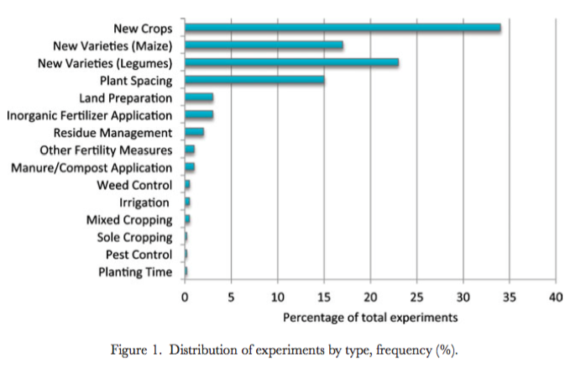

Types of experimenting

* **Non-experimenters** (n = 96): farmers who are not trying anything new
* **Project participants** (n = 145): farmers trying something that has been actively promoted to them (e.g., by extension agents, intervention projects, etc.)
* **Followers** (n = 64): farmers trying something that they had observed/heard (e.g., from peers, radio, family members);
* **Independents** (n = 19): farmers trying something that was their own idea.

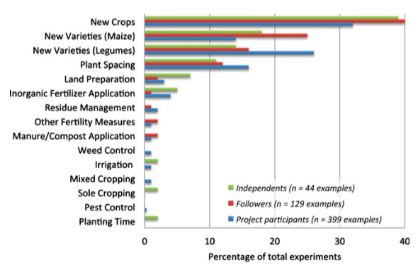

Interview technique

Straight forward positive outcome:

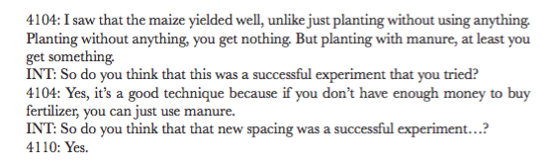

Failed experiment can also lead to positive outcome:

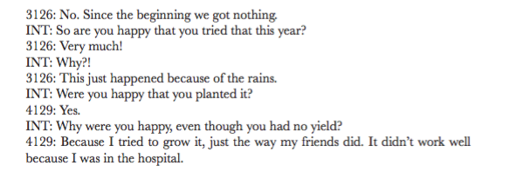

Motivations and decision-making processes:

Proactive, Reactive, External, Multiple Motivations

*“During the in-depth interviews, farmers spoke of proactive experimentation 162 times, reactive experimentation 65 times and external experiments 77 times.”*

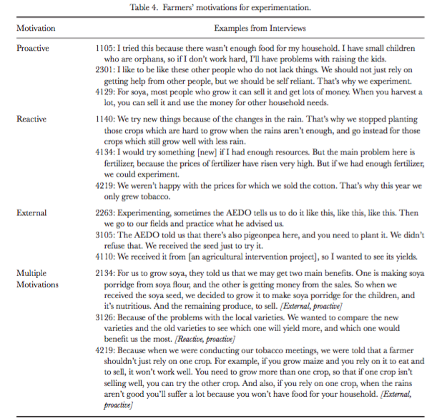

Limitations of the study:

* Recall error from recalling experiments
* Difficulty recalling experiments from previous growing seasons
* Do non-experimenters exist? (or is everyone experimenting always?)
* Longitudinal study would be more powerful: intentions, success and modifications during growing seasons, post-harvest modifications.
* Does ‘independent experimentation’ exist, given saturation of ideas from so many sources – agricultural extension officers, radio, seed distributors, subsidy programs, development projects, etc…?

## (Isaacs et al. 2016) Assessing the Value of Diverse Cropping Systems under a New Agricultural Policy Environment in Rwanda, Food Security, 8(3), pp. 491–506.

Methods summary:

Mixed methods to apply farmer-driven criteria to assess the value of intercrop and sole crop systems in Rwanda.

Objectives:

1. Identify services farmers expect to obtain from crop systems;
2. Apply this framework to assess 4 bean & maize systems within the agro-ecological and political context of northern Rwanda
3. Evaluate the contribution of sole versus mixed cropping systems to system resilience.

Methods:

Collaborative and participatory approach: scientists work with farmers to develop a knowledge system that combines both their ways of knowing.

Two main sources of data:

1. Yield measurements taken from agronomic field trials

2. In-depth interviews with farmers: open-ended interviews at the end of growing with 44 farmers who participated in the field trials.

Research methodology for analysis of field trials using emergent data from farmer interviews

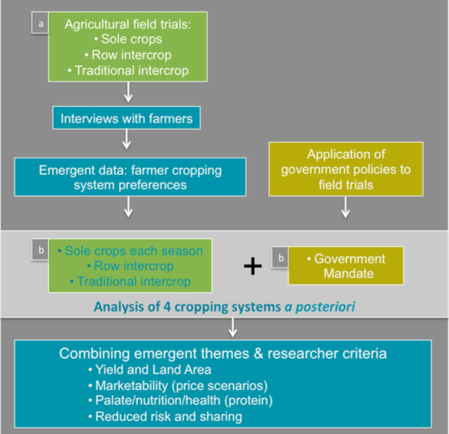

Interviews:

“What do farmers expect from their cropping systems?”

Smallholders are looking for diverse services including:

* Providing the family with sufficient, nutritious and diverse foods;
* Products to sell in exchange for other goods or to cover expenses;
* Diverse, culturally valued foods to share with neighbors and bring family members together (which contribute to ‘a good life’ but is not part of sole-cropped systems promoted by government).

Most farmers wanted to grow multiple crops, but the cropping system in which they wanted to grow them varied. 4 main themes from interviews: marketability, dietary quality, sharing, and well-being.

Combining field trials and emergent interview data

Two pieces of emergent data from the interviews used to analyze the field trials a posteriori.

1. The types of cropping systems preferred by the farmers:
   1. Sole crop of beans and sole crop of maize grown each season
   2. Bean-maize row intercrop grown each season
   3. Bean-maize traditional intercrop grown each season

[Compared to Government Mandate cropping system: sole crop of beans in Season B and a sole crop of maize in Season A.]

2. Farmer expectations of these cropping systems.

Conclusion:

“This study adds qualitative evidence that smallholder farmers value crop diversity at the production level because it improves their access to diverse foods and contributes to family well-being. The loss of such diversity, if not replaced via effective and accessible market-oriented mechanisms, could have serious nutritional implications.”

* Smallholder farmers are also innovators with their own criteria for system performance.
* Government policies leave little room for experimentation (intercropping or growing different crops)
* Flexibility/adaptability to experiment with systems and crop species, very difficult to develop efficient and resilient systems.

## (Bennett et al. 2014) The capacity to adapt?: communities in a changing climate, environment, and economy on the northern Andaman coast of Thailand, Ecology and Society 19(2): 5.

**Methods**

Multiple case study approach – 7 coastal fishing communities based on set of criteria.

A mixed-methods approach was employed to assess the adaptive capacity of the selected communities over a 10-month period in 2011-2012.

Fieldwork included:

* Review of secondary documents
* Key informant (structured) and in-depth interviews (open-ended): Qualitative data were coded against indicators related to components of the adaptive capacity framework
* Community household survey (quantitative)

Interview participants were sampled using purposive and snowball samplings.

A total of 85 individual interviews were conducted with community leaders (n = 22), community group leaders (n = 5), community members (n = 35), and government employees in the communities (n = 3), as well as outside government (n = 10), NGO (n = 7), and academic (n = 3) representatives.

Limitations: 1. Language/translation; 2. Gender bias (interviews male, surveys female); 3. Sampling communities; 4. Results not verified by community.

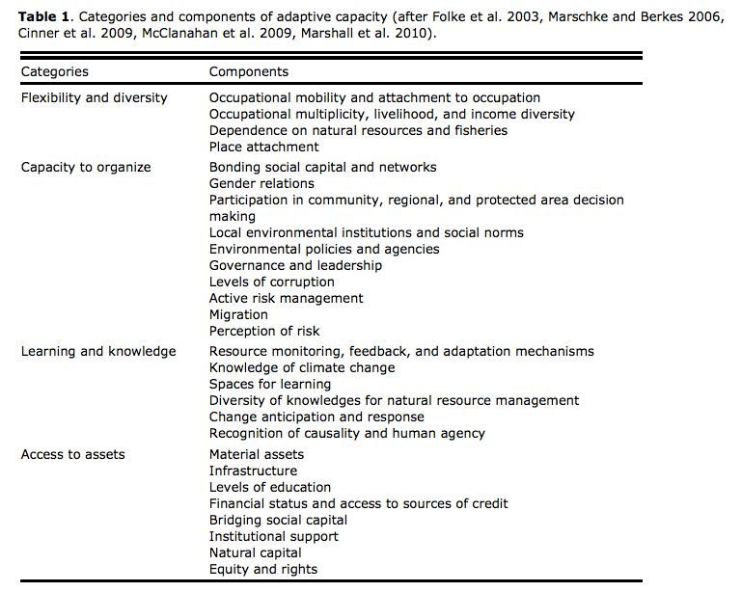

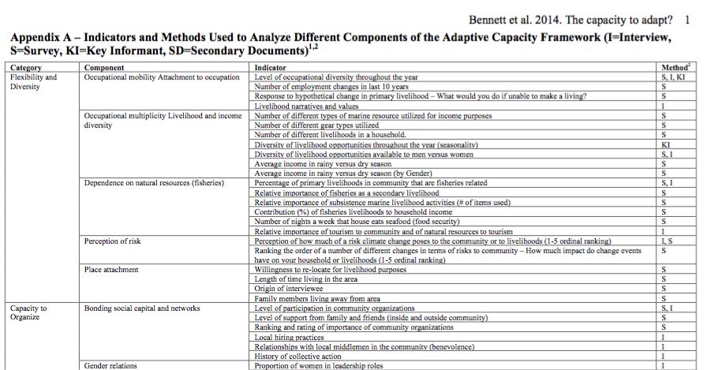

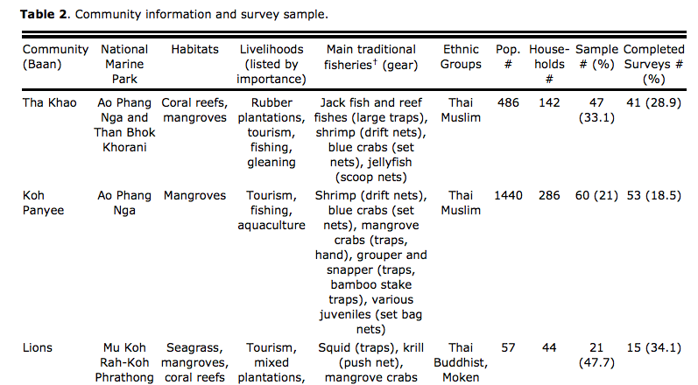

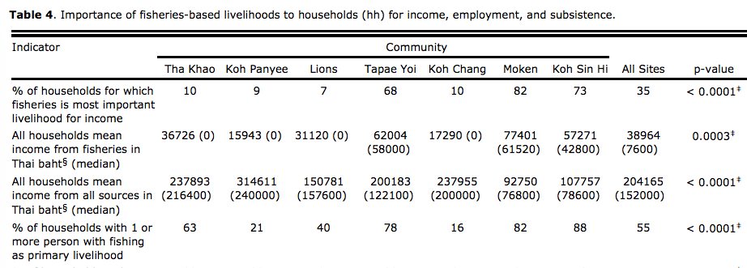

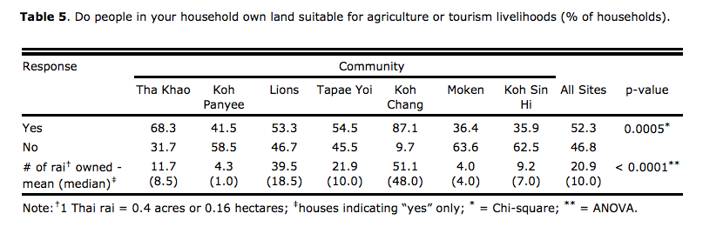

## (Tumuhairwe 2003) Agrobiodiversity potential of smallholder farms in a dissected highland plateau of western Uganda, East Africa PLEC General Meeting – Arusha, Tanzania

Methods:

* Transects:
  + transects to identify the major land-use systems
  + community workshops
* Demonstration site selection, based on:
  + receptiveness of the people
  + ethnic diversity
  + accessibility
  + number of land-use types
  + number of crop combinations
* Identifying farmers based on:
  + innovation in conserving several plant species or varieties
  + innovation in management of the system:
    - spatial arrangement
    - soil management
    - timeliness in planting
    - weeding
  + degree of understanding and explanation of techniques
  + willingness to seek or take up more information and skills
  + ability to learn, work with PLEC scientists, and change where necessary
  + willingness to demonstrate and train other farmers and other stakeholders.
* Demonstration activities:
  + Participatory evaluation of expert farmers’ innovations.
  + Regular field visits of candidate farmers and activities to exchange knowledge, experiences, and ideas
  + Farmer experimentation of model
  + Adoption of the necessary improvements by expert farmers.
  + Demonstrations to other farmers, local leaders, and other stakeholders during field workshops.
  + Field visits by/to other collaborating farmers to share experiences and knowledge.
* Dissemination (of innovative approaches):
  + farmer-to-farmer field visit
  + field training sessions led by expert farmers with scientistsproviding technical and logistical back-up
  + field evaluation of developing technologies carried out by separate groups of farmers, local leaders, and district-level experts in agriculture, environment, forestry, and community development.
* Sustainability (methods used to ensure sustainability):
  + Motivating expert farmers.
  + Participatory assessment and evaluation.
  + Involvement of stakeholders
  + Strengthening common-interest farmer groups around the expert
  + Development of policy and technical recommendations.

## (Mikhailovich 2016) Exploring the Lives of Women Smallholder Farmers in Papua New Guinea through a Collaborative Mixed Methods Approach, Cogent Social Sciences, 2(1), p. 1143328.

**Background**

Participatory research approaches in developing countries:

Sustainable livelihoods approach (Chambers, 1993; Fliert, 2003; Green, 2014; Hopwood, Mellor, & O’Brien, 2005; Ramish, 2012).

PAR combined with small-scale surveys, these have been found to be more efficient, effective, economical, and inclusive (see e.g. Bird, Campbell-Hall, Kakuma, & MHaPP Research Programme Consortium, 2013; Chambers & Conway, 1991; Ellis, 2000; Ghaye et al., 2008; Kindon, Pain, & Kesby, 2007; Malleson, Asaha, Burnham, & Egot, 2008).

Participatory approaches criticised by research that is funder driven, designed by academics and experts rather than the grassroots community that is the subject of research.

Collaboration instead of participation.

Asset-based community development (Green & Haines, 2012; Kretzmann & McKnight, 1993) Appreciative inquiry (Cooperrider, Whitney, & Stavros, 2003).

**Methodology**

First 12 months: mixed method baseline with community workshops and small-scale livelihood survey

Livelihood survey:

* agricultural activities
* household division of labour
* training experiences and needs
* business and financial practices
* income: survey, national statistics, the literature, and a collaborative validation process with community members in workshops
* health
* education
* literacy

Collaborative community workshops:

* **Ten Seed Technique** (Jayakaran, 2002):
  + Trends analysis
  + Seasonality diagram
  + Livelihood analysis
  + Expenditure analysis
  + Problem analysis
  + Rapid Food Security status assessment (RFSA)

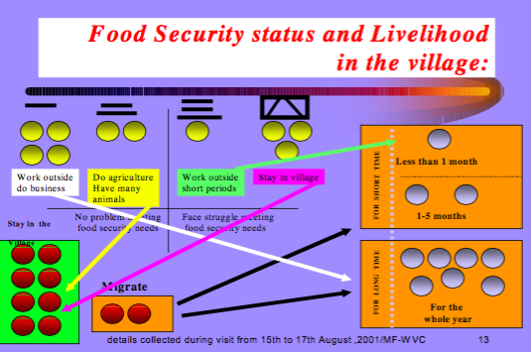

* **A Day in the Life of a Smallholder Farmer** (from the FAO field guide: Social analysis for agriculture and rural investment projects.
* **Talking Tables: discussions round a table with note taking and rotating tables.**

## (Limon et al. 2014) Using Mixed Methods to Investigate Factors Influencing Reporting of Livestock Diseases: A Case Study among Smallholders in Bolivia, Preventive Veterinary Medicine, 113(2), pp. 185–196.

Mixed methods design used to gain understanding of factors that influence reporting of livestock diseases in Bolivia.

Findings: livestock keepers unlikely to report occurrence of livestock health events…communication happens through alternative routes. Main barriers to disease reporting were institutional credibility and conflicting priorities.

**Mixed methods explanatory sequential design**

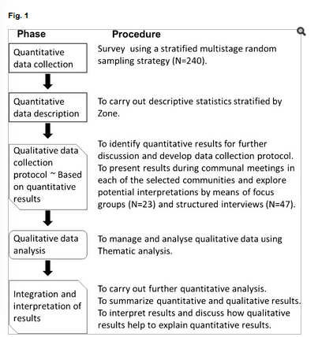

**Survey was carried out in 240 households from 24 communities**

## (Santiago-Brown et al. 2014) What Does Sustainability Mean? Knowledge Gleaned From Applying Mixed Methods Research to Wine Grape Growing, Journal of Mixed Methods Research, 9(3).

Methods**:**

83 participants from the wine grape industry participated in 14 focus groups in 5 countries. Quantitative measures were compared with results from qualitatively coded participant utterances using two content analysis software tools.

**3 stages for ‘assessment of sustainability in viticulture’**

Stage 1: 14 focus groups. Snowball sampling. 9 questions in focus group. Transcribed sessions, concept maps and word clouds/lists.

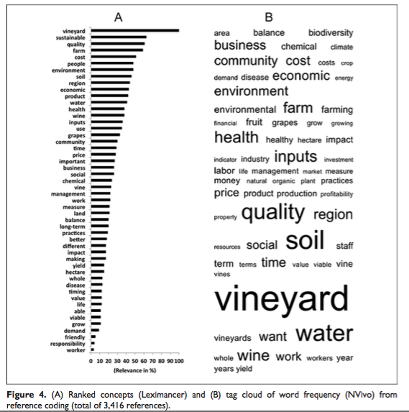

Stage 2: generating list of indicators to assess sustainability using data from the second section of focus group sessions

Stage 3: describing engagement process

(Misiko 2013) Dilemma in participatory selection of varieties, Agricultural Systems, 119, pp. 35-42

Study: to investigate long-term problems with Participatory Variety Selection/Breeding programs

Methods: literature review; survey (n=300) and key informant interviews (n=15) in 3 rural sites in western Kenya; field notes based on direct observations made and recorded during PVS processes; focus group discussions and participant observation; direct and field observations.

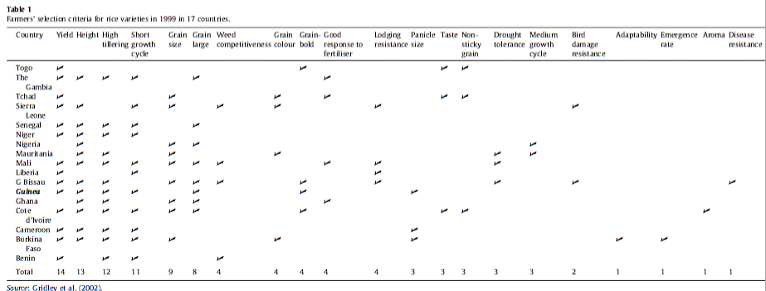

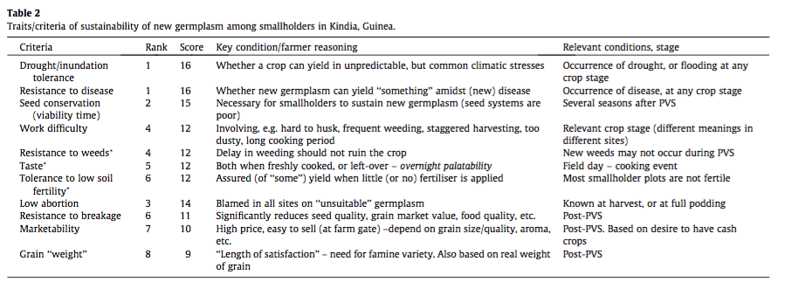

**Participation in key stages of PVS: figure shows that smallholders participate in some stages more than others – some clash with time demands on smallholders. Field day is popular as this is when selection mostly takes place.**

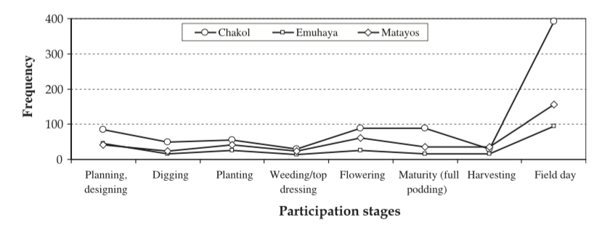

# 

Focus group discussions: showed that smallholders need an integrated knowledge exchange process that lasts a long time. They are unable to participate consistently in PVS so they don’t have enough knowledge to sustain/promote new germplasm.

**Reasons for sustaining new soya bean varieties after 5 years:**

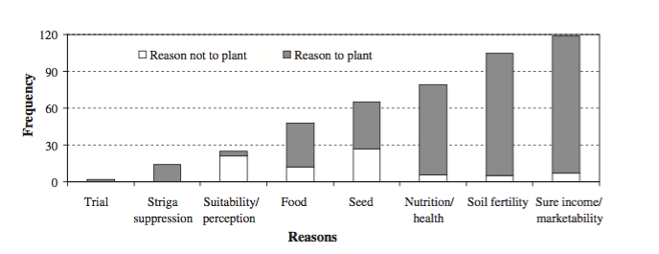

**Conclusion**: An integrated knowledge exchange system must be an innovative combination of science and interactive learning approaches that address gaps in participatory approaches.

# Other studies

## (Lacosteet al. 2016) **Comparative Agriculture Methods Capture Distinct Production Practices across a Broadacre Australian Landscape,** Agriculture, Ecosystems & Environment, 233, pp. 381–395.

Applied approach to examine the impact of soil heterogeneity on farmers’ practices, production orientation and crop performances, expressed as rotation composition, farm type and grain yield (Australia).

Methods:

Qualitative and quantitative.

1. Landscape analysis

2. Historical investigation: in-depth & demi-structured interviews with retired farmers.

3. Characterisation of current farming systems

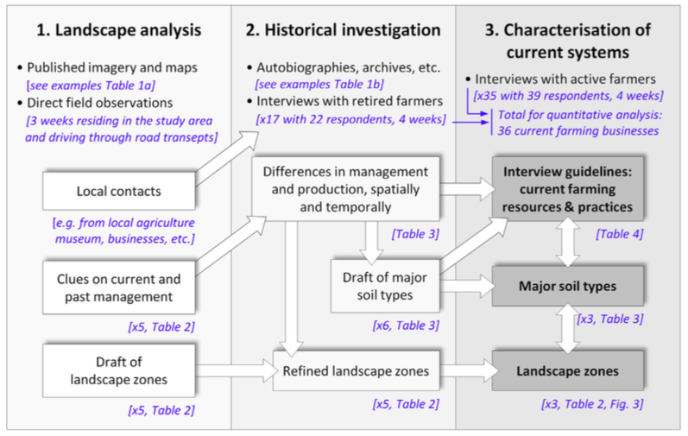

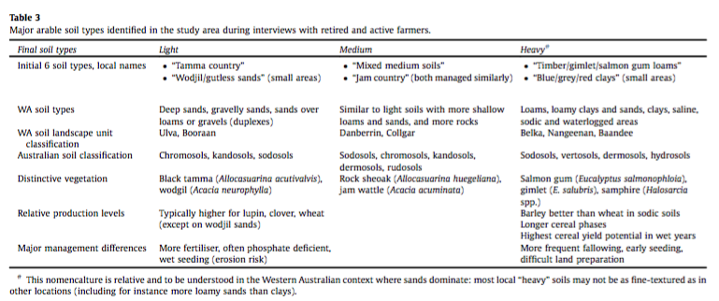

## (Murgue et al. 2016) Hybridizing Local and Generic Information to Model Cropping System Spatial Distribution in an Agricultural Landscape, Land Use Policy, 54, pp. 339–354.

Study: based on multiple methods and mixed sources to model an agricultural landscape (AL) that represents spatial distribution of cropping systems. Based on ‘progressively hybridizing databases and local actors’ and experts’ knowledge.

Local knowledge is used to identify factors determining spatial distribution of cropping systems and to build a generic model that simulates farmers' crop-management strategies.

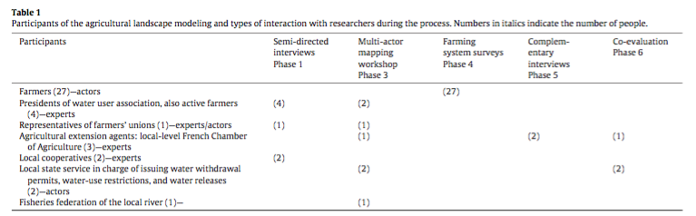



## (Bezner Kerr et al. 2016) Food Sovereignty, Agroecology and Resilience: Competing or Complementary Frames? An international colloquium 4‐5 February 2016 The Hague, The Netherlands: International Institute of Social Studies.

Study type: Longitudinal mixed methods case study of a participatory agriculture nutrition project.

Methods: In-depth interviews, structured surveys, participatory workshops and informal observations.

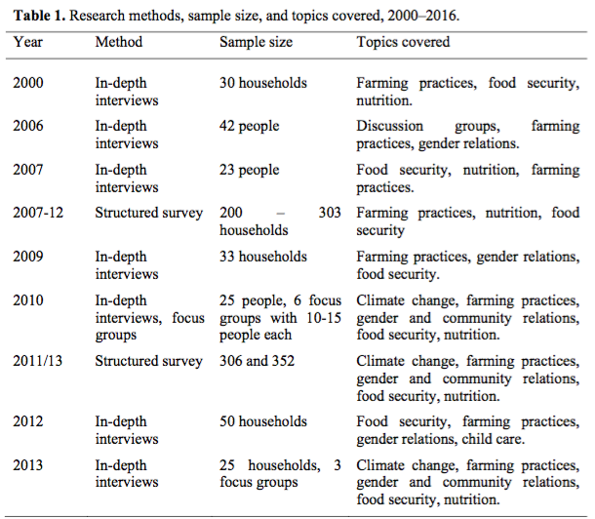

Conclusion:

Drawing on long-term participatory research in Malawi, in this study the conceptual and empirical links between agroecology, food sovereignty and resilience are discussed. We demonstrate that under climate variability, smallholders who use a diverse range of agroecological farming practices can build food sovereignty and resilience.