# Appendices - R

## Appendix 1 – Interaction Plots

setwd("C:/INSERT FOLDER WITH DATA IN HERE")

library(openxlsx)

Beans<-read.xlsx(xlsxFile="BeanTrial.xlsx","Raw Data")

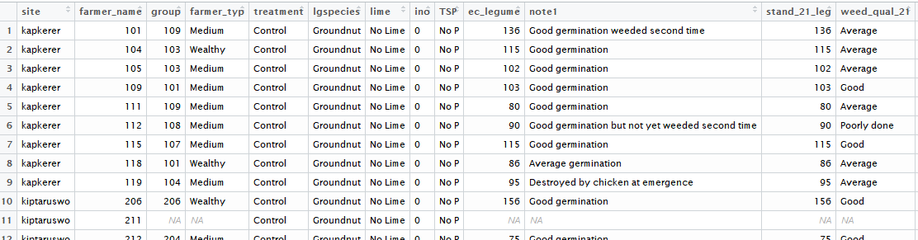

library(ggplot2)

ggplot(data=Beans,aes(y=gyield,x=TSP,group=lime))+

stat_summary(geom="line",aes(col=lime))+facet_wrap(~site)

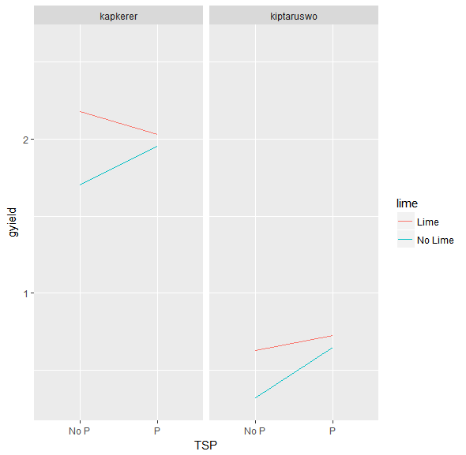

## Appendix 2 – Cumulative Risk Plot

setwd("C:/INSERT FOLDER WITH DATA IN HERE")

library(openxlsx)

Beans<-read.xlsx(xlsxFile="BeanTrial.xlsx","Raw Data")

library(RCCRP)

riskdiff(outcome=Beans$gyield,

plotID=Beans$farmer_name,

trtID =Beans$treatment,

trt1="Lime + TSP",

trt2 = "TSP Only")

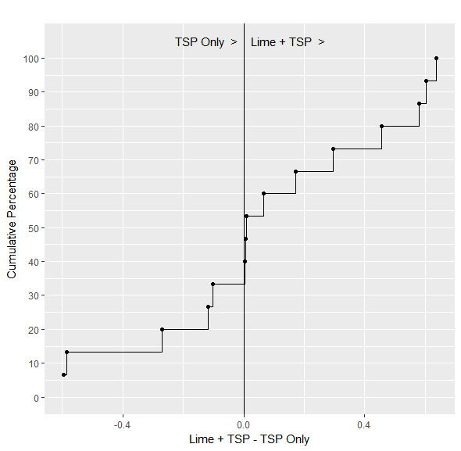

## Appendix 3 – Pairwise Treatment Scatterplot

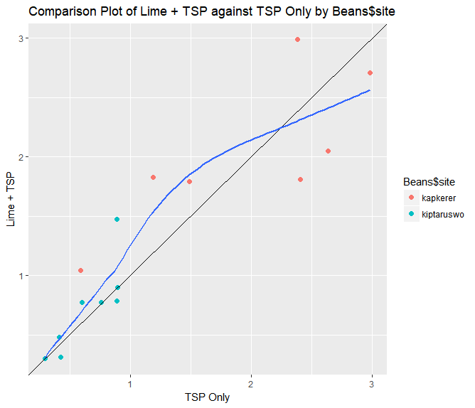

setwd("C:/INSERT FOLDER WITH DATA IN HERE")

library(openxlsx)

library(RCCRP)

Beans<-read.xlsx(xlsxFile="BeanTrial.xlsx","Raw Data")

Producing this plot can be done using the compare_trt() function in the RCCRP library (refer to previous installation instructions). The openxlsx library is also used to read in a data file.

To use the compare_trt() function you need a dataset in long format with one observation for each farmer (or plot) for each treatment. The function has arguments for an outcome variable (e.g. yield), a plotID variable, a treatment ID variable and the names of the two treatments you want to compare.

compare_trt(outcome=Beans$gyield,

plotID=Beans$farmer_name,

trtID =Beans$treatment,

trt1 = "TSP Only",

trt2 = "Lime + TSP",

grpID=Beans$site,

smoother = T)

## Appendix 4 – Plots of Yield by Variety by Season

MultiSeason<-read.csv("MultiSeasonTrial.csv")

library(ggplot2)

ggplot(data=MultiSeason,

aes(y=Yield,x=Variety,group=Location))+

geom_point(aes(col=Location))+facet_wrap(~Season)

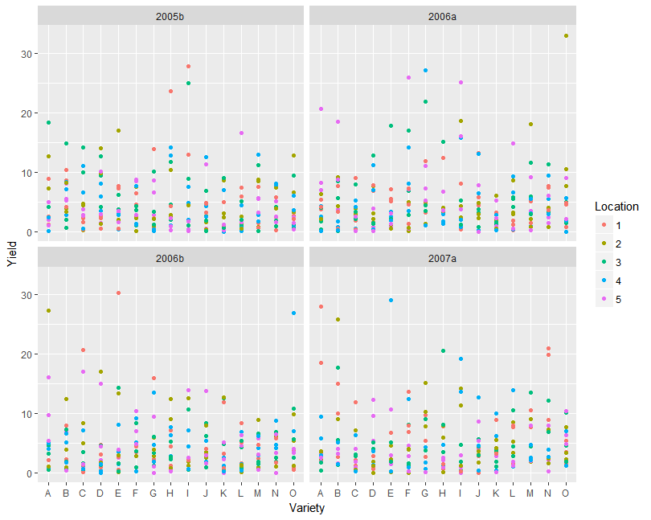

## Appendix 5 – Advanced Cumulative Risk Plots

Using the RCCRP library – see Appendix 0 for how to load this into R.

#Read in data set

setwd("C:/INSERT FOLDER WITH DATA IN HERE")

library(openxlsx)

DiffData<-read.xlsx(xlsxFile="GDIFF.xlsx","Raw Data")

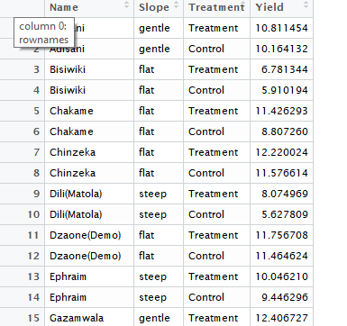

library(RCCRP)

#Overall Plot

riskdiff(outcome = DiffData$Yield,

plotID = DiffData$Name,

trtID = DiffData$Treatment,

trt1 = "Treatment",

trt2 = "Control",

approx = TRUE)

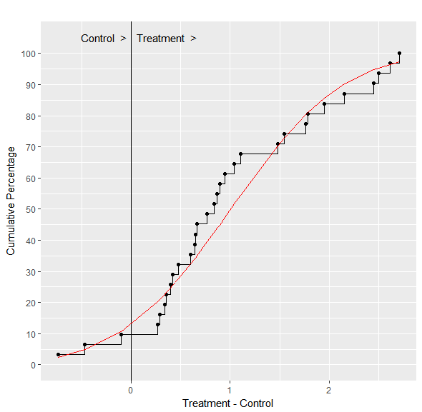

#Split by Slope; Remove the empirical lines and only use the theoretical

riskdiff(outcome=DiffData$Yield,

plotID=DiffData$Name,

trtID = DiffData$Treatment,

trt1 = "Treatment",

trt2 = "Control",

grpID = DiffData$Slope,

approx = TRUE,

emperical=FALSE)

