Testing Your Soil With Plants

By: Samuel Nderitu; GROW BIOINTENSIVE Agriculture Center Kenya

Discover what your soil needs simply by observing the plants growing in and near your farm. Every plant speaks of the conditions in which it grows. Each plant describes the soil quality through its presence or characteristics such as form, color, and vigor.

By analyzing these characteristics, a knowledgeable farmer can understand the moisture, acidity, nutrient content and other conditions of the soil. If your crops are purple, lacking phosphorus, add compost rich with phosphorus, could mean low temps, not good soil prep or over weeding.

Chemical analysis of soil conditions continues to be the dominant method used by farmers to determine the conditions and nutrient status of their soil. One disadvantage is that chemical analysis or soil analysis is only able to reflect the soils conditions at one point in time. While some nutrients do not change over the period of a season or year such as manganese and copper, some soil nutrients and conditions can change dramatically over that period of time such as nitrogen and potassium.

Many farmers throughout the world do not have access to or cannot afford the cost of laboratory analysis of their soil. Therefore, these farmers must attempt to maintain or improve its fertility with limited knowledge about that soil. As a result, most land goes unfertilized or fertilized with the wrong nutrients while yield potential of that soil is not realized across generations.

Using plants to analyze the soil overcomes all these disadvantages. A farmer, equipped with the appropriate knowledge, can analyze the condition of crops and weeds already growing on the farm over long periods of time without needing any money or equipment. This knowledge is available through training at some local community organic farming centers such as The GROW BIOINTENSIVE Agriculture Center Kenya.

|  |  |
| --- | --- |
| Symptom | Potential Cause(s) |
| Red and purple leaves | Phosphorus deficiency, low temperatures, drought, waterlogging, lack of compost, excessive friability, poor soil preparation, potato eelworm, wireworms, cutworms, apple canker, bark injuries to trees |
| Yellow, red and purple leaves | Nitrogen deficiency, low temperatures, drought, waterlogging, lack of compost, damage during weeding, excess weeds, poor soil preparation, potato eelworm, wireworms, cutworms, apple canker, bark injuries to trees |
| Leaf tips roll | Calcium deficiency, potato stem canker |
| Death of tissue between leaf veins and yellowing | Magnesium deficiency, apple canker, potato virus diseases, bark injuries to trees |
| Leaves are pale green | Iron deficiency, manganese deficiency, zinc deficiency, waterlogging |

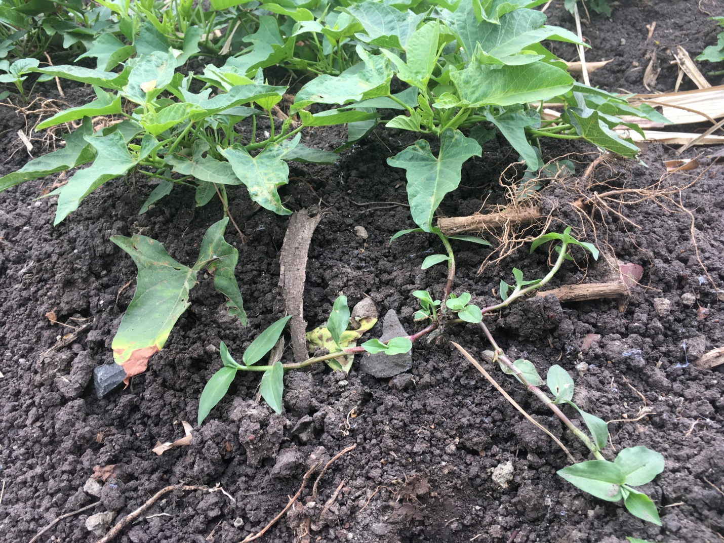

Caption: This photo shows a Wandering Jew weed growing with sweet potato vines. This is a weed that indicates fertile soil quality.