Agroecology: A Sustainable Transformation Approach to Agri-Food Systems – Module P – Sustainable Management of Mediterranean Agroecosystems

Sustainable Management of Mediterranean Agroecosystems

TEACHING GUIDE

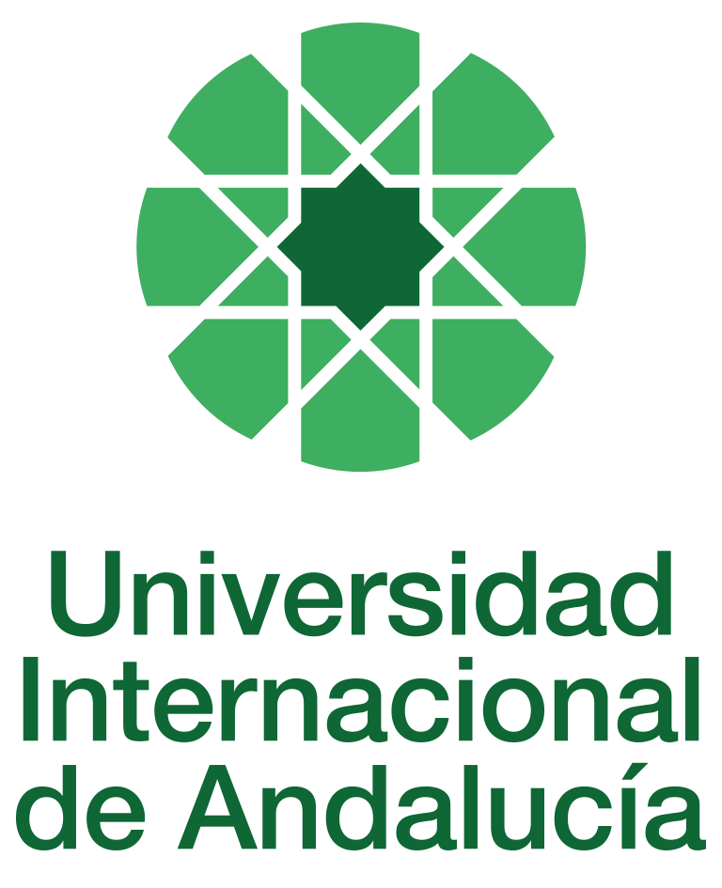

INSTRUCTIONS FOR THE PREPARATION AND PROCESSING OF TEACHING GUIDES FOR COURSES

Type of Training Activity | Master's Degree
Name of the Training Activity | Agroecology: An Approach to the Sustainable Transformation of Agri-Food Systems
Name of the Subject | Sustainable Management of Mediterranean Agroecosystems
Module | Module P - Sustainable Management of Mediterranean Agroecosystems
Academic | 2024-2025
Type | Optional
ECTS | Theory: | 3.00 | Practical: | 0.00 | Total: | 3.00
Teaching method | IN-PERSON
Teaching period | 7 to 11 April 2025
Coordinating university website | https://www.unia.es/estudios-y-acceso/oferta-academica/masteres-oficiales/master-oficial-en-agroecologia-un-enfoque-para-la-sustentabilidad-rural-2
Collaborating university website | https://www.uco.es/estudios/idep/agroecologia / https://www.upo.es/postgrado/Master-Oficial-Agroecologia-Un-Enfoque-de-Transformacion-Sustentable-de-los-Sistemas-Agroalimentarios/
Language(s) of instruction | Spanish

Course coordinator
Name | Email | University | Credits
Gloria Guzmán Casado | *** | PABLO DE OLAVIDE UNIVERSITY | 1.00

Teaching staff
First name and surname | Email | University | Credits
Antonio Manuel Alonso Mielgo | *** | SELF-EMPLOYED | 1.00
Pilar Fernández Rebollo | *** | UNIVERSITY OF CORDOBA | 1.00
Gloria Guzmán Casado | *** | PABLO DE OLAVIDE UNIVERSITY | 1.00
TUTORIALS: Schedule and location
Tutorials/seminars: Wednesday and Thursday mornings: 9-11:30
Teaching staff office

RESULTS OF THE TRAINING AND LEARNING PROCESS
Knowledge or content | Understand the ecological basis of how Mediterranean agroecosystems function; the agroecological processes that occur in agricultural soils, delving into how management affects their quality and, ultimately, plant and animal health in this geographical area; the interaction between functional plant biodiversity and arthropods for proper pest management; and apply the ecological bases for proper weed management.
Competencies | Design agroecosystems that combine the capacity to produce food and/or other goods and services with a high degree of resilience and autonomy in Mediterranean soil and climate conditions; Master the criteria for evaluating and proposing crop management techniques that result in greater sustainability of Mediterranean agroecosystems; design fertilisation programmes adapted to different agroclimatic scenarios; develop research proposals that contribute knowledge for the design of sustainable agroecosystems.
Skills or abilities | Management of fertilisation programmes adapted to different agroclimatic scenarios

CONTENT DESCRIPTORS
Theoretical classes:
•
Organic olive growing
• Organic horticulture
• Organic irrigated fruit growing
• Organic livestock farming
• Dehesa management
• Irrigated industrial crops.
• Sustainable irrigation management in Mediterranean agroecosystems
Practical classes:
Field trip: Visit to an irrigated fruit farm in Alhama de Almería and an organic olive grove in Tabernas, also in Almería, which are models of organic farming and efficient water use, recognised with several awards and mentions for quality.
Guided activities:
• Seminar: Students will discuss their experience of the field trip, taking notes on common characteristics, distinguishing features, deficiencies found, innovations, social role and potential.
• Lecture: A lecture-colloquium on research into sustainable agroecosystems in the Mediterranean will be given by the head of the Research Department of IFAPA, the Agricultural Research and Training Institute of the Regional Government of Andalusia, or, failing that, by IRTA or INIA.

TRAINING ACTIVITIES AND TEACHING METHODOLOGIES
Training activity | Teaching method | Commitment  (hours of independent study) | Dedication  (hours of class work by the student with teacher support)
Lectures and practical activities (face-to-face, synchronous and/or asynchronous) | IN-PERSON | 0 | 18
Academically directed and/or supervised activities | IN-PERSON | 0 | 4
Field trip | IN PERSON | 0 | 8
Independent student activities | TO BE DETERMINED | 45 | 0
ASSESSMENT SYSTEM
The course will be assessed through an individual reflection and analysis assignment using the readings and content provided in class and on Moodle.
At the end of the course, there will be a discussion and sharing of the content and main practical contributions.
These assignments must be submitted before the deadline, either by email to the module coordinator or by uploading a file as an assignment in the corresponding section of the course on Moodle.
Assessment strategies/methodologies |  |  |  | Percentage of total assessment
Class participation and discussion forums |  |  |  | 50%
Completion and presentation of group assignments |  |  |  | 25
Internship reports/memoirs |  |  |  | 25
TEACHING RESOURCES AND MATERIALS
Lectures
Group work and/or group presentations
Field trips
Study and analysis of materials and readings
BIBLIOGRAPHY
Alonso, A.M.; Arcos, J.M.; Guzmán, G.I. 2009. Fruit tree cultivation in organic farming. Published by the Ministry of the Environment, Rural and Marine Affairs.
Domínguez Gento, A. 2008. Organic citrus farming. Published by the Regional Ministry of Agriculture and Fisheries. Regional Government of Andalusia.
García, R.A. and Rebollo, X. 2008. Organic sheep production. Published by the Regional Ministry of Agriculture and Fisheries. Regional Government of Andalusia.
García, R.A.; Berrocal, J.; Moreno, L.; and Ferrón, G. 2008. Organic production of laying hens. Ed: Regional Ministry of Agriculture and Fisheries. Regional Government of Andalusia.
García, R.A.; Mudarra, I.; 2009. Organic vine cultivation. Ed. Ministry of the Environment, Rural and Marine Affairs.
Guzmán, G.I. and Foraster, L.; 2009. Olive cultivation in organic farming. Ed. Ministry of the Environment, Rural and Marine Affairs.
Guzmán, G.I.; Alonso, A.M; 2009. Vegetable cultivation in organic farming. Ed. Ministry of the Environment, Rural and Marine Affairs.
Guzmán, G.I, García, A.R., Alonso, A.M. and Perea, J.M. 2009. Organic Production. Influence on Rural Development. Published by: Ministry of the Environment, Rural and Marine Affairs. Madrid.
CONTINGENCY PLAN

In Seville, on 15 July 2024.
Signed: González de Molina, Manuel
In accordance with current legislation on the protection of personal data (Regulation(EU) 2016/679 of 27 April), we inform you that the personal data you have provided will be processed by the INTERNATIONAL UNIVERSITY OF ANDALUSIA as the data controller, with the Academic Management Department (Monasterio Santa María de las Cuevas, C / Américo Vespucio nº2. Isla de La Cartuja - 41092 - Seville), before whom you may exercise your rights of access, rectification, limitation, opposition or portability, specifically indicating the reason for your request and attaching a copy of your identity document. The request may be made in writing on paper or by electronic means.
If you do not receive a response or your request is rejected, you may contact the University's Data Protection Officer (rgpd@unia.es Tel. 954 462299) or lodge a complaint with the Spanish Data Protection Agency using the forms provided for this purpose on its website: https://sedeagpd.gob.es.
As the data controller, the University informs you that it will only process the personal data you provide for the following purposes:
a) Academic and administrative management of:
• Participation in the admission and enrolment processes for official courses (Bachelor's, Master's and Doctorate degrees) or continuing education at the International University of Andalusia.
• Enrolment and/or registration as a student in any of the official degree programmes (bachelor's, master's and doctoral), continuing education or other academic activities offered by the International University of Andalusia.
• Participation in calls for scholarships and study grants from the International University of Andalusia, the General State Administration or the Autonomous Communities and other public or private entities.
• Participation in calls for national or international mobility programmes.
• Obtaining and issuing official degrees, university-specific degrees and other academic qualifications.
b) Management of your participation as a student in national or international internships and training activities in institutions, companies, organisations or other centres.
c) Use of university services such as obtaining a university card, libraries, sports activities, or others.
The University is entitled to process this data as it is necessary for the execution of the legal relationship established between you and the University and for the University to comply with its legal obligations established in Organic Law 6/2001 on Universities.
You are responsible for the accuracy of the personal data you have provided to the University and for keeping it up to date.
The University will communicate the personal data that is essential, and never in any other case, to the following categories of recipients:
• Other public administrations and bodies for the exercise of their own powers and in accordance with the purposes set out above (including, but not limited to, ministries with powers in education and science, other administrations, other universities or equivalent training centres for the management of transfers, and companies for the purpose of work placements).
• To banking institutions for the management of payments and collections.
• To public or private bodies by virtue of collaboration agreements or contracts, in accordance with the provisions of current legislation on data protection.
• To the University's own services that are appropriate for managing the use of the university services offered.
Your personal data will be processed and stored by the University in accordance with current data protection legislation, and will then become part of the University Historical Archive, after being purged, in accordance with the provisions of the legislation on Historical Heritage.
The University only envisages the transfer of data to third countries in the case of your participation as a student in any of the international training programmes or scholarships. The transfer will be carried out in accordance with the guidelines established in this regard by the European Data Protection Regulation and implementing regulations.
The Data Protection Service of the International University of Andalusia has a website that includes legislation, information and models relating to Personal Data Protection, which can be accessed via the following link: https://www.unia.es/protecciondatos

