Agroecology: An Approach to Sustainable Transformation of Agri-Food Systems – Module S – Master's Thesis

Master's Thesis

TEACHING GUIDE

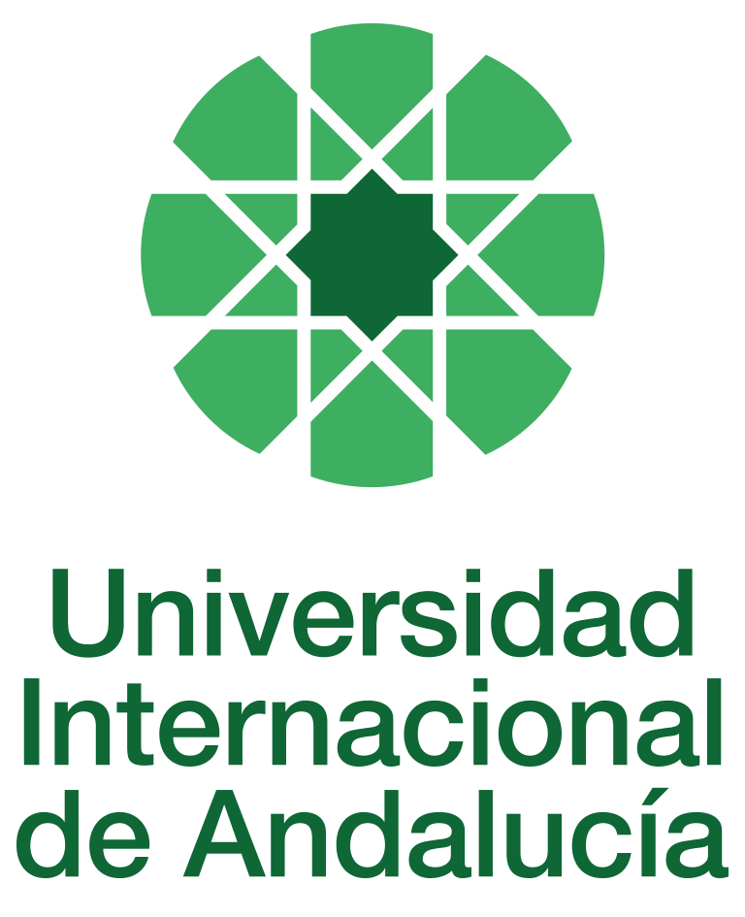

INSTRUCTIONS FOR THE PREPARATION AND PROCESSING OF COURSE GUIDES

Type of Training Activity | Master's Degree
Name of the Training Activity | Agroecology: An Approach to the Sustainable Transformation of Agri-Food Systems
Name of the Subject | Master's Thesis
Module | Module S - Master's Thesis
Academic | 2024-2025
Type | Compulsory
ECTS | Theory: | 12.00 | Practical: | 0.00 | Total: | 12.00
Teaching method | HYBRID (BLENDED)
Teaching period | April - September 2025
Coordinating university website | https://www.unia.es/estudios-y-acceso/oferta-academica/masteres-oficiales/master-oficial-en-agroecologia-un-enfoque-para-la-sustentabilidad-rural-2
Collaborating university website | https://www.uco.es/estudios/idep/agroecologia / https://www.upo.es/postgrado/Master-Oficial-Agroecologia-Un-Enfoque-de-Transformacion-Sustentable-de-los-Sistemas-Agroalimentarios/
Language(s) of instruction | Spanish

Course coordinator
Name | Email | University | Credits

Teaching staff
First name and surname | Email | University | Credits
- No teaching staff assigned | *** | None | 12:00
TUTORIALS: Schedule and location
Tutorials during the face-to-face phase (face-to-face)
On demand with each of the tutors once defined (online or in person)

RESULTS OF THE TRAINING AND LEARNING PROCESS
Knowledge or content | Thorough and holistic knowledge of the basic and specific theoretical and thematic background of the agroecological approach and the development of socio-environmental sustainability proposals
Competencies | Analyse the content of the readings and summarise this content for further study through questions that encourage the development of key concepts from the readings.  Organise all the activities to be carried out, such as tutorials and question resolution, gauge the time to be invested in each of them and plan your study schedule through the virtual platform and online contact with the assigned teacher.  Be able to develop adequate written communication, clear and orderly presentation of ideas, logical and argumentative justification, as well as relate general concepts to others of a more practical nature.  Solve problems and make decisions, not only in relation to specific issues and problems, but above all in relation to the ability to react to any unforeseen or new situation.  Reason critically, based on questioning the path followed by scientific thinking, and point out corrective paths. Agroecology can only be understood through practice, so it must be approached in a different way, in such a way that it leads students to understanding and reflection, based on praxis, thus developing a critical reading of events.  Propose and develop community projects for agroecological transformation or maintenance individually, in teams, and through participatory action research.  Have the capacity for innovation and make novel contributions both in the approach and in the chosen theme within the framework of agroecology.  Develop fieldwork according to good design and correct application of research techniques.  Contribute to the development of recommendations (improvements, applications), together with social dissemination (participatory feedback, journals or books relevant to agroecology) and scientific dissemination (peer-reviewed and indexed journals, project for a future thesis).
Skills or abilities | Communicate orally, using the terminology and techniques accepted in the field of the corresponding discipline

CONTENT DESCRIPTORS
• Theoretical and methodological support
• Thematic support
• Support in the design, execution, analysis and writing of the research
The Master's Thesis will be presented in written format and defended before a panel of three members, which may not include the thesis supervisor. This defence may be in person or virtual, via videoconference or similar methods, in accordance with the calls for applications established annually.

TRAINING ACTIVITIES AND TEACHING METHODOLOGIES
Training activity | Teaching method | Dedication  (hours of independent study) | Dedication  (hours of class work by the student with teacher support)
Lectures and practical activities | IN-PERSON | 0 | 2
Academically directed and/or supervised activities | IN PERSON | 0 | 18
Independent student activities | ONLINE | 280 | 0
ASSESSMENT SYSTEM
Assessment by the Master's Thesis Examination Board.
Assessment criteria:
Assessment by the Master's Thesis Examination Board
Assessment strategies/methodologies |  |  |  | Percentage of total assessment
Master's thesis text |  |  |  | 80%
Presentation and defence of the Master's Thesis |  |  |  | 20
TEACHING RESOURCES AND MATERIALS
Tutoring and support in research
Study and analysis of materials and readings
BIBLIOGRAPHY
BECK, U. (1998), Risk Society: Towards a New Modernity. Barcelona. Paidós
CALLEJO, J. (2001), The Discussion Group. Barcelona, Ariel
CHALMERS, A (1998), What is this thing called science?, Madrid, Siglo XXI.
ECHEVARRÍA, J (1994), Introduction to the Methodology of Science. Barcelona,
GARCÍA FERRANDO, M. et al. (comp.), (1992), The Analysis of Social Reality, Madrid, Alianza
FEYERABEND, P. (1981), Treatise on Method, Madrid, Tecnos.
FUNTOWICZ, S. and RAVETZ, J. (2002), Political Epistemology, Barcelona, Icaria. Madrid, Alianza.
KUHN, Th. (1979), The Structure of Scientific Revolutions, Madrid, FCE.
LECOMPTE, J. et al (1992), The Handbook of Qualitative Research, London, Academic Press.
MARTÍ, MONTAÑÉS, VILLASANTE, T.R. (2001), Participatory Social Research, Barcelona, El Viejo Topo.
MARTÍ, MONTAÑÉS, VILLASANTE, T.R. (2001), Local Practices of Social Creativity, Barcelona, El Viejo Topo.
MERTON, R.K. et al. (1956), The focused interview, Glencoe (Il.), Free Press.
POPPER, K. (1980), The Logic of Scientific Discovery, Madrid, Tecnos.
RUBIO, M.J. and VARAS, J. (1999). Analysis of reality in social intervention. Research methods and techniques, Madrid, CCS.
RUIZ OLABUENAGA, J.E. (1996), Methodology of Qualitative Research, Bilbao, University of Deusto.
SANTOS SOUSA, Boaventura de (2009) An Epistemology of the South: The Claim to Knowledge and Emancipation, Mexico, CLACSO/Siglo XXI.
SEVILLA GUZMÁN, E (2002), "The sociological perspective in agroecology: a systematisation of its
methods and techniques." In Agroecology and Sustainable Rural Development. EMATER/RS. No. 1; vol. 3; pp. 18-28.
TABERNER, J. (2008), Sociology and Education, Madrid, Tecnos (4th edition).
WALKER, R. (ed.) (1985), Applied Qualitative Research, Gowwer, Aldershot.
VALLES, M.S. (2002), The Qualitative Interview, Madrid, CIS.
VILLASANTE, T. R, (2001): Participatory Social Research, Madrid, Viejo Topo.
RUBIO, M.J. and VARAS, J. (1999). The Analysis of Reality in Social Intervention. Research Methods and Techniques, Madrid, CCS.
RUIZ OLABUENAGA, J.E. (1996), Methodology of Qualitative Research, Bilbao, University of Deusto.
TABERNER, J. (2008), Sociology and Education, Madrid, Tecnos (4th edition).
WALKER, R. (ed.) (1985), Applied Qualitative Research, Gowwer, Aldershot.
VALLES, M.S. (2002), The Qualitative Interview, Madrid, CIS.
VILLASANTE, T. R, (2001): Participatory Social Research, Madrid, Viejo Topo.
CONTINGENCY PLAN

In None, 10 May 2024.
Signed: David Gallar Hernández

In accordance with current legislation on the protection of personal data (Regulation(EU) 2016/679 of 27 April), we inform you that the personal data you have provided will be processed by the INTERNATIONAL UNIVERSITY OF ANDALUSIA as the data controller, with the Academic Management Department (Monasterio Santa María de las Cuevas, C / Américo Vespucio nº2. Isla de La Cartuja - 41092 - Seville), before whom you may exercise your rights of access, rectification, limitation, opposition or portability, specifically indicating the reason for your request and attaching a copy of your identity document. The request may be made in writing on paper or by electronic means.
If you do not receive a response or your request is rejected, you may contact the University's Data Protection Officer (rgpd@unia.es Tel. 954 462299) or lodge a complaint with the Spanish Data Protection Agency using the forms provided for this purpose on its website: https://sedeagpd.gob.es.
As the data controller, the University informs you that it will only process the personal data you provide for the following purposes:
a) Academic and administrative management of:
• Participation in the admission and enrolment processes for official courses (Bachelor's, Master's and Doctorate degrees) or continuing education at the International University of Andalusia.
• Enrolment and/or registration as a student in any of the official degree programmes (bachelor's, master's and doctoral), continuing education or other academic activities offered by the International University of Andalusia.
• Participation in calls for scholarships and study grants from the International University of Andalusia, the General State Administration or the Autonomous Communities and other public or private entities.
• Participation in calls for national or international mobility programmes.
• Obtaining and issuing official degrees, university-specific degrees and other academic qualifications.
b) Management of your participation as a student in national or international internships and training activities in institutions, companies, organisations or other centres.
c) Use of university services such as obtaining a university card, libraries, sports activities, or others.
The University is entitled to process this data as it is necessary for the execution of the legal relationship established between you and the University and for the University to comply with its legal obligations established in Organic Law 6/2001 on Universities.
You are responsible for the accuracy of the personal data you have provided to the University and for keeping it up to date.
The University will communicate the personal data that is essential, and never in any other case, to the following categories of recipients:
• Other public administrations and bodies for the exercise of their own powers and in accordance with the purposes set out above (including, but not limited to, ministries with powers in education and science, other administrations, other universities or equivalent training centres for the management of transfers, and companies for the purpose of work placements).
• To banking institutions for the management of payments and collections.
• To public or private bodies by virtue of collaboration agreements or contracts, in accordance with the provisions of current legislation on data protection.
• To the University's own services that are appropriate for managing the use of the university services offered.
Your personal data will be processed and stored by the University in accordance with current data protection legislation, and will then become part of the University Historical Archive, after being purged, in accordance with the provisions of the legislation on Historical Heritage.
The University only envisages the transfer of data to third countries in the event of your participation as a student in any of the international training programmes or scholarships. The transfer will be carried out in accordance with the guidelines established in this regard by the European Data Protection Regulation and implementing regulations.
The Data Protection Service of the International University of Andalusia has a website that includes legislation, information and models relating to Personal Data Protection, which can be accessed via the following link: https://www.unia.es/protecciondatos

