Agroecology: An Approach to Sustainable Transformation of Agri-Food Systems – Module R – Food Consumption from an Agroecological Perspective

Food consumption from an agroecological perspective

TEACHING GUIDE

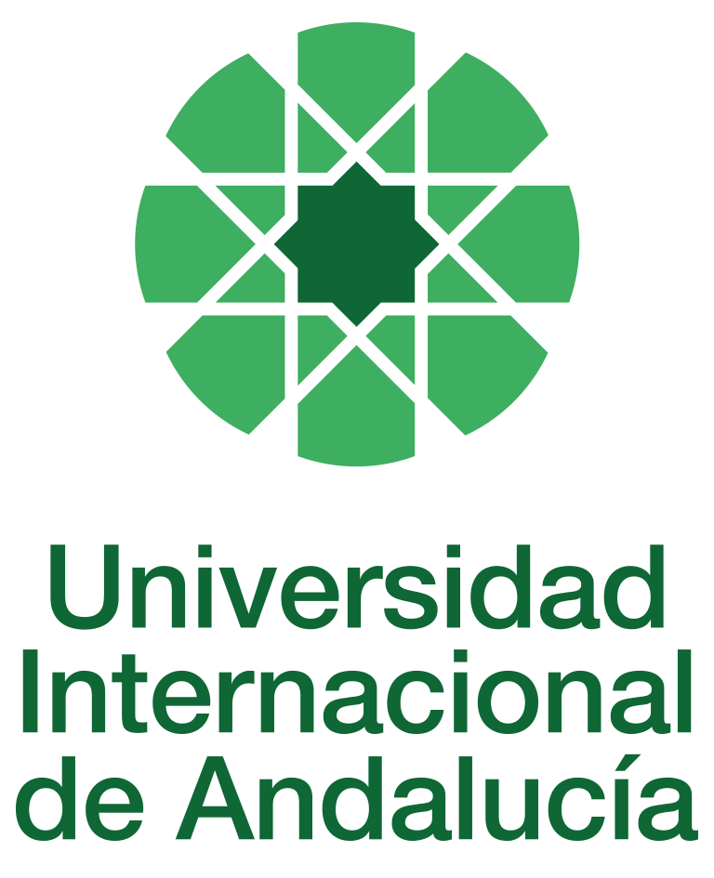

INSTRUCTIONS FOR THE PREPARATION AND PROCESSING OF TEACHING GUIDES FOR COURSES

Type of Training Activity | Master's Degree
Name of the Training Activity | Agroecology: An Approach to the Sustainable Transformation of Agri-Food Systems
Name of the Subject | Food Consumption from an Agroecological Perspective
Module | Module R - Food Consumption from an Agroecological Perspective
Academic | 2024-2025
Type | Optional
ECTS | Theory: | 3.00 | Practical: | 0.00 | Total: | 3.00
Teaching method | IN-PERSON
Teaching period | 7 to 11 April 2025
Coordinating university website | https://www.unia.es/estudios-y-acceso/oferta-academica/masteres-oficiales/master-oficial-en-agroecologia-un-enfoque-para-la-sustentabilidad-rural-2
Collaborating university website | https://www.uco.es/estudios/idep/agroecologia / https://www.upo.es/postgrado/Master-Oficial-Agroecologia-Un-Enfoque-de-Transformacion-Sustentable-de-los-Sistemas-Agroalimentarios/
Language(s) of instruction | Spanish

Course coordinator
Name | Email | University | Credits
David Gallar Hernández | *** | UNIVERSITY OF CORDOBA | 0

Teaching staff
First name and surname | Email | University | Credits
Nicolás Olea Serrano | *** | UNIVERSITY OF GRANADA | 1.00
Sonia Otero Estévez | *** | UNIVERSITY OF OVIEDO | 1.00
Carles Soler Novás | *** | ECOLOGICAL CANTEENS | 1.00
TUTORIALS: Schedule and location
Monday and Tuesday, from 4:30 p.m. to 6:30 p.m.

RESULTS OF THE TRAINING AND LEARNING PROCESS
Knowledge or content | Learn about consumption habits, food strategies and nutritional transition guidelines as they apply to the consumption of organic foods; the main chemical contaminants present in foods related to production, processing, distribution and preparation in the conventional agri-food sector and their effects on health; the ways, difficulties and benefits of using organic foods in professional gastronomy and collective catering.
Competencies | Handle research questions on consumption habits and diet at micro and macro levels; achieve a dialogue of knowledge with gastronomy professionals for the incorporation of organic food
Skills | Identify exposure via food to chemical contaminants present in food by identifying alerts, acronyms and food codes.

CONTENT DESCRIPTORS
Theoretical classes:
1. Introduction to food science and food technology applied to agroecology
2. Chemical components in food and packaging in the conventional agri-food system: effects on health
3. Nutrition and organic foods
4. Consumption habits and food strategies for the consumption of (agro)ecological products
5. Agroecological diets
6. Gastronomy in agroecology: popular cuisine and haute cuisine at the service of agroecology
7. Key points in the use of agroecological foods in cooking
8. Management of agroecological foods in collective catering
Practical classes:
Workshop on agrochemicals
Analysis of agroecological menus in school canteens

TRAINING ACTIVITIES AND TEACHING METHODOLOGIES
Lectures and practical activities (face-to-face, synchronous and/or asynchronous)
Academically directed and/or supervised activities
Independent student activities

Training activity | Teaching modality | Commitment  (hours of independent study) | Dedication  (hours of class work by the student with teacher support)
Lectures and practical activities (face-to-face, synchronous and/or asynchronous) | IN-PERSON | 0 | 20
Academically directed and/or supervised activities | IN-PERSON | 0 | 10
Independent student activities | TO BE DETERMINED | 45 | 0
ASSESSMENT SYSTEM
The course will be assessed through the completion of an individual reflection and analysis assignment using the readings and content provided in class and on Moodle.
These assignments must be submitted before the deadline, either by email to the module coordinator or by uploading a file as an assignment in the corresponding section of the course on Moodle.
Assessment strategies/methodologies |  |  |  | Percentage of total assessment
Cases and practical scenarios |  |  |  | 25
Long-answer tests |  |  |  | 50
Group work |  |  |  | 25
TEACHING RESOURCES AND MATERIALS
Lecture
Group work and/or group presentations
Study and analysis of materials and readings
BIBLIOGRAPHY
• Botella, J Crespo, A Rivas, I Cerrillo, MF Olea-Serrano, N Olea Exposure of women to organochlorine pesticides in Southern Spain, Environmental Research 2004, 96 (1), 34-40
• Cerrillo, A Granada, MJ López-Espinosa, B Olmos, M Jiménez, A Caño, et al. Endosulfan and its metabolites in fertile women, placenta, cord blood, and human milk Environmental Research 2005, 98 (2), 233-239
• Contreras, J.; Gracia-Arnaiz, M. Food and Culture. Anthropological Perspectives; Ariel: Barcelona, Spain, 2005; Volume 505, ISBN 9788434422230
• From the Field to School (2018). School canteens in Spain. From diagnosis to proposals. Retrieved from: http://delcampoalcole.org/investigacion/Error! Invalid hyperlink reference.
• Díaz Méndez, I García Espejo, R Gutiérrez Palacios, A Novo Vázquez, Eating habits of Spaniards Ministry of Agriculture, Food and the Environment, 2013
• Díaz Méndez, IG Espejo, A sociological view of food: critical analysis of research developments in the field of food, Política y Sociedad 2014, 51 (1), 15-49
• Díaz-Méndez Stability and change in the eating habits of Spaniards. Spanish Paediatric Journal 2016, 74 (1)
• Díaz-Méndez, I García-Espejo, Eating practice models in Spain and the United Kingdom: A comparative time-use analysis International Journal of Comparative Sociology 2014, 55 (1), 24-44
• Echeverría R, Vrhovnik P, Salcedo-Bellido I, Pérez-Carrascosa FM, Gómez-Peña C, et al., Associations of residential and occupational history with the distribution of persistent pollutant mixtures in adipose tissue samples. Environ Res. 2021 Mar;194:110687
• Echeverría R, Vrhovnik P, Salcedo-Bellido I, Iribarne-Durán LM, Fiket Ž, et al. Levels and determinants of adipose tissue cadmium concentrations in an adult cohort from Southern Spain. Sci Total Environ. 20 June 2019;670:1028-1036
• Esteban, A; Fernández, J.L; Gónzalez, L. (2019). Feeding change. Practical guide. Experience and reflections on educational, sustainable and healthy school canteens. Garúa and Ecologists in Action Madrid: Libros en accion.
• FEADRS. (2009). The social function of collective catering. Distribution and Consumption. 50-57.
• Fernandez, J. L; Morán, N. (2017). Public procurement as a factor in promoting agroecology, or how Gulliver ended up supporting Lilliput. In López, D; Fernández, J,L; Morán, N; Oteros, E. Rooting institutions (pp. 192-200). Madrid: Libros en acción.
• Fernández-Rodríguez M, Arrebola JP, Artacho-Cordón F, Amaya E, Aragones N, Llorca J, et al., Levels and predictors of persistent organic pollutants in an adult population from four Spanish regions. Sci Total Environ. 15 December 2015;538:152-61.
• Fischler, C. The Omnivore's Dilemma: Taste, Cooking and the Body; Anagrama: Barcelona, Spain, 1995; Volume 424, ISBN 9788433913982.
• Freire C, Suárez B, Vela-Soria F, Castiello F, Reina-Pérez I, Andersen HR, Olea N, Fernández MF. Urinary metabolites of non-persistent pesticides and serum hormones in Spanish adolescent males. Environ Res. 2021 Jun;197:111016.
• Freire C, Amaya E, Gil F, Fernández MF, Murcia M, Llop S, et al, INMA Project. Prenatal co-exposure to neurotoxic metals and neurodevelopment in preschool children: The Environment and Childhood (INMA) Project. Sci Total Environ. 2018 Apr 15;621:340-351.
• Fuentes-Guerra, R; Toral, I ; Martín, A. (2015). Responsible Eating in Public Schools: An Experience in Self-Managed Eco-Canteens. Habitat y Sociedad. (8): 169-179.
• Gallar Hernández, D.; Saracho-Domínguez, H.; Rivera-Ferré, M.G.; Vara-Sánchez, I. Eating Well with Organic Food: Everyday (Non-Monetary) Strategies for a Change in Food Paradigms: Findings from Andalusia, Spain. Sustainability 2019, 11, 1003. https://doi.org/10.3390/su11041003
• Garúa. (2017). Feeding change. Diagnosis of school canteens in the Community of Madrid and their transition to healthier and more sustainable models. Retrieved from: http://alimentarelcambio.es/wp-content/uploads/2017/03/informe_reducido.pdf [accessed: 05-06-2019]
• Garúa. (2019). Madrid nursery schools "Kilometre 0": gazpacho and organic melon to combat the heat in four Madrid nursery schools. Feeding change
• González-Garzón; L, M; Pérez, C; Pérez, M. (2003). School canteen: educational time and space. Pulso. 9(3):39-51.
• Gonzalez, L. (2016). Organic school canteens. Transition experiences and educational potential. VI International Congress of Agroecology. University of Vigo. Retrieved from: https://tv.uvigo.es/video/5b5b64fc8f4208025d811b2c, VI International Congress of Agroecology. [accessed: 08-08-2019]
• González-Alzaga B, Lacasaña M, Hernández AF, Arrebola JP, López-Flores I, Artacho-Cordón F, et al., Serum concentrations of organochlorine compounds and predictors of exposure in children living in agricultural communities from South-Eastern Spain. Environ Pollut. 2018 Jun;237:685-694.
• Guthman, J. Bringing good food to others: Investigating the subjects of alternative food practice. Cult. Geogr. 2008, 15, 431–447
• Hughner, R.S.; McDonagh, P.; Prothero, A.; Shultz, C.J.; Stanton, J. Who are organic food consumers? A compilation and review of why people purchase organic food. J. Consumer Behaviour. 2007, 6, 94–110.
• Lockie, S. ‘The Invisible Mouth’: Mobilising ‘the Consumer’ in Food Production–Consumption Networks. Sociol. Rural. 2002, 42, 278–294.
• Mares Madrid. (2019). Recipes and conclusions from the CAP on organic school canteens in nursery schools.
• Mosquera, C. (2016). Healthy and organically produced food in school canteens in Asturias.
• Mustieles V, Fernández MF, Martin-Olmedo P, González-Alzaga B, Fontalba-Navas A, et al., Human adipose tissue levels of persistent organic pollutants and metabolic syndrome components: Combining a cross-sectional with a 10-year longitudinal study using a multi-pollutant approach. Environ Int. 2017 Jul;104:48-57.
• Pastor-Barriuso R, Fernández MF, Castaño-Vinyals G, Whelan D, Pérez-Gómez B, Llorca J, et al., Total Effective Xenoestrogen Burden in Serum Samples and Risk for Breast Cancer in a Population-Based Multicase-Control Study in Spain. Environ Health Perspect. 2016 Oct;124(10):1575-1582.
• Perez-Lobato R, Mustieles V, Calvente I, Jimenez-Diaz I, Ramos R, Caballero-Casero N, et al., Exposure to bisphenol A and behaviour in school-age children. Neurotoxicology. 2016 Mar;53:12-19
• Platform for public and quality canteens. (2016). Social innovation in the management of public school canteens in Aragon.
• Pollan, M. The Omnivore’s Dilemma: A Natural History of Four Meals; The Penguin Press: London, UK, 2006.
• Poulain, J.P. The Sociology of Food: Eating and Place of Food in Society; Bloomsbury: London, UK, 2017.
• Rodríguez-Pérez C, Vrhovnik P, González-Alzaga B, Fernández MF, Martin-Olmedo P, Olea N, et al., Socio-demographic, lifestyle, and dietary determinants of essential and possibly-essential trace element levels in adipose tissue from an adult cohort. Environ Pollut. 2018 May;236:878-888.
• Santos, Vega (2019), Experiences of agroecological school canteens. Recommendations for school canteens in Córdoba. Master's Thesis. UCO
• Sirieix, L.; Kledal, P.R.; Sulitang, T. Organic food consumers’ trade-offs between local or imported, conventional or organic products: A qualitative study in Shanghai. Int. J. Consum. Stud. 2011, 35, 670–678.
• Soares, P; Martinez-Mian, M; Caballero, P; Vives-Cases, C; Davó- Blanes, M. C. (2017). Locally produced food in school canteens in Spain. Gaceta Sanitaria. 31, 466-471.
• Soler, C; Duch, G. (2011). Food sovereignty on school tables. Friends of the Earth.
• Southerton, C Díaz-Méndez, A Warde Behavioural change and the temporal ordering of eating practices: A UK–Spain comparison The International Journal of Sociology of Agriculture and Food 2012, 19 (1), 19-36
• Suárez B, Vela-Soria F, Castiello F, Olivas-Martinez A, Acuña-Castroviejo D, Gómez-Vida J, Olea N, et al., Organophosphate pesticide exposure, hormone levels, and interaction with PON1 polymorphisms in male adolescents. Sci Total Environ. 15 May 2021;769:144563.
• Vandenberg, R Hauser, M Marcus, N Olea, WV Welshons, Human exposure to bisphenol A (BPA), Reproductive toxicology 2007, 24 (2), 139-177
• VSF- Justicia Alimentaria, (2017). School canteens in the Basque Autonomous Community. Retrieved from: https://justiciaalimentaria.org/recursos/comedores-escolares-en-la-cav.
CONTINGENCY PLAN

In None, 25 April 2024.
Signed: Gallar Hernández, David

In accordance with current legislation on the protection of personal data (Regulation(EU) 2016/679 of 27 April), we inform you that the personal data you have provided will be processed by the INTERNATIONAL UNIVERSITY OF ANDALUSIA as the data controller, with the Academic Management Department (Monasterio Santa María de las Cuevas, C / Américo Vespucio nº2. Isla de La Cartuja - 41092 - Seville), before whom you may exercise your rights of access, rectification, limitation, opposition or portability, specifically indicating the reason for your request and attaching a copy of your identity document. The request may be made in writing on paper or by electronic means.
If you do not receive a response or your request is rejected, you may contact the University's Data Protection Officer (rgpd@unia.es Tel. 954 462299) or lodge a complaint with the Spanish Data Protection Agency using the forms provided for this purpose on its website: https://sedeagpd.gob.es.
As the data controller, the University informs you that it will only process the personal data you provide for the following purposes:
a) Academic and administrative management of:
• Participation in the admission and enrolment processes for official courses (Bachelor's, Master's and Doctorate degrees) or continuing education at the International University of Andalusia.
• Enrolment and/or registration as a student in any of the official degree programmes (bachelor's, master's and doctoral), continuing education or other academic activities offered by the International University of Andalusia.
• Participation in calls for scholarships and study grants from the International University of Andalusia, the General State Administration or the Autonomous Communities and other public or private entities.
• Participation in calls for national or international mobility programmes.
• Obtaining and issuing official degrees, university-specific degrees and other academic qualifications.
b) Management of your participation as a student in national or international internships and training activities in institutions, companies, organisations or other centres.
c) Use of university services such as obtaining a university card, libraries, sports activities, or others.
The University is entitled to process this data as it is necessary for the execution of the legal relationship established between you and the University and for the University to comply with its legal obligations established in Organic Law 6/2001 on Universities.
You are responsible for the accuracy of the personal data you have provided to the University and for keeping it up to date.
The University will communicate the personal data that is essential, and never in any other case, to the following categories of recipients:
• Other public administrations and bodies for the exercise of their own powers and in accordance with the purposes set out above (including, but not limited to, ministries with powers in education and science, other administrations, other universities or equivalent training centres for the management of transfers, and companies for the purpose of work placements).
• To banking institutions for the management of payments and collections.
• To public or private bodies by virtue of collaboration agreements or contracts, in accordance with the provisions of current legislation on data protection.
• To the University's own services that are appropriate for managing the use of the university services offered.
Your personal data will be processed and stored by the University in accordance with current data protection legislation, and will then become part of the University Historical Archive, after being purged, in accordance with the provisions of the legislation on Historical Heritage.
The University only envisages the transfer of data to third countries in the event of your participation as a student in any of the international training programmes or scholarships. The transfer will be carried out in accordance with the guidelines established in this regard by the European Data Protection Regulation and implementing regulations.
The Data Protection Service of the International University of Andalusia has a website that includes legislation, information and models relating to Personal Data Protection, which can be accessed via the following link: https://www.unia.es/protecciondatos

