Subscribe to DeepL Pro to edit this document.
Visit www.DeepL.com/pro for more information.

Agroecology: An Approach to Sustainable Transformation of Agri-Food Systems – Module Q – Political Agroecology: Ethnicity, Citizenship and Democracy

Political Agroecology: Ethnicity, Citizenship and Democracy

TEACHING GUIDE

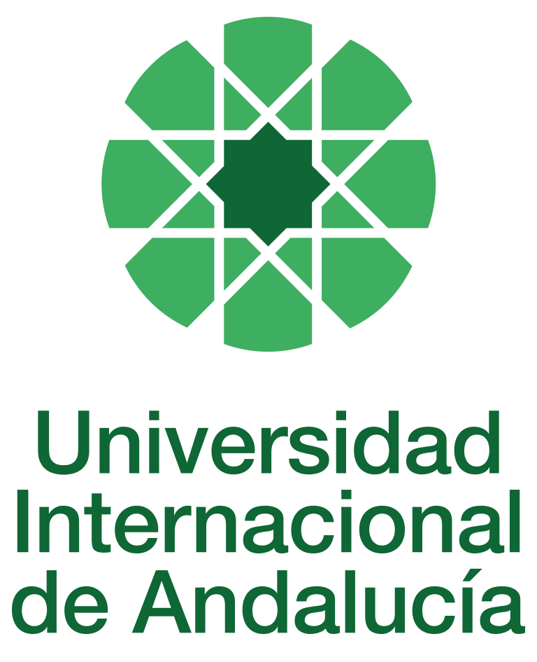

INSTRUCTIONS FOR THE PREPARATION AND PROCESSING OF COURSE GUIDES

Type of Training Activity | Master's Degree
Name of the Training Activity | Agroecology: An Approach to the Sustainable Transformation of Agri-Food Systems
Name of the Subject | Political Agroecology: Ethnicity, Citizenship and Democracy
Module | Module Q - Political Agroecology: Ethnicity, Citizenship and Democracy
Academic | 2024-2025
Type | Elective
ECTS | Theory: | 3.00 | Practical: | 0.00 | Total: | 3.00
Teaching method | IN-PERSON
Teaching period | 7 to 11 April 2025
Coordinating university website | https://www.unia.es/estudios-y-acceso/oferta-academica/masteres-oficiales/master-oficial-en-agroecologia-un-enfoque-para-la-sustentabilidad-rural-2
Collaborating university website | https://www.uco.es/estudios/idep/agroecologia / https://www.upo.es/postgrado/Master-Oficial-Agroecologia-Un-Enfoque-de-Transformacion-Sustentable-de-los-Sistemas-Agroalimentarios/
Language(s) of instruction | Spanish

Course coordinator
Name | Email | University | Credits
David Gallar Hernández | *** | UNIVERSITY OF CORDOBA | 1.00

Teaching staff
First name and surname | Email | University | Credits
Isabel Álvarez Vispo | *** | EHNE BIZKAIA TRADE UNION | 1.00
Ángel Calle Collado | *** | ECOJERTE COOPERATIVE | 0.5
David Gallar Hernández | *** | UNIVERSITY OF CORDOBA | 1.00
Marta Guadalupe Rivera Ferré | *** | UNIVERSITY OF VIC | 0.5
TUTORIALS: Schedule and location
Tutorials/seminars: Wednesday and Thursday mornings: 9-11:30
Teaching staff office

RESULTS OF THE TRAINING AND LEARNING PROCESS
Knowledge or content | Understand the dimensions of power, democracy and sustainable management of natural resources; historical and current debates on citizenship, participation, public institutions, social movements and social change; current critiques of the dynamics of government and governance in the context of globalisation; the concepts of participatory democracy and radical democracy in the context of rural and urban sustainability.
Competencies
Skills | Use conceptual and practical tools related to cross-cutting dimensions of agroecology in the context of food globalisation: post-normal science, philosophy of participatory action, the social construction of knowledge and trust, post-development and degrowth, gender relations.

CONTENT DESCRIPTORS
Theoretical classes:
• Bifurcations and disaffections in contemporary democracies: open debates on the role of citizenship, political participation and organisational systems in the construction of sustainable rural and urban development.
• Classical approaches to democracy: socialism, liberalism and anarchism. Expanding paradigms: ecological democracy, communal and new commons, the ecofeminist perspective on power and social change, post-development and democracy.
• Critical networks, social movements and expressions of radical democracy. Analysis of contemporary forms of satisfying basic needs "from below". Municipalist strategies.
• The construction of democracy: from everyday life to public policy, from power to sustainable alternatives, from the local situation and territory to the global scale, from domination to forms of participation that work from biocultural diversity. The struggle for food sovereignty.
Practical classes:
• Analysis of the democratic nature of the cooperative system in Spain.
Guided activities:
1. Seminar: Discussion, with regard to the democratic dimension, of the experiences in which students and teachers have participated in the field of agroecology.
2. Lectures: The current state of democracy, social movements and the state in Latin America and the European Union: rethinking politics?

TRAINING ACTIVITIES AND TEACHING METHODOLOGIES
Training activity | Teaching method | Commitment  (hours of independent study) | Dedication  (hours of class work by the student with teacher support)
Lectures and practical activities (face-to-face, synchronous and/or asynchronous) | IN-PERSON | 0 | 10
Academically directed and/or supervised activities | IN-PERSON | 0 | 20
Independent student activities | TO BE DETERMINED | 45 | 0
ASSESSMENT SYSTEM
The course will be assessed through an individual reflection and analysis assignment using the readings and content provided in class and on Moodle.
At the end of the course, there will be a discussion and sharing of the content and main practical contributions.
These assignments must be submitted before the deadline, either by email to the module coordinator or by uploading a file as an assignment in the corresponding section of the course on Moodle.
Assessment strategies/methodologies |  |  |  | Percentage of total assessment
Internship report/memoir |  |  |  | 40%
Long-answer tests |  |  |  | 40
Group work |  |  |  | 20
TEACHING RESOURCES AND MATERIALS
Lecture
Group work and/or group presentations
Discussions
Study and analysis of materials and readings
BIBLIOGRAPHY
Political Agroecology: social transition and peasantry. Authors: Ángel CALLE COLLADO and David GALLAR. Alasru, 2010.
Angel Calle Collado: (co-editor) Rebeldías en común. Sobre comunales, nuevos comunes y economías cooperativas (Rebellions in common. On communes, new commons and cooperative economies), Madrid, Libros en Acción, 2017
Angel Calle Collado: (co-author with Ricard Vilaregut) Territories in Democracy. Icaria, Barcelona, 104 pages, 2015, ISBN 9788498886351
Angel Calle Collado: (author) The Unpostponable Transition. The new political subjects to overcome the crisis, Icaria, Barcelona, 269 pages, 2013, ISBN 9788498884982
Angel Calle Collado: (coord. With Mamen Cuéllar and David Gallar) Processes towards food sovereignty. Perspectives and practices from political agroecology, Icaria, Barcelona, 216 pages, 2013, ISBN 9788498884531.
Víctor Manuel Toledo. Metabolisms, nature and history. Towards a theory of socio-ecological transformations. Editorial Icaria, Barcelona, 2011
Fernando Prats, Yayo Herrero and Alicia Torrego, The Great Crossroads. On the eco-social crisis and the change of historical cycle, Publisher: Libros en Acción, 2016
Siliprandi and Gloria Patricia Zuloaga (coord.) Gender, Agroecology and Food Sovereignty. Barcelona: Icaria, 2015.
Stephan Rist (author): If we are of good heart, there is always production. Paths in the renewal of traditional forms of production and life and their importance for sustainable development, Agruco, 2002.
See special issue in Revista Agroecología: https://www.agroecologia.net/revista-agroecologia-no6/
CONTINGENCY PLAN

In None, 25 April 2024.
Signed: Gallar Hernández, David

In accordance with current legislation on the protection of personal data (Regulation(EU) 2016/679 of 27 April), we inform you that the personal data you have provided will be processed by the INTERNATIONAL UNIVERSITY OF ANDALUSIA as the data controller, with the Academic Management Department (Monasterio Santa María de las Cuevas, C / Américo Vespucio nº2. Isla de La Cartuja - 41092 - Seville), before whom you may exercise your rights of access, rectification, limitation, opposition or portability, specifically indicating the reason for your request and attaching a copy of your identity document. The request may be made in writing on paper or by electronic means.
If you do not receive a response or your request is rejected, you may contact the University's Data Protection Officer (rgpd@unia.es Tel. 954 462299) or lodge a complaint with the Spanish Data Protection Agency using the forms provided for this purpose on its website: https://sedeagpd.gob.es.
As the data controller, the University informs you that it will only process the personal data you provide for the following purposes:
a) Academic and administrative management of:
• Participation in the admission and enrolment processes for official courses (Bachelor's, Master's and Doctorate) or continuing education at the International University of Andalusia.
• Enrolment and/or registration as a student in any of the official degree programmes (bachelor's, master's and doctoral), continuing education or other academic activities offered by the International University of Andalusia.
• Participation in calls for scholarships and study grants from the International University of Andalusia, the General State Administration or the Autonomous Communities and other public or private entities.
• Participation in calls for national or international mobility programmes.
• Obtaining and issuing official degrees, university-specific degrees and other academic qualifications.
b) Management of your participation as a student in national or international internships and training activities in institutions, companies, organisations or other centres.
c) Use of university services such as obtaining a university card, libraries, sports activities, or others.
The University is entitled to process this data as it is necessary for the execution of the legal relationship established between you and the University and for the University to comply with its legal obligations established in Organic Law 6/2001 on Universities.
You are responsible for the accuracy of the personal data you have provided to the University and for keeping it up to date.
The University will communicate the personal data that is essential, and never in any other case, to the following categories of recipients:
• Other public administrations and bodies for the exercise of their own powers and in accordance with the purposes set out above (including, but not limited to, ministries with powers in education and science, other administrations, other universities or equivalent training centres for the management of transfers, and companies for the purpose of work placements).
• To banking institutions for the management of payments and collections.
• To public or private bodies by virtue of collaboration agreements or contracts, in accordance with the provisions of current legislation on data protection.
• To the University's own services that are appropriate for managing the use of the university services offered.
Your personal data will be processed and stored by the University in accordance with current data protection legislation, and will then become part of the University Historical Archive, after being purged, in accordance with the provisions of the legislation on Historical Heritage.
The University only envisages the transfer of data to third countries in the case of your participation as a student in any of the international training programmes or scholarships. The transfer will be carried out in accordance with the guidelines established in this regard by the European Data Protection Regulation and implementing regulations.
The Data Protection Service of the International University of Andalusia has a website that includes legislation, information and models relating to Personal Data Protection, which can be accessed via the following link: https://www.unia.es/protecciondatos

