Agroecology: An Approach to Sustainable Transformation of Agri-Food Systems – Module O – Agroecological Extension

Agroecological Extension

TEACHING GUIDE

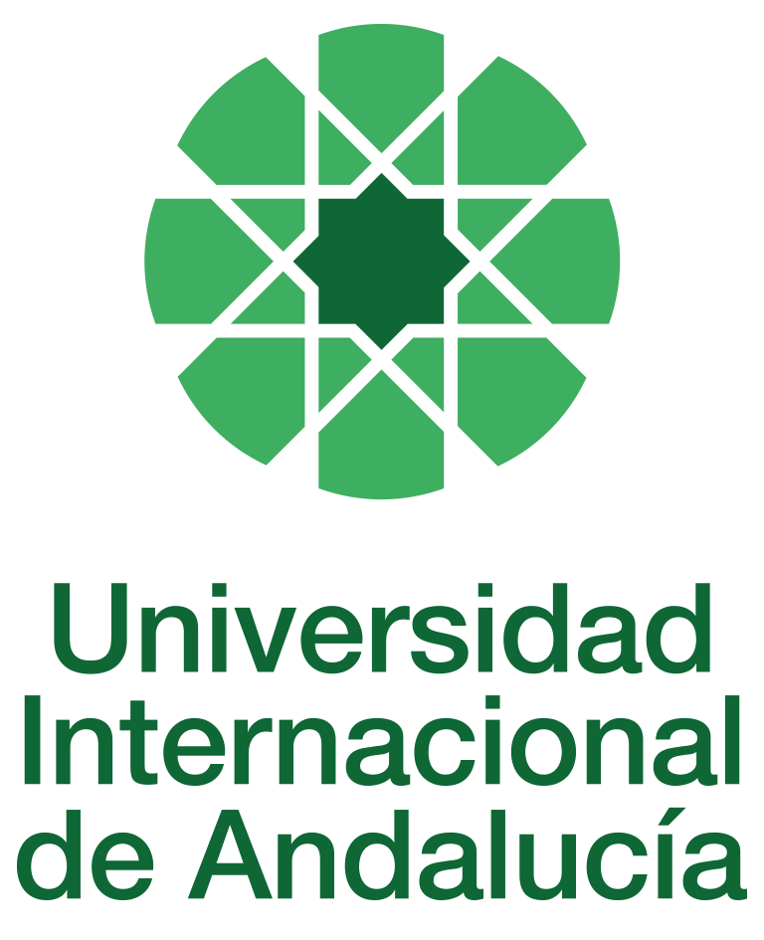

INSTRUCTIONS FOR THE PREPARATION AND PROCESSING OF TEACHING GUIDES FOR COURSES

Type of Training Activity | Master's Degree
Name of Training Activity | Agroecology: A Sustainable Transformation Approach to Agri-Food Systems
Name of the Subject | Agroecological Extension
Module | Module O - Agroecological Extension
Academic | 2024-2025
Type | Optional
ECTS | Theory: | 3.00 | Practical: | 0.00 | Total: | 3.00
Teaching method | IN-PERSON
Teaching period | 21 to 25 April 2025
Coordinating university website | https://www.unia.es/estudios-y-acceso/oferta-academica/masteres-oficiales/master-oficial-en-agroecologia-un-enfoque-para-la-sustentabilidad-rural-2
Collaborating university website | https://www.uco.es/estudios/idep/agroecologia / https://www.upo.es/postgrado/Master-Oficial-Agroecologia-Un-Enfoque-de-Transformacion-Sustentable-de-los-Sistemas-Agroalimentarios/
Language(s) of instruction | Spanish

Course coordinator
Name | Email | University | Credits
Jaime Morales Hernández | *** | TRAINING CENTRE FOR AGROECOLOGY AND SUSTAINABILITY | 1.00

Teaching staff
First and last names | Email | University | Credits
Miguel Ángel Escalona Aguilar | *** | VERACRUZ UNIVERSITY | 1.00
David Gallar Hernández | *** | UNIVERSITY OF CORDOBA | 1.00
Jaime Morales Hernández | *** | TRAINING CENTRE FOR AGROECOLOGY AND SUSTAINABILITY | 1.00
TUTORIALS: Schedule and location
Tutorials/seminars: Wednesday and Thursday mornings: 9-11:30
Teaching staff office

RESULTS OF THE TRAINING AND LEARNING PROCESS
Knowledge or content | Understands the history of rural extension; the theoretical foundations of conventional rural extension and agroecological rural extension; participatory methodologies for extension from an agroecology perspective; practical experiences of agroecological rural extension; recognises the characteristics of sustainable agri-food systems.
Competencies | Have a critical awareness of communicative intervention in Extension.  Use agroecological extension methods and theories from the perspective of popular education and the co-construction of agroecological knowledge, as well as communication techniques for rural innovation and knowledge dialogue.
Skills | Manage communication and dissemination resources for the production of agroecological knowledge.  Use participatory techniques for social intervention in the agricultural environment and in agri-food systems for the construction of agroecological knowledge.

CONTENT DESCRIPTORS
Theoretical classes: 1. From Agricultural Extension to Agroecological Extension. 2. The construction of agroecological knowledge and the transition to sustainable agri-food systems. 3. Co-construction of knowledge: participatory methodologies for extension. 4. Accompanying processes and strengthening organisations: collective political subjects for re-peasantisation Practical classes and guided activities: 1. Practices for the massification of agroecology: case studies 2. Agroecological communication and dissemination: presentation of experiences

TRAINING ACTIVITIES AND TEACHING METHODOLOGIES
Training activity | Teaching modality | Commitment  (hours of independent study) | Dedication  (hours of class work by the student with teacher support)
Lectures and practical activities (face-to-face, synchronous and/or asynchronous) | IN-PERSON | 0 | 10
Academically directed and/or supervised activities | IN-PERSON | 0 | 15
Field trip | IN PERSON | 0 | 5
Independent student activities | TO BE DETERMINED | 45 | 0
ASSESSMENT SYSTEM
The course will be assessed through an individual reflection and analysis assignment using the readings and content provided in class and on Moodle.
At the end of the course, there will be a discussion and sharing of the content and main practical contributions.
These assignments must be submitted before the deadline, either by email to the module coordinator or by uploading a file as an assignment in the corresponding section of the course on Moodle.
Assessment strategies/methodologies |  |  |  | Percentage of total assessment
Cases and practical scenarios |  |  |  | 20%
Internship reports/memoirs |  |  |  | 30
Long-answer tests |  |  |  | 50
TEACHING RESOURCES AND MATERIALS
Lectures
Group work and/or group presentations
Field trips
Study and analysis of materials and readings
BIBLIOGRAPHY
ALBRECHT, H. et al (1989): Agricultural Extension. Vol. 1. Rural Development Series. Eschborn. Wiley Eastern Limited.
ALEMANY, C. and SEVILLA GUZMÁN E. (2007) "Is rural extension making a comeback? Agroecological reflections and proposals linked to the return and strengthening of rural extension in Latin America" (in collaboration with Carlos Alemany) in Realidad Económica. Economics journal published by the Argentine Institute for Economic Development (IADE) No. 227: 52-74.
ANSORENA, I. (1972): "Decades of Latin American rural extension: adoption, adaptation and reflection (Need to establish new guidelines for rural development)" in Rural Development in the Americas, Vol. IV, No. 3. pp. 249-278.
BRAZIL. Ministry of Agrarian Development. (2004): National Policy on Technical Assistance and Rural Extension. Brasília, DF: SAF; Dater.
CAPORAL, F. R. (1998): Public sector agricultural extension in the face of the challenges of sustainable development: the case of Rio Grande do Sul, Brazil. Córdoba, 1998. 517f. (Doctoral thesis) Doctoral Programme in Agroecology, Peasantry and History, ISEC-ETSIAN, University of Córdoba, Spain.
CAPORAL, F. R.; COSTABEBER, J. A. (2007): Agroecology and rural extension: contributions to the promotion of sustainable rural development. 3rd ed. Brasília, MDA: SAF.
CIMADEVILLA, G. and CARNIGLIA, E. (2004): Communication, Rurality and Development. Myths, paradigms and mechanisms of change. INTA Editions. Buenos Aires; Argentina.
CUÉLLAR PADILLA, M. C. and SEVILLA GUZMÁN E. (2008): "Certification participative et transformation sociale" in Silvia Pérez-Victoria and Eduardo Sevilla Guzmán (eds.) Petit précis d'Agroecologie. Nourriture, autonomie, paysannerie☹(Alby/Paris: La ligne d'Horizon. France: pp. 72–88).
FALS?BORDA, O.; ZAMOSC, L. et al. (eds) (1987): Participatory Action Research in Colombia. Bogotá. Punta de Lanza.
FREIRE, P. (1975): Pedagogy of the Oppressed. Rio de Janeiro: Paz e Terra.
FREIRE, P. (1980): Conscientização: teoria e prática da libertação, uma introdução ao pensamento de Paulo Freire. São Paulo: Ed. Moraes.
FREIRE, P. (1982): Extension or Communication? Ed. Paz y Tierra. Rio de Janeiro. Brazil.
FREIRE, P. (1982): Cultural Action for Freedom and Other Writings. Rio de Janeiro: Paz e Terra.
FREIRE, P. (1983): Extension or Communication? Rio de Janeiro: Paz e Terra.
FREIRE, P. (1989): Education as the practice of freedom. Rio de Janeiro: Paz e Terra.
M., J.; BARRANCO, J. and CANO, F. (1988): Animation Techniques and Group Work. Seville. Department of Education and Science of the Regional Government of Andalusia.
JONES, G.E. (1986): Investing in Rural Extension: Strategies and Goals. Elsevier Applied Science Publishers LTD. New York; United States of America.
KING, C; GAFFNEY, J. and GUNTON, J. (2001): "Does Participatory Action Learning Make a Difference?" in The Journal of Agricultural Extension and Education, Vol. 7, No. 4, pp. 133-146.
LEEUWIS, CEES (with contributions from Anne van der Ban), 2004: Communication for Rural Innovation. Rethinking Agricultural Extension. Hong Kong, Blackwell Publishing.
RIVERA, W.M. and GUSTAFSON, D.J. (eds) (1991): Agricultural Extension: Worldwide Institutional Evolution and Forces for Change. Amsterdam. Elsevier.
RIVERA, W.M. (2001): “Whither Agricultural Extension Worldwide? Reforms and Prospects”. Institutional Evolution and Forces for Change”. Paper presented at the 15th International Seminar on Extension and Education. Wageningen, 28-31 August.
ROGERS, E.M. (1995): Diffusion of Innovations 4th ed.. New York. The Free Press.
RÖLLING, N.G. (1988): Extension Science. Information Systems in Agricultural Development. Cambridge. Cambridge University Press.
RÖLLING, N.G. and JIGGINS, J.S.L. (1996): "The Ecological Knowledge System" in Communications to the Second European Symposium on Rural and Farming Systems Research, Granada, 27-29 March. Association for Farming Systems Research-Extension. European Group. (mimeo).
RÖLLING, N.G. and WAGEMAKERS, M.A.E. (eds), 1998: Facilitating Sustainable Agriculture, Participatory Learning and Adaptive Management in times of Environmental Uncertainty. Cambridge University Press.
SÁNCHEZ DE PUERTA, F. (1996): Agricultural Extension and Rural Development. Madrid. Ministry of Agriculture, Fisheries and Food.
SÁNCHEZ DE PUERTA, F. (1997): "State and Agriculture: Agricultural Extension" in GÓMEZ BENITO, C. and GONZÁLEZ, J.J. (eds): Sociology of Rural Spain. Madrid. Siglo XXI.
SANDERS, H.C. (ed.) (1966): The Cooperative Extension Service. Prentice – Hall inc.; Englewood Cliffs. United States of America.
SEVILLA GUZMÁN, E. (2006) Agroecological Perspectives from Agrarian Social Thought (Córdoba: ISEC/Publications Service of the University of Córdoba, 2006: 285 pp.).
SEVILLA GUZMÁN, E. (2006) From Rural Sociology to Agroecology (Barcelona: ICARIA. 255 pp.). ISBN 84-7426-908-3.
SWANSON B.E., 1984: Agricultural Extension. A Reference Manual. FAO, Rome.
SWANSON, B.E.; FARMER, B.J. and BAHAL, R. (1990): The current status of agricultural extension worldwide. (Report for INTERPAKS and FAO). Urbana-Champaign. University of Illinois.
TAVARES DE LIMA, J.R. and BEZERRA FIGUEIREDO, M. (2006): Rural Extension, challenges of new times. Agroecology and Sustainability. Edições Bagaço. Recife; Brazil.
THORNTON, R. and CIMADEVILLA, G. (2003): Rural Extension under debate. Concepts, retrospectives, changes and strategies for MERCOSUR. Ediciones INTA. Buenos Aires; Argentina.
TOMASSINO, H. and HEGEDÜS, P. (eds.) (2006): Extension. Reflections for intervention in urban and rural areas. University of the Republic. Montevideo; Uruguay.
VAN DEN BAN A. and H.S. HAWKINGS, 1996: Agricultural Extension. Blackwell Science; Oxford.
CONTINGENCY PLAN

In None, 25 April 2024.
Signed: Gallar Hernández, David
In accordance with current legislation on the protection of personal data (Regulation(EU) 2016/679 of 27 April), we inform you that the personal data you have provided will be processed by the INTERNATIONAL UNIVERSITY OF ANDALUSIA as the data controller, with the Academic Management Department (Monasterio Santa María de las Cuevas, C / Américo Vespucio nº2. Isla de La Cartuja - 41092 - Seville), before whom you may exercise your rights of access, rectification, limitation, opposition or portability, specifically indicating the reason for your request and attaching a copy of your identity document. The request may be made in writing on paper or by electronic means.
If you do not receive a response or your request is rejected, you may contact the University's Data Protection Officer (rgpd@unia.es Tel. 954 462299) or lodge a complaint with the Spanish Data Protection Agency using the forms provided for this purpose on its website: https://sedeagpd.gob.es.
As the data controller, the University informs you that it will only process the personal data you provide for the following purposes:
a) Academic and administrative management of:
• Participation in the admission and enrolment processes for official courses (Bachelor's, Master's and Doctorate degrees) or continuing education at the International University of Andalusia.
• Enrolment and/or registration as a student in any of the official degree programmes (bachelor's, master's and doctoral), continuing education or other academic activities offered by the International University of Andalusia.
• Participation in calls for scholarships and study grants from the International University of Andalusia, the General State Administration or the Autonomous Communities and other public or private entities.
• Participation in calls for national or international mobility programmes.
• Obtaining and issuing official degrees, university-specific degrees and other academic qualifications.
b) Management of your participation as a student in national or international internships and training activities in institutions, companies, organisations or other centres.
c) Use of university services such as obtaining a university card, libraries, sports activities, or others.
The University is entitled to process this data as it is necessary for the execution of the legal relationship established between you and the University and for the University to comply with its legal obligations established in Organic Law 6/2001 on Universities.
You are responsible for the accuracy of the personal data you have provided to the University and for keeping it up to date.
The University will communicate the personal data that is essential, and never in any other case, to the following categories of recipients:
• Other public administrations and bodies for the exercise of their own powers and in accordance with the purposes set out above (including, but not limited to, ministries with powers in education and science, other administrations, other universities or equivalent training centres for the management of transfers, and companies for the purpose of work placements).
• To banking institutions for the management of payments and collections.
• To public or private bodies by virtue of collaboration agreements or contracts, in accordance with the provisions of current legislation on data protection.
• To the University's own services that are appropriate for managing the use of the university services offered.
Your personal data will be processed and stored by the University in accordance with current data protection legislation, and will then become part of the University Historical Archive, after being purged, in accordance with the provisions of the legislation on Historical Heritage.
The University only envisages the transfer of data to third countries in the event of your participation as a student in any of the international training programmes or scholarships. The transfer will be carried out in accordance with the guidelines established in this regard by the European Data Protection Regulation and implementing regulations.
The Data Protection Service of the International University of Andalusia has a website that includes legislation, information and models relating to Personal Data Protection, which can be accessed via the following link: https://www.unia.es/protecciondatos

