Agroecology: An Approach to Sustainable Transformation of Agri-Food Systems – Module N – Rural Development vs. Post-Development

Rural Development vs Post-Development

TEACHING GUIDE

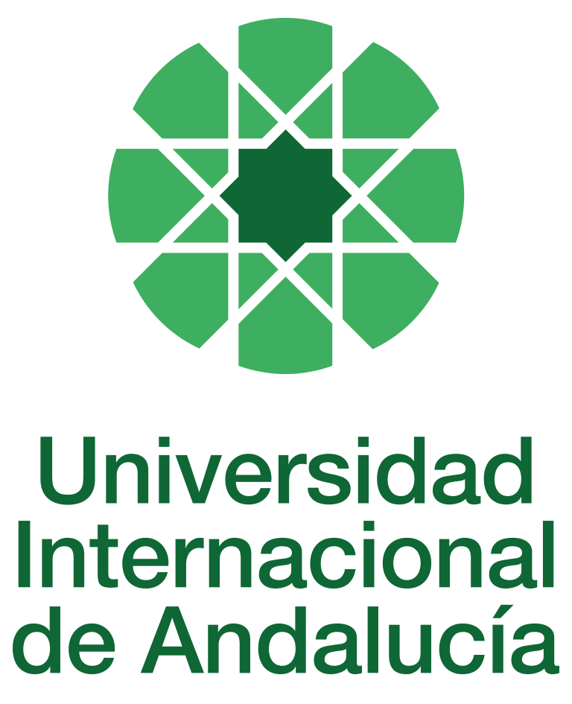

INSTRUCTIONS FOR PREPARING AND PROCESSING TEACHING GUIDES FOR COURSES

Type of Training Activity | Master's Degree
Name of Training Activity | Agroecology: An Approach to the Sustainable Transformation of Agri-Food Systems
Name of the Subject | Rural Development vs Post-Development
Module | Module N - Rural Development vs Post-Development
Academic | 2024-2025
Type | Optional
ECTS | Theory: | 3.00 | Practical: | 0.00 | Total: | 3.00
Teaching method | IN-PERSON
Teaching period | 21 to 25 April 2025
Coordinating university website | https://www.unia.es/estudios-y-acceso/oferta-academica/masteres-oficiales/master-oficial-en-agroecologia-un-enfoque-para-la-sustentabilidad-rural-2
Collaborating university website | https://www.uco.es/estudios/idep/agroecologia / https://www.upo.es/postgrado/Master-Oficial-Agroecologia-Un-Enfoque-de-Transformacion-Sustentable-de-los-Sistemas-Agroalimentarios/
Language(s) of instruction | Spanish

Course coordinator
Name | Email | University | Credits
María de África Jiménez Ruíz | *** | UNIVERSITY OF CORDOBA | 0.80

Teaching staff
First name and surname | Email | University | Credits
José María Egea Fernández | *** | UNIVERSITY OF MURCIA | 0.40
María de África Jiménez Ruíz | *** | UNIVERSITY OF CORDOBA | 0.80
Jessica Milgroom | *** | UNIVERSITY OF CORDOBA | 1.00
Silvia Pérez-Vitoria | *** | LA LIGNE DHORIZON | 0.80
TUTORIALS: Schedule and location
Tutorials/seminars: Wednesday and Thursday afternoons: 5pm-7.30pm
Teaching staff office

RESULTS OF THE TRAINING AND LEARNING PROCESS
Knowledge or content | Understand the modernisation processes developed and imposed in rural areas during the 20th century as a result of different rural development paradigms; the environmental, ecological, social, economic, cultural and political impacts that these hegemonic rural development paradigms have generated in different territories from a transnational and global perspective; the theoretical proposals subordinate to the hegemonic paradigms of rural development: post-development, Good Living, ecological economics, feminist economics and agroecological social transition; experiences and realities in which subordinate approaches have been applied; recognises the progress and debates that have taken place in different territories around these paradigms, as well as the importance of peasant movements in designing alternatives to conventional rural development.
Competencies | Have a critical awareness of the dominant rural development model and the guidelines shared between the different theoretical approaches applied to rural development.  Detect and analyse the main features of different rural development models; communicate orally and in writing in one's own language using the terminology and techniques accepted in the scientific community for communicative interaction with local knowledge and in order to convey proposals for promoting agroecological development processes in a comprehensible and coherent manner.
Skills | Combines a holistic and generalist approach to reflection and analysis with specialised and practical analysis for action; constructs innovative and creative proposals, applicable to a territory, inspired by theoretical frameworks subordinate to rural development.  Uses participatory tools in the development of local development plans, in all their phases: diagnosis, proposal development, planning and management of the entire process.

CONTENT DESCRIPTORS
Theoretical classes: 1. Basic concepts of development and their application to agriculture and rural societies; 2. The ecotechnocratic discourse of sustainability: development as a history of a Western belief; 3. Alternative visions and proposals for development: post-development and food sovereignty; 4. Peasant agroecology; 5. Proposals and paradigms from subalternity. Practical part: 1. The territorial impacts of hegemonic paradigms of rural development. Peasantry and institutional development. 2. Subaltern paradigms in practice: experiences and realities Guided activities: Field trip: Subbética region (Córdoba) Through this visit, we aim to identify and discuss experiences, both from the business sector and from civil society and public policy, which have addressed processes of social transition from an agroecological perspective, applying principles of subaltern paradigms.

TRAINING ACTIVITIES AND TEACHING METHODOLOGIES
Training activity | Teaching method | Commitment  (hours of independent study) | Dedication  (hours of class work by the student with teacher support)
Lectures and practical activities (face-to-face, synchronous and/or asynchronous) | IN-PERSON | 0 | 5
Academically directed and/or supervised activities | IN-PERSON | 0 | 18
Field trip | IN PERSON | 0 | 7
Independent student activities | TO BE DETERMINED | 45 | 0
ASSESSMENT SYSTEM
The course will be assessed through an individual reflection and analysis assignment using the readings and content provided in class and on Moodle.
At the end of the course, there will be a discussion and sharing of the content and main practical contributions.
These assignments must be submitted before the deadline, either by email to the module coordinator or by uploading a file as an assignment in the corresponding section of the course on Moodle.
Assessment strategies/methodologies |  |  |  | Percentage of total assessment
Completion and presentation of group work |  |  |  | 20%
Resolution of cases, problems and practical scenarios |  |  |  | 20
Written examinations |  |  |  | 60
TEACHING RESOURCES AND MATERIALS
Lectures
Group work and/or group presentations
Field trips
Case studies
Study and analysis of materials and readings
BIBLIOGRAPHY
Caporal, F. R. and Costabeber, J. A. (2002): Agroecology: A scientific and strategic approach to supporting sustainable rural development. Porto Alegre. EMATER/RS-ASCAR.
Escobar, A. (1996): The invention of the Third World. Construction and reconstruction of development. Vitral Collection, Norma publishing group, Colombia.
Guzmán Casado, G., González de Molina, M. and Sevilla Guzmán, E. (2000): Introduction to Agroecology as sustainable rural development. Ediciones Mundi-Prensa, Madrid: pp. 115–148.
Herrero, Y.; Cembranos, F. and Pascual, M. (2011). Changing glasses to change the world. Ed. Libros en Acción: Madrid
Latouche, S. (2007): The Bet on Degrowth. Ed. Icaria, Barcelona.
Leff, E. (coord.) (2000): The problems of knowledge and the environmental perspective of development. Siglo XXI editores, Mexico. Second revised edition (first edition 1986).
Marsden, T. (2003): The condition of rural sustainability. Royal Van Gorcum. Assen. Netherlands.
Naredo, J. M. (2006): Economic roots of ecological and social deterioration: beyond dogmas. Siglo XXI de España Editores, S.A. Madrid.
Noorgard, R.B. (1994): Development Detrayed. The End of Development and a Coevolutionary Revisionary of the Future. Routledge. London.
Partant, F. (2007): La ligne d’horizon. Essay on post-development. Ed. La Découverte. Paris (first edition: 1988).
Pérez Rubio, J.A. (ed.) (2007): Sociology and development. The challenge of sustainable development. Ministry of Agriculture, Fisheries and Food. Madrid. Articles by Sevilla Guzmán, E.; Rodríguez Villasante, T.; Camarero, L. and García, E.
Pérez-Vitoria, S. (ed.) (2003): Défaire le développement, refaire le monde . Ed. Parangon. France. Chapter by Illich, I. (2003): "Le développement ou la corruption de l'harmonie en valeur": pp. 9–15.
Pérez-Vitoria, S. El retorno de los campesinos (The Return of the Peasants) (2005) Icaria editorial, (2010)
Ploeg, J.D. (2006): El futuro Robado. Tierra, agua y lucha campesina. Instituto de Estudios Peruanos; Walir. Lima, Peru.
Ploeg, J.D., Long, N. and Banks, J. (2002): Living Countrysides. Rural development processes in Europe: the state of the art. Elsevier Bedrejsinformatie bv. Doetinchem, Netherlands.
Redclift, M. and Woodgate, G. (eds) (1997): The International Handbook of Environmental Sociology. Edward Elgar. Cheltenham, United Kingdom – Northampton, MA – United States. Spanish version: Redclift, M. and Woodgate, G. (coord) (2002): Sociology of the Environment. An international perspective. Editorial Mc Graw Hill. Madrid. Chapter by Sevilla Guzmán, E. and Woodgate, G. (2002): "Sustainable Rural Development: from industrial agriculture to agroecology": pp.77-96.
Rist, G. (2002): Development: A History of Western Belief. University Institute for Development and Cooperation, Complutense University of Madrid. Ed. Catarata. Madrid.
Sachs, W. (1992): The Development Dictionary: A Guide to Knowledge as Power. Zed Books, London, United Kingdom. Spanish editions available from Pratec, 1996; Lima, Peru and Agruco, 2008; Cochabamba, Bolivia.
Sevilla Guzmán, E. (2005): “Agroecology and Sustainable Rural Development”. In de Aquino, A.M. and Linhares de Assis, R. (eds.): Agroecology. Principles and techniques for sustainable organic agriculture. Brasilia, DF: Embrapa Informaçao Tecnológica: 101-132). There is an earlier Spanish version from 2002 entitled “Agroecología y desarrollo rural sustentable: una propuesta desde Latino América” (Agroecology and sustainable rural development: a proposal from Latin America), in Sarandón, S. (ed.) (2002): Agroecología. El camino hacia una agricultura sustentable (Agroecology. The path to sustainable agriculture). La Plata: Ediciones Científicas Americanas.
CONTINGENCY PLAN

In None, 25 April 2024.
Signed: Gallar Hernández, David

In accordance with current legislation on the protection of personal data (Regulation(EU) 2016/679 of 27 April), we inform you that the personal data you have provided will be processed by the INTERNATIONAL UNIVERSITY OF ANDALUSIA as the data controller, with the Academic Management Department (Monasterio Santa María de las Cuevas, C / Américo Vespucio nº2. Isla de La Cartuja - 41092 - Seville), before whom you may exercise your rights of access, rectification, limitation, opposition or portability, specifically indicating the reason for your request and attaching a copy of your identity document. The request may be made in writing on paper or by electronic means.
If you do not receive a response or your request is rejected, you may contact the University's Data Protection Officer (rgpd@unia.es Tel. 954 462299) or lodge a complaint with the Spanish Data Protection Agency using the forms provided for this purpose on its website: https://sedeagpd.gob.es.
As the data controller, the University informs you that it will only process the personal data you provide for the following purposes:
a) Academic and administrative management of:
• Participation in the admission and enrolment processes for official courses (Bachelor's, Master's and Doctorate degrees) or continuing education at the International University of Andalusia.
• Enrolment and/or registration as a student in any of the official degree programmes (bachelor's, master's and doctoral), continuing education or other academic activities offered by the International University of Andalusia.
• Participation in calls for scholarships and study grants from the International University of Andalusia, the General State Administration or the Autonomous Communities and other public or private entities.
• Participation in calls for national or international mobility programmes.
• Obtaining and issuing official degrees, university-specific degrees and other academic qualifications.
b) Management of your participation as a student in national or international internships and training activities in institutions, companies, organisations or other centres.
c) Use of university services such as obtaining a university card, libraries, sports activities, or others.
The University is entitled to process this data as it is necessary for the execution of the legal relationship established between you and the University and for the University to comply with its legal obligations established in Organic Law 6/2001 on Universities.
You are responsible for the accuracy of the personal data you have provided to the University and for keeping it up to date.
The University will communicate the personal data that is essential, and never in any other case, to the following categories of recipients:
• Other public administrations and bodies for the exercise of their own powers and in accordance with the purposes set out above (including, but not limited to, ministries with powers in education and science, other administrations, other universities or equivalent training centres for the management of transfers, and companies for the purpose of work placements).
• To banking institutions for the management of payments and collections.
• To public or private bodies by virtue of collaboration agreements or contracts, in accordance with the provisions of current legislation on data protection.
• To the University's own services that are appropriate for managing the use of the university services offered.
Your personal data will be processed and stored by the University in accordance with current data protection legislation, and will then become part of the University Historical Archive, after being purged, in accordance with the provisions of the legislation on Historical Heritage.
The University only envisages the transfer of data to third countries in the event of your participation as a student in any of the international training programmes or scholarships. The transfer will be carried out in accordance with the guidelines established in this regard by the European Data Protection Regulation and implementing regulations.
The Data Protection Service of the International University of Andalusia has a website that includes legislation, information and models relating to Personal Data Protection, which can be accessed via the following link: https://www.unia.es/protecciondatos

