Agroecology: An Approach to Sustainable Transformation of Agri-Food Systems – Module Ñ – Public Policies for Agricultural Sustainability

Public policies for agricultural sustainability

TEACHING GUIDE

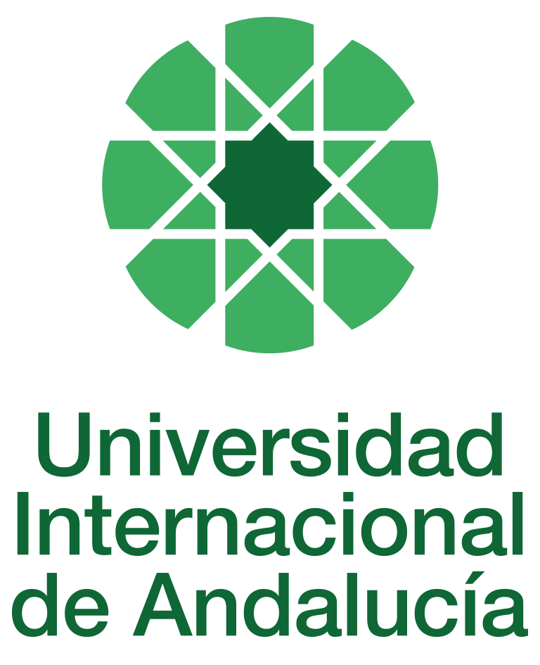

INSTRUCTIONS FOR THE PREPARATION AND PROCESSING OF TEACHING GUIDES FOR COURSES

Type of Training Activity | Master's Degree
Name of the Training Activity | Agroecology: An Approach to the Sustainable Transformation of Agri-Food Systems
Name of the Subject | Public Policies for Agricultural Sustainability
Module | Module Ñ - Public Policies for Agricultural Sustainability
Academic | 2024-2025
Type | Elective
ECTS | Theory: | 3.00 | Practical: | 0.00 | Total: | 3.00
Teaching method | IN-PERSON
Teaching period | 21 to 25 April 2025
Coordinating university website | https://www.unia.es/estudios-y-acceso/oferta-academica/masteres-oficiales/master-oficial-en-agroecologia-un-enfoque-para-la-sustentabilidad-rural-2
Collaborating university website | https://www.uco.es/estudios/idep/agroecologia / https://www.upo.es/postgrado/Master-Oficial-Agroecologia-Un-Enfoque-de-Transformacion-Sustentable-de-los-Sistemas-Agroalimentarios/
Language(s) of instruction | Spanish

Course coordinator
Name | Email | University | Credits
Paulo Frederico Petersen | *** | FAMILY FARMING AND AGROECOLOGY (ASPTA) | 1.25

Teaching staff
First and last names | Email | University | Credits
Manuel Luis González de Molina Navarro | *** | PABLO DE OLAVIDE UNIVERSITY | 1.00
Daniel López García | *** | INSTITUTE OF ECONOMICS, GEOGRAPHY AND DEMOGRAPHY (IEGDCSIC) | 0.75
Paulo Frederico Petersen | *** | FAMILY FARMING AND AGROECOLOGY (ASPTA) | 1.25
TUTORIALS: Schedule and location
Tutorials/seminars: Wednesday and Thursday afternoons: 5–7.30 p.m.
Teaching staff office

RESULTS OF THE TRAINING AND LEARNING PROCESS
Knowledge or content | Understands the concepts of public policy, public goods and private goods, and the differences in policy formulation; the public policy design cycle; analyses experiences of public policies for agricultural sustainability; and recognises the participation of social actors in the demand for and formulation of public policies.
Competencies | Identify the theoretical elements that stand out in public policy formulation processes; be able to systematise information and communicate orally; and have the ability to work with groups.
Skills | Employ negotiation methods for public policy formulation.

CONTENT DESCRIPTORS
Theoretical classes:
• Concepts of public policy and public goods. Actors and relationships.
• The Reference Framework for Research in Agroecology in Brazil: process of construction and social participation.
• The National Policy for Technical Assistance and Rural Extension in Brazil: participatory construction process, progress and challenges in implementation.
• The experience of the Andalusian Plan for Organic Agriculture: institutional and political limits to policy implementation.
• Policies for Strengthening Family Farming in Brazil.
• Institutional purchasing and consumption programmes as a means of promoting organic family farming: experiences in Brazil and Andalusia.
• Legal framework for the certification of organic products: Third Party versus GSP
• Methodologies for the participatory development and discussion of promotion plans and other public policies.
• Systems for evaluating public policies and strategic plans.
Practical classes:
Visit to a Participatory Guarantee System developed in an attempt to generate a public policy recognising this type of guarantee mechanism for organic production in the Sierra de Segura (Jaén).
Guided activities:
1. Seminar: Debate on the minimum content that a strategic plan for the promotion of organic or ecologically-based agriculture should have.
2. Lectures: aimed at introducing students to current debates on the subject.
TRAINING ACTIVITIES AND TEACHING METHODOLOGIES
Training activity | Teaching method | Commitment  (hours of independent study) | Dedication  (hours of class work by the student with teacher support)
Lectures and practical activities (face-to-face, synchronous and/or asynchronous) | IN-PERSON | 0 | 10
Academically directed and/or supervised activities | IN-PERSON | 0 | 15
Field trip | IN PERSON | 0 | 5
Independent student activities | TO BE DETERMINED | 45 | 0
ASSESSMENT SYSTEM
The course will be assessed through an individual reflection and analysis assignment using the readings and content provided in class and on Moodle.
At the end of the course, there will be a discussion and sharing of the content and main practical contributions.
These assignments must be submitted before the deadline, either by email to the module coordinator or by uploading a file as an assignment in the corresponding section of the course on Moodle.
Assessment strategies/methodologies |  |  |  | Percentage of total assessment
Cases and practical scenarios |  |  |  | 30%
Internship reports/memoirs |  |  |  | 30
Long-answer tests |  |  |  | 40
TEACHING RESOURCES AND MATERIALS
Lectures
Group work and/or group presentations
Field trips
Case studies
BIBLIOGRAPHY
BRAZIL. Ministry of Agrarian Development. 2004 National Policy on Technical Assistance and Rural Extension. Brasília, DF: SAF; Dater,
CAPORAL, F. R. 1998 Agricultural extension in the public sector in the face of the challenges of sustainable development: the case of Rio Grande do Sul, Brazil. 517 f. Thesis (Doctorate in Agroecology, Peasantry and History) – ISECETSIAN, University of Córdoba, Córdoba, Spain, 1998.
CAPORAL, F. R. 2008 The Conceptual Framework of Agroecology in the National Rural Extension Policy in Brazil. Article presented at the SEAE Congress -2008. Available at www.seae.es
CAPORAL, F. R. 2008 The rediscovery of Technical Assistance and Rural Extension and the implementation of Pnater: a new anchor for enabling access to policies to strengthen Family Farming. Article presented at the Rural Networks Congress – Brazil 17-07-2008. Available at www.pronaf.gov.br/dater
CAPORAL, F. R. 2006 National Ater Policy: first steps in its implementation and some obstacles and challenges to be overcome. In: RAMOS, L.; TAVARES, J. (Org.). Technical Assistance and Rural Extension: building agroecological knowledge. Manaus: Ed. Bagaço, 2006. p. 9-34.
CAPORAL, F. R. 2008. The experience of agroecological rural extension for family farming in Brazil. Article presented at the VII Congress of the Spanish Society of Organic Agriculture. Bullas, Murcia, 17 to 19 September 2008. Available at www.pronaf.gov.br/dater
CRISTÓVAM, J. S. Brief considerations on the concept of public policies and their jurisdictional control. 2005. Available at: http://jus2.uol.com.br/doutrina/texto.asp?id=7254. Accessed on 13/07/08.
CUÉLLAR, M. C. (2009): Towards a Participatory Guarantee System for Organic Production in Andalusia. Doctoral thesis for the Agroecology, Sociology and Sustainable Rural Development Programme. University of Córdoba.
CUÉLLAR, M. C. and DE LA CRUZ ABARCA, C. (2008): "Weaving networks between the countryside and the city through quality labels: Participatory Guarantee Systems". In MARTÍNEZ, Z. and BLAS, A.: Political power and participation. Demokrazia: ogi gogorrari hagin zorrotza. Creative Commons. Basque Country: pp. 175–192
EMBRAPA Reference Framework in Agroecology. Brasília, EMBRAPA. 2008. 70p.
GRAÇAS RUA, M. 2007 Analysis of Public Policies: basic concepts. Text available on the CD of the Advanced Course in Agroecology, promoted by Dater/SAF/MDA.
GAMBETTA, D. (ed.) (2000): Trust: Making and breaking cooperative relations. Department of Sociology, University of Oxford.
GARRIDO PEÑA, F. (1996), Political Ecology as the Politics of Time. Granada: Editorial Comares.
GONZÁLEZ DE MOLINA, M.; GUZMÁN CASADO, (2007), “Organic farming in Spain from an agroecological perspective”, Journal of Agrosocial and Fisheries Studies. Vol. 244, pp. 47-73.
GONZÁLEZ DE MOLINA, M. (Ed.) (2009), The Development of Organic Farming in Andalusia (2004-2007). Chronicle of an Agroecological Experience. Barcelona: Icaria
PONS, J. C. and SIVARDIÈRE, P. (2002): Training manual. Food quality certification geared towards value attribute labels in Latin American countries. ECOCERT and FAO, France and Chile. 2002.
ROURE, K. (coord.) (2007): Participatory Guarantee Systems for associative and solidarity-based organic agriculture
et solidaire. Nature & Progrès Editions. Uzès, France.
RUNDGREN, G. (2007): Participatory Guarantee Systems in East Africa. Study conducted in collaboration with NOGAMU, KOAN and TOAM.
http://www.ifoam.org/about_ifoam/standards/pgs/pdfs/PGS_East_Africa_Report_FRENCH.pdf (accessed on 7 October 2008)
SILVA, I. F. 2000. The decision-making process in the collegiate bodies of the SUS in the State of Rio de Janeiro.
[Master's thesis] Oswaldo Cruz Foundation, National School of Public Health; 2000. 100 p. Available at: http://portalteses.cict.fiocruz.br/transf.php?script=thes_chap&id=00008701&lng=pt&nrm=iso Accessed on 13/07/08.
SYLVANDER, B. (2004): Credibility and flexibility of certification in a context of globalisation and food crises: the case of organic farming. INRA, Le Mans.
CONTINGENCY PLAN

In Seville, on 15 July 2024.
Signed: González de Molina, Manuel

In accordance with current legislation on the protection of personal data (Regulation(EU) 2016/679 of 27 April), we inform you that the personal data you have provided will be processed by the INTERNATIONAL UNIVERSITY OF ANDALUSIA as the data controller, with the Academic Management Department (Monasterio Santa María de las Cuevas, C / Américo Vespucio nº2. Isla de La Cartuja - 41092 - Seville), before whom you may exercise your rights of access, rectification, limitation, opposition or portability, specifically indicating the reason for your request and attaching a copy of your identity document. The request may be made in writing on paper or by electronic means.
If you do not receive a response or your request is rejected, you may contact the University's Data Protection Officer (rgpd@unia.es Tel. 954 462299) or lodge a complaint with the Spanish Data Protection Agency using the forms provided for this purpose on its website: https://sedeagpd.gob.es.
As the data controller, the University informs you that it will only process the personal data you provide for the following purposes:
a) Academic and administrative management of:
• Participation in the admission and enrolment processes for official courses (Bachelor's, Master's and Doctorate) or continuing education at the International University of Andalusia.
• Enrolment and/or registration as a student in any of the official degree programmes (bachelor's, master's and doctoral), continuing education or other academic activities offered by the International University of Andalusia.
• Participation in calls for scholarships and study grants from the International University of Andalusia, the General State Administration or the Autonomous Communities and other public or private entities.
• Participation in calls for national or international mobility programmes.
• Obtaining and issuing official degrees, university-specific degrees and other academic qualifications.
b) Management of your participation as a student in national or international internships and training activities in institutions, companies, organisations or other centres.
c) Use of university services such as obtaining a university card, libraries, sports activities, or others.
The University is entitled to process this data as it is necessary for the execution of the legal relationship established between you and the University and for the University to comply with its legal obligations established in Organic Law 6/2001 on Universities.
You are responsible for the accuracy of the personal data you have provided to the University and for keeping it up to date.
The University will communicate the personal data that is essential, and never in any other case, to the following categories of recipients:
• Other public administrations and bodies for the exercise of their own powers and in accordance with the purposes set out above (including, but not limited to, ministries with powers in education and science, other administrations, other universities or equivalent training centres for the management of transfers, and companies for the purpose of work placements).
• To banking institutions for the management of payments and collections.
• To public or private bodies by virtue of collaboration agreements or contracts, in accordance with the provisions of current legislation on data protection.
• To the University's own services that are appropriate for managing the use of the university services offered.
Your personal data will be processed and stored by the University in accordance with current data protection legislation, and will then become part of the University Historical Archive, after being purged, in accordance with the provisions of the legislation on Historical Heritage.
The University only envisages the transfer of data to third countries in the case of your participation as a student in any of the international training programmes or scholarships. The transfer will be carried out in accordance with the guidelines established in this regard by the European Data Protection Regulation and implementing regulations.
The Data Protection Service of the International University of Andalusia has a website that includes legislation, information and models relating to Personal Data Protection, which can be accessed via the following link: https://www.unia.es/protecciondatos

