Agroecology: An Approach to Sustainable Transformation of Agri-Food Systems – Module M – Feminist Approaches to Agroecology

Feminist Approaches to Agroecology

TEACHING GUIDE

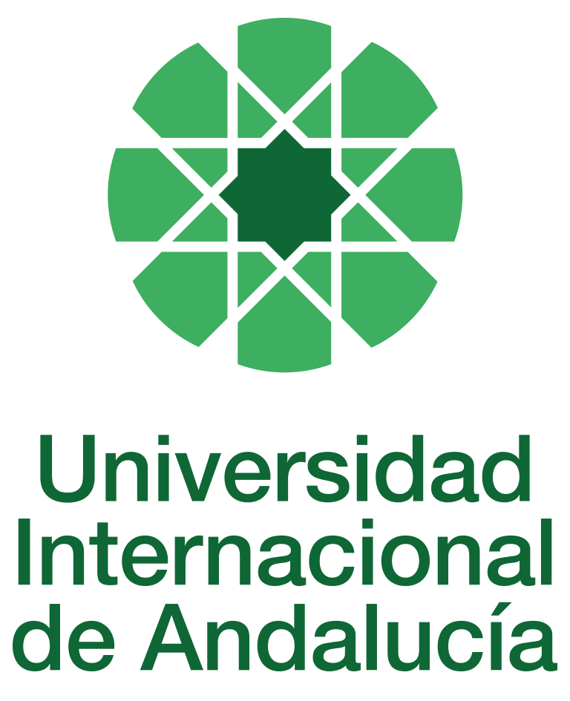

INSTRUCTIONS FOR THE PREPARATION AND PROCESSING OF COURSE GUIDES

Type of Training Activity | Master's Degree
Name of the Training Activity | Agroecology: An Approach to the Sustainable Transformation of Agri-Food Systems
Name of the Subject | Feminist Approaches to Agroecology
Module | Module M - Feminist Approaches to Agroecology
Academic | 2024-2025
Type | Compulsory
ECTS | Theory: | 3.00 | Practical: | 0.00 | Total: | 3.00
Teaching method | IN-PERSON
Teaching period | 3 to 7 February 2025
Coordinating university website | https://www.unia.es/estudios-y-acceso/oferta-academica/masteres-oficiales/master-oficial-en-agroecologia-un-enfoque-para-la-sustentabilidad-rural-2
Collaborating university website | https://www.uco.es/estudios/idep/agroecologia / https://www.upo.es/postgrado/Master-Oficial-Agroecologia-Un-Enfoque-de-Transformacion-Sustentable-de-los-Sistemas-Agroalimentarios/
Language(s) of instruction | Spanish

Course coordinator
Name | Email | University | Credits
Emma Cademartori Siliprandi | *** | FAO (FOOD AND AGRICULTURE ORGANISATION OF THE UNITED NATIONS) | 1.50

Teaching staff
First name and surname | Email | University | Credits
Emma Cademartori Siliprandi | *** | FAO (FOOD AND AGRICULTURE ORGANISATION OF THE UNITED NATIONS) | 1.50
David Pérez Neira | *** | UNIVERSITY OF LEÓN | 0.5
Marta María Soler Montiel | *** | UNIVERSITY OF SEVILLE | 1.00
TUTORIALS: Schedule and location
Monday, Tuesday, Wednesday and Thursday, from 4pm to 7pm

RESULTS OF THE TRAINING AND LEARNING PROCESS
Knowledge or content | C01 Understands the principles and scientific basis of agroecology as a tool for the sustainable transformation of agri-food systems.  C02 Understand the sociological and anthropological foundations that enable analysis of the structure and functioning of food systems, as well as the social and participatory dimension of agroecology.  C03 Understands the ecological foundations of the functioning of agroecosystems and their application as a basis for the design of sustainable agricultural systems.  C04 Understand the agronomic foundations of the functioning of agroecosystems and their application as a basis for the design of sustainable agricultural systems.  C05 Knows the basic principles of economic analysis applied to agricultural and food activities from the perspective of ecological economics  C06 Understand the fundamentals of the relationship between biodiversity and cultural diversity, applied to the management of agroecosystems and food systems.  C7 Understand the basic principles of political-institutional analysis applied to agricultural and food activities from the perspective of political ecology, with special emphasis on the role of the state and social movements in their regulation  C8 Understand the theoretical proposals and practical tools proposed for the design of the agroecological transition.  C9 Understand the sociological, economic and institutional causes of the global food crisis and the principles that should guide the construction of sustainable agri-food systems.  C10 Understand the different feminist perspectives and their application to the analysis of agri-food systems.
Competencies | COM01 Analyse the content of the readings, synthesise this content to identify key concepts.  COM02 Be able to develop adequate written and oral communication, the orderly presentation of ideas, logical and argumentative justification, as well as relate general concepts to others of a more practical nature.  COM03 Ability to make an ethical commitment to the sustainable transformation of the food system, as advocated by agroecology.  COM04 Integrate social, economic, cultural, agronomic and ecological aspects into the design of the agroecological transition.  COM05 Identify the reproduction of gender inequalities in the agroecological social reality in the field of agri-food systems.  COM06 Reflect self-critically on power relations in research, incorporating critical reflections on authoritarian relations and patriarchy into theoretical considerations and practices.  COM07 Propose and develop community projects for agroecological transformation or maintenance individually, in teams, and in participatory action research.
Skills | HD01 Handles the different theoretical and methodological perspectives and social research techniques applied to agroecology.  HD02 Knows the main methodologies for the economic and environmental analysis of agroecosystems, with special attention to sustainability assessment tools.  HD03 Designs agroecosystems that combine the capacity to produce food and/or other goods and services with a high degree of resilience and autonomy and the maintenance of biodiversity.  HD04 Develops community projects for agroecological transformation or maintenance individually, in teams, in participatory action research, with special attention to sustainable rural development.  HD05 Manages and applies theories and concepts of political ecology, ecological economics, and techniques for stimulating social participation in agro-environmental decision-making.  HD06 Manages feminist methodologies, tools and organisational approaches aimed at eliminating inequalities and building new gender relations; applies a feminist perspective to the analysis of specific agroecological experiences.  HD07 Diagnostics and methodologically solves agroecological problems and prepares reports and forecasts for the implementation of sustainable practices in agroecosystems and agri-food systems.  HD08 Carries out fieldwork in accordance with good design and correct application of participatory action research techniques.

CONTENT DESCRIPTORS
Theoretical classes:
Feminist theoretical foundations for a non-androcentric agroecology
Intersectionality and food, the three biases of the Western perspective
Feminist economics and agroecology: theoretical foundations and indicators for analysis
Political subjects and feminist and agroecological social movements
Masculinities and agroecology
Non-hegemonic feminisms
Domestic groups, communities and work in agroecology
Strategies, proposals and questions about how to participate, accompany, raise awareness and conduct research with a feminist perspective in agroecology.
Practical classes
Group work and case studies on feminist and agroecological social movements and on how to apply a feminist perspective to agroecological research.
Seminars: Analysis of cases of application of the feminist perspective to the analysis of agroecological experiences.

TRAINING ACTIVITIES AND TEACHING METHODOLOGIES
Presentations and practical activities (face-to-face, synchronous and/or asynchronous)
Academically directed and/or supervised activities
Independent student activities

Training activity | Teaching modality | Commitment  (hours of independent study) | Dedication  (hours of class work by the student with teacher support)
Lectures and practical activities (face-to-face, synchronous and/or asynchronous) | IN-PERSON | 0 | 10
Academically directed and/or supervised activities | IN-PERSON | 0 | 20
Independent student activities | TO BE DETERMINED | 45 | 0
ASSESSMENT SYSTEM
The course will be assessed through the completion of an individual piece of work involving personal reflection and analysis of the readings and content provided in class and on Moodle. These pieces of work must be submitted before the deadline, either by email to the module coordinator or by uploading a file as an assignment in the corresponding section of the course on Moodle.
Assessment strategies/methodologies |  |  |  | Percentage of total assessment
Completion and presentation of group assignments |  |  |  | 40
Resolution of cases, problems and practical scenarios |  |  |  | 60
TEACHING RESOURCES AND MATERIALS
Lecture
Group work and/or group presentations
Debates
Study and analysis of materials and readings

BIBLIOGRAPHY
Amorós, Celia (2007). The Great Difference and its Small Consequences for Women's Struggle. Madrid: Ediciones Cátedra.
Anzaldúa, Gloria (2016). Borderlands. The new mestiza. Madrid: Capitan Swing.
Butler, Judith (2001). Gender Trouble: Feminism and the Subversion of Identity. Buenos Aires: Paidós.
Cabnal, Lorena (2010). An Approach to the Construction of Epistemic Thought among Indigenous Feminist Community Women of Abya Yala. In Lorena Cabnal and ACSUR, Diverse Feminisms: Community Feminism, pp. 10–26. Madrid: ACSUR las Segovias.
Carrasco, Cristina (2014): With Our Own Voice. Feminist Economics as a Theoretical and Political Commitment, ed. La oveja Roja and Viento Surhttps://vientosur.info/con-voz-propia-la-economia-feminista-como-apuesta-teorica-y-politica-9513/
Carrasco, Cristina (2001). The sustainability of life: a women's issue? Mientras Tanto, 82, pp. 43–70.
Davis, Angela (2005). Women, Race and Class. Madrid: Akal.
Faria, Nalu (2009). Feminist economics and the agenda for women's struggle in rural areas. In Andrea Butto (ed.), Rural statistics and feminist economics: a look at women's work, pp. 11–30. Brasília: NEAD.
Haraway, Donna (1991), Science, Cyborgs and Women: The Reinvention of Nature. Madrid: Cátedra.
Federeci, Silvia (2010). Caliban and the Witch: Women, the Body and Primitive Accumulation. Madrid: Traficantes de Sueños.
Galindo, María (2013). You cannot decolonise without depatriarchalising. La Paz: Mujeres Creando.
Harding, Sandra (2008). Sciences from Below: Feminisms, Postcolonialities, and Modernities. Durham: Duke University Press.
Harding, Sandra (1996). Science and Feminism. Madrid: Morata.
Harris, Olivia (1986). The Domestic Unit as a Natural Unit. Nueva Antropología, 8(30), pp. 199–222.
Herrero, Yayo (2013). Ecofeminist perspectives for transitioning to a fair and sustainable world. Revista de Economía Crítica, 16, pp. 278–307.
hooks, bell (2004). Black Women. Shaping Feminist Theory. In bell hooks et al.
hooks, bell; Brah, Avtar; Sandoval, Chela and Anzaldúa, Gloria (2004). Other Inappropriables. Feminisms from the Frontiers. Madrid: Traficantes de Sueños.
Kimbel, Michael (2017). Angry (white) men. Masculinity at the end of an era. Barlin Libros.
Mies, María (1997). Feminist research, science, violence and responsibility in María Mies and Vandana Shiva, Ecofeminism. Theory, criticism and perspectives, pp. 59–86. Barcelona: Icaria.
Moore, Henrietta (1991). Anthropology and Feminism. Barcelona: Cátedra
Pacheco, María Emilia Lisboa (2002). Family farming: environmental sustainability and gender equality. In GT Gender, Gender perspectives: debates and issues for NGOs, Gender and Citizenship, pp. 138–163. Recife: Novib/SOS CORPO.
Pérez Neira, David; Collado, Angel and Vacluende, José María (2013). What about men? Feminist reflections on masculinities and agroecology. In Siliprandi, Emma and Zuluaga, Gloria Patricia (Eds.). Gender, Agroecology and Food Sovereignty. Ed. Icaria.
Pérez Neira, David, Soler Montiel, Marta (2013): Agroecology and ecofeminism to decolonise and depatriarchalise globalised food. International Journal of Political Thought No. 8. https://dialnet.unirioja.es/servlet/articulo?codigo=4724089
Pérez Orozco, Amaia (2014). Feminist subversion of the economy. Contributions to a debate on the capital–life conflict. Madrid: Traficantes de Sueños– Mapas. https://traficantes.net/libros/subversi%C3%B3n-feminista-de-la-econom%C3%ADa
Pérez Orozco, Amaia Orozco (2005): Gender economics and feminist economics: reconciliation or rupture? Venezuelan Journal of Women's Studies, vol. 10, no. 25, pp. 43–64.
Puleo, Alicia (2000). Ecofeminisms towards a redefinition of nature and human beings. In Celia Amorós (ed.), Feminism and Philosophy, pp. 165–190. Madrid: Síntesis.
Roces, Irene García (2017) Ecofeminist perspective on work and power relations: the ACS–Amazonia Agroecology Network in Acre–Brazil (Doctoral thesis). University of Córdoba, ISEC, Córdoba.
Roces, Irene García and Soler Montiel, Marta (2010). Women, agroecology and food sovereignty in the Moreno Maia community in the state of Acre. Brazil. Feminist research, 1, pp. 43–65.
Segato, Rita (2012) The Elementary Structures of Violence. Buenos Aires: Editorial Prometeo
Shiva, Vandana (1991). Embracing Life: Women, Ecology and Survival. Montevideo: Third World Institute.
Siliprandi, Emma (2015). Women and agroecology: transforming the countryside, forests and people. Rio de Janeiro: Editora da UFRJ.
Siliprandi, Emma and Zuluaga, Gloria (2014). Gender, Agroecology and Food Sovereignty. Barcelona: Icaria.
Soler Montiel, Marta and Pérez Neira, David (2013). Towards an ecofeminist re-peasantisation that overcomes the three biases of the Western gaze. Papers on Ecosocial Relations and Global Change, 121, pp. 131–141.
Suárez Navaz, Liliana and Hernández, Rosalva Aída (2008). Decolonising feminism. Theories and practices from the margins. Madrid: Cátedra University of Valencia Women's Institute.
Zuluaga, Gloria P., Catacora-Vargas, G. and Siliprandi, Emma (coordinators) (2018). Agroecology in the Feminine. Reflections based on our experiences. La Paz: SOCLA/CLACSO.
Warren, Karen J. (2003). Ecofeminist Philosophies. Barcelona: Icaria Editorial.
CONTINGENCY PLAN

In None, 25 April 2024.
Signed: Gallar Hernández, David
In accordance with current legislation on the protection of personal data (Regulation(EU) 2016/679 of 27 April), we inform you that the personal data you have provided will be processed by the INTERNATIONAL UNIVERSITY OF ANDALUSIA as the data controller, with the Academic Management Department (Monasterio Santa María de las Cuevas, C / Américo Vespucio nº2. Isla de La Cartuja - 41092 - Seville), before whom you may exercise your rights of access, rectification, limitation, opposition or portability, specifically indicating the reason for your request and attaching a copy of your identity document. The request may be made in writing on paper or by electronic means.
If you do not receive a response or your request is rejected, you may contact the University's Data Protection Officer (rgpd@unia.es Tel. 954 462299) or lodge a complaint with the Spanish Data Protection Agency using the forms provided for this purpose on its website: https://sedeagpd.gob.es.
As the data controller, the University informs you that it will only process the personal data you provide for the following purposes:
a) Academic and administrative management of:
• Participation in the admission and enrolment processes for official courses (Bachelor's, Master's and Doctorate degrees) or continuing education at the International University of Andalusia.
• Enrolment and/or registration as a student in any of the official degree programmes (bachelor's, master's and doctoral), continuing education or other academic activities offered by the International University of Andalusia.
• Participation in calls for scholarships and study grants from the International University of Andalusia, the General State Administration or the Autonomous Communities and other public or private entities.
• Participation in calls for national or international mobility programmes.
• Obtaining and issuing official degrees, university-specific degrees and other academic qualifications.
b) Management of your participation as a student in national or international internships and training activities in institutions, companies, organisations or other centres.
c) Use of university services such as obtaining a university card, libraries, sports activities, or others.
The University is entitled to process this data as it is necessary for the execution of the legal relationship established between you and the University and for the University to comply with its legal obligations established in Organic Law 6/2001 on Universities.
You are responsible for the accuracy of the personal data you have provided to the University and for keeping it up to date.
The University will communicate the personal data that is essential, and never in any other case, to the following categories of recipients:
• Other public administrations and bodies for the exercise of their own powers and in accordance with the purposes set out above (including, but not limited to, ministries with powers in education and science, other administrations, other universities or equivalent training centres for the management of transfers, and companies for the purpose of work placements).
• To banking institutions for the management of payments and collections.
• To public or private bodies by virtue of collaboration agreements or contracts, in accordance with the provisions of current legislation on data protection.
• To the University's own services that are appropriate for managing the use of the university services offered.
Your personal data will be processed and stored by the University in accordance with current data protection legislation, and will then become part of the University Historical Archive, after being purged, in accordance with the provisions of the legislation on Historical Heritage.
The University only envisages the transfer of data to third countries in the event of your participation as a student in any of the international training programmes or scholarships. The transfer will be carried out in accordance with the guidelines established in this regard by the European Data Protection Regulation and implementing regulations.
The Data Protection Service of the International University of Andalusia has a website that includes legislation, information and models relating to Personal Data Protection, which can be accessed via the following link: https://www.unia.es/protecciondatos

