Agroecology: An Approach to Sustainable Transformation of Agri-Food Systems – Module L – Sustainable Agri-Food Systems

Sustainable Agri-Food Systems

TEACHING GUIDE

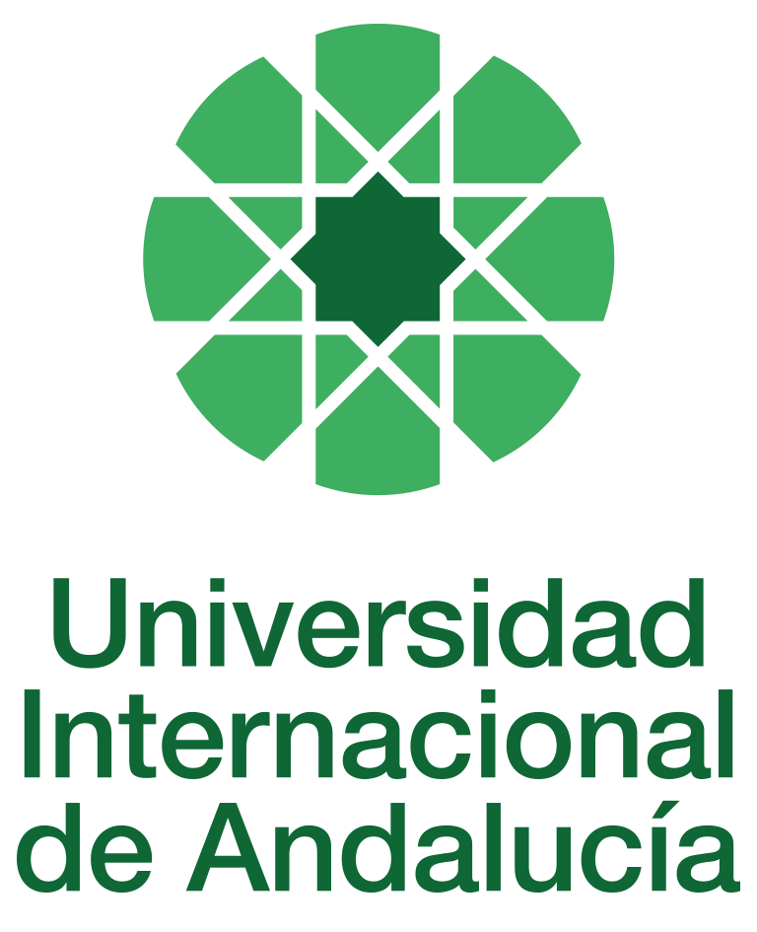

INSTRUCTIONS FOR THE PREPARATION AND PROCESSING OF TEACHING GUIDES FOR COURSES

Type of Training Activity | Master's Degree
Name of the Training Activity | Agroecology: An Approach to the Sustainable Transformation of Agri-Food Systems
Name of the Subject | Sustainable Agri-Food Systems
Module | Module L - Sustainable Agri-Food Systems
Academic year | 2024-2025
Type | Compulsory
ECTS | Theory: | 3.00 | Practical: | 0.00 | Total: | 3.00
Teaching method | IN-PERSON
Teaching period | From 31 March to 4 April 2025
Coordinating university website | https://www.unia.es/estudios-y-acceso/oferta-academica/masteres-oficiales/master-oficial-en-agroecologia-un-enfoque-para-la-sustentabilidad-rural-2
Collaborating university website | https://www.uco.es/estudios/idep/agroecologia / https://www.upo.es/postgrado/Master-Oficial-Agroecologia-Un-Enfoque-de-Transformacion-Sustentable-de-los-Sistemas-Agroalimentarios/
Language(s) of instruction | Spanish

Course coordinator
Name | Email | University | Credits
Marta María Soler Montiel | *** | UNIVERSITY OF SEVILLE | 0

Teaching staff
First name and surname | Email | University | Credits
María del Carmen Cuéllar Padilla | *** | UNIVERSITY OF CORDOBA | 1.00
María de África Jiménez Ruíz | *** | UNIVERSITY OF CORDOBA | 1.00
Jessica Milgroom | *** | UNIVERSITY OF CORDOBA | 1.00
TUTORIALS: Schedule and location
Tutorials/seminars: Wednesday and Thursday afternoons: 5pm-7.30pm
Teaching staff office

RESULTS OF THE TRAINING AND LEARNING PROCESS
Knowledge or content | C01 Understands the principles and scientific basis of agroecology as a tool for the sustainable transformation of agri-food systems.  C02 Understand the sociological and anthropological foundations that enable analysis of the structure and functioning of food systems, as well as the social and participatory dimension of agroecology.  C03 Knows the ecological bases of the functioning of agroecosystems and their application as a basis for the design of sustainable agricultural systems.  C04 Understand the agronomic foundations of agroecosystem functioning and their application as a basis for the design of sustainable agricultural systems.  C05 Knows the basic principles of economic analysis applied to agricultural and food activities from the perspective of ecological economics  C06 Understand the fundamentals of the relationship between biodiversity and cultural diversity, applied to the management of agroecosystems and food systems.  C7 Understand the basic principles of political-institutional analysis applied to agricultural and food activities from the perspective of political ecology, with special emphasis on the role of the state and social movements in their regulation  C8 Understand the theoretical proposals and practical tools proposed for the design of the agroecological transition.  C9 Understand the sociological, economic and institutional causes of the global food crisis and the principles that should guide the construction of sustainable agri-food systems.  C10 Understand the different feminist perspectives and their application to the analysis of agri-food systems.
Competencies | COM01 Analyse the content of the readings, synthesise this content to identify key concepts.  COM02 Be able to develop adequate written and oral communication, the orderly presentation of ideas, logical and argumentative justification, as well as relate general concepts to others of a more practical nature.  COM03 Ability to make an ethical commitment to the sustainable transformation of the food system, as advocated by agroecology.  COM04 Integrate social, economic, cultural, agronomic and ecological aspects into the design of the agroecological transition.  COM05 Identify the reproduction of gender inequalities in the agroecological social reality in the field of agri-food systems.  COM06 Reflect self-critically on power relations in research, incorporating critical reflections on authoritarian relations and patriarchy into theoretical considerations and practices.  COM07 Propose and develop community projects for agroecological transformation or maintenance individually, in teams, and in participatory action research.
Skills | HD01 Handles the different theoretical and methodological perspectives and social research techniques applied to agroecology.  HD02 Knows the main methodologies for the economic and environmental analysis of agroecosystems, with special attention to sustainability assessment tools.  HD03 Designs agroecosystems that combine the capacity to produce food and/or other goods and services with a high degree of resilience and autonomy and the maintenance of biodiversity.  HD04 Develops community projects for agroecological transformation or maintenance individually, in teams, in participatory action research, with special attention to sustainable rural development.  HD05 Manages and applies theories and concepts of political ecology, ecological economics, and techniques for stimulating social participation in agro-environmental decision-making.  HD06 Manages feminist methodologies, tools and organisational approaches aimed at eliminating inequalities and building new gender relations; applies a feminist perspective to the analysis of specific agroecological experiences.  HD07 Diagnoses and methodologically solves agroecological problems and prepares reports and forecasts for the implementation of sustainable practices in agroecosystems and agri-food systems.  HD08 Carries out fieldwork in accordance with good design and correct application of participatory action research techniques.

CONTENT DESCRIPTORS
TRAINING ACTIVITIES AND TEACHING METHODOLOGIES
Training activity | Teaching modality | Dedication  (hours of independent study) | Dedication  (hours of class work by the student with teacher support)
Lectures and practical activities (face-to-face, synchronous and/or asynchronous) | IN-PERSON | 0 | 8
Academically directed and/or supervised activities | IN-PERSON | 0 | 15
Field trip | IN PERSON | 0 | 7
Independent student activities | TO BE DETERMINED | 45 | 0
ASSESSMENT SYSTEM
The course will be assessed through an individual reflection and analysis assignment using the readings and content provided in class and on Moodle.
At the end of the course, there will be a discussion and sharing of the content and main practical contributions gathered from the field trip.
Prior to the field trip, some questions will be posed as a guide for observation and analysis of the experiences visited.
This assignment may be organised in groups.
These assignments must be submitted before the deadline by uploading a file as a task in the corresponding section of the course on Moodle.
Assessment strategies/methodologies |  |  |  | Percentage of total assessment
Comprehension tests |  |  |  | 30%
Writing tests |  |  |  | 40
Problem solving |  |  |  | 30%
TEACHING RESOURCES AND MATERIALS
Lecture
Group work and/or group presentations
Field trips
Debates
Study and analysis of materials and readings
BIBLIOGRAPHY
SHORT MARKETING CHANNELS
1. Sevilla Guzmán, Eduardo, Soler Montiel, Marta, Gallar Hernández, David, Vara Sánchez, Isabel, Calle Collado, Ángel (2012): Short food marketing channels in Andalusia. Seville, Spain. Andalusian Public Foundation Centre for Andalusian Studies, Regional Ministry of the Presidency and Equality, Regional Government of Andalusia. https://www.centrodeestudiosandaluces.es/datos/factoriaideas/FI014_12_ok_ok.pdf
2. Soler Montiel, Marta, Calle Collado, Ángel (2010): Rearticulating from food: short marketing channels in Andalusia in Cultural Heritage in the new Andalusian rurality, Andalusian Institute of Historical Heritage, Regional Government of Andalusia p. 258-283 http://institucional.us.es/compromiso/libreconf/docs/canales.pdf
3. Matarán et al. (2021): Diagnosis of local agroecological networks in Andalusia https://www.juntadeandalucia.es/organismos/agriculturaganaderiapescaydesarrollosostenible/areas/produccion-ecologica/promocion/paginas/biodistritos-andalucia.html
FEMINIST ANALYSES OF LOCAL AGROECOLOGICAL SYSTEMS
5 Costa Bezerra, A. Geane, Soler Montiel, Marta, Butto Zarzar, Andrea L, García Roces, Irene (2022): Gender, agroecology and local markets at São José de Mipibu in Rio Grande do Norte, Brazil, Agroecology and Sustainable Food Systems, 46:4, 604-625, DOI: 10.1080/21683565.2021.2025193
6. García Roces, Irene, Soler Montiel, Marta (2014): Ecofeminist perspective on food sovereignty: the Agroecology Network in the Moreno Maia Community in the Brazilian Amazon. International Relations, Vol. 27. pp 75-96. https://revistas.uam.es/index.php/relacionesinternacionales/article/view/5238/5681
7. García Roces, Irene, Soler Montiel, Marta (2010): Women, Agroecology and Food Sovereignty in the Moreno Maia Community in the State of Acre, Brazil. Feminist Research. 2010. Vol. 1. pp. 43-65. http://revistas.ucm.es/index.php/INFE/article/view/INFE1010110043A
TRUST AND CERTIFICATION SYSTEMS
8. Cuéllar-Padilla, M. and Ganuza-Fernández, E. 2018. We don't want to be officially certified! Reasons and implications of the Participatory Guarantee Systems. Sustainability2018, 10, 1142; doi:10.3390/su10041142https://www.researchgate.net/publication/324458070_We_Don't_Want_to_Be_Officially_Certified_Reasons_and_Implications_of_the_Participatory_Guarantee_Systems
9. Cuéllar-Padilla, M. and di Masso. M. 2021. Building trust in agroecological proposals. Participatory Guarantee Systems. Teaching material for the Postgraduate Course in Local Agroecological Revitalisation. Autonomous University of Barcelona.
10. Cuéllar-Padilla, M. and Castillo-Ruiz, J. (2015). "Mechanisms for revaluing agricultural heritage from a local perspective: certification and guarantee systems". In CASTILLO RUIZ, J. and MARTÍNEZ YÁÑEZ, C. (Eds.) Agricultural heritage. The cultural construction of territory through agricultural activity, UNIA, Seville; pp. 121-148. ISBN 978-84-7993-264-0
11. Cuéllar-Padilla, M.; Haro-Pérez, I.; Begiristain- Zubillaga, M. Participatory Guarantee Systems: When People Want to Take Part. Sustainability 2022, 14, 3325. https://doi.org/10.3390/su14063325
CHALLENGES AND REALITIES OF CCCs FROM THE PERSPECTIVE OF PRODUCTION AND CONSUMPTION
11. Rucabado-Palomar, T. and Cuéllar-Padilla, M. 2019 Are municipal markets an opportunity for small and medium-sized local farms? Spanish Journal of Agro-Social and Fisheries Studies, no. 252. Available on Moodle2.
12. Rucabado-Palomar, T. and Cuéllar-Padilla, 2018. M. Short food supply chains for local food: a difficult path. Renewable Agriculture and Food Systems, online. DOI: 10.1017/S174217051800039Xhttps://www.cambridge.org/core/journals/renewable-agriculture-and-food-systems/article/short-food-supply-chains-for-local-food-a-difficult-path/35F1BF522F060E2838002CD089C2FAC9
13. Gallar-Hernández, D.; Saracho-Domínguez, H.; Rivera-Ferré, M. and Vara-Sánchez, I. 2019. Eating Well with Organic Food: Everyday (Non-Monetary) Strategies for a Change in Food Paradigms: Findings from Andalusia, Spain. Sustainability, 11(4); doi:10.3390/su11041003
CONTINGENCY PLAN

In None, 25 April 2024.
Signed: Gallar Hernández, David

In accordance with current legislation on the protection of personal data (Regulation(EU) 2016/679, of 27 April), we inform you that the personal data you have provided will be processed by the INTERNATIONAL UNIVERSITY OF ANDALUSIA as the data controller, with the Academic Management Department (Monasterio Santa María de las Cuevas, C / Américo Vespucio nº2. Isla de La Cartuja - 41092 - Seville), before whom you may exercise your rights of access, rectification, limitation, opposition or portability, specifically indicating the reason for your request and attaching a copy of your identity document. The request may be made in writing on paper or by electronic means.
If you do not receive a response or your request is rejected, you may contact the University's Data Protection Officer (rgpd@unia.es Tel. 954 462299) or lodge a complaint with the Spanish Data Protection Agency using the forms provided for this purpose on its website: https://sedeagpd.gob.es.
As the data controller, the University informs you that it will only process the personal data you provide for the following purposes:
a) Academic and administrative management of:
• Participation in the admission and enrolment processes for official courses (Bachelor's, Master's and Doctorate degrees) or continuing education at the International University of Andalusia.
• Enrolment and/or registration as a student in any of the official degree programmes (bachelor's, master's and doctoral), continuing education or other academic activities offered by the International University of Andalusia.
• Participation in calls for scholarships and study grants from the International University of Andalusia, the General State Administration or the Autonomous Communities and other public or private entities.
• Participation in calls for national or international mobility programmes.
• Obtaining and issuing official degrees, university-specific degrees and other academic qualifications.
b) Management of your participation as a student in national or international internships and training activities in institutions, companies, organisations or other centres.
c) Use of university services such as obtaining a university card, libraries, sports activities, or others.
The University is entitled to process this data as it is necessary for the execution of the legal relationship established between you and the University and for the University to comply with its legal obligations established in Organic Law 6/2001 on Universities.
You are responsible for the accuracy of the personal data you have provided to the University and for keeping it up to date.
The University will communicate the personal data that is essential, and never in any other case, to the following categories of recipients:
• Other public administrations and bodies for the exercise of their own powers and in accordance with the purposes set out above (including, but not limited to, ministries with powers in education and science, other administrations, other universities or equivalent training centres for the management of transfers, and companies for the purpose of work placements).
• To banking institutions for the management of payments and collections.
• To public or private bodies by virtue of collaboration agreements or contracts, in accordance with the provisions of current legislation on data protection.
• To the University's own services that are appropriate for managing the use of the university services offered.
Your personal data will be processed and stored by the University in accordance with current data protection legislation, and will then become part of the University Historical Archive, after being purged, in accordance with the provisions of the legislation on Historical Heritage.
The University only envisages the transfer of data to third countries in the event of your participation as a student in any of the international training programmes or scholarships. The transfer will be carried out in accordance with the guidelines established in this regard by the European Data Protection Regulation and implementing regulations.
The Data Protection Service of the International University of Andalusia has a website that includes legislation, information and models relating to Personal Data Protection, which can be accessed via the following link: https://www.unia.es/protecciondatos

