Agroecology: An Approach to Sustainable Transformation of Agri-Food Systems – Module B – Sociological Foundations of Agroecology

Sociological Foundations of Agroecology

TEACHING GUIDE

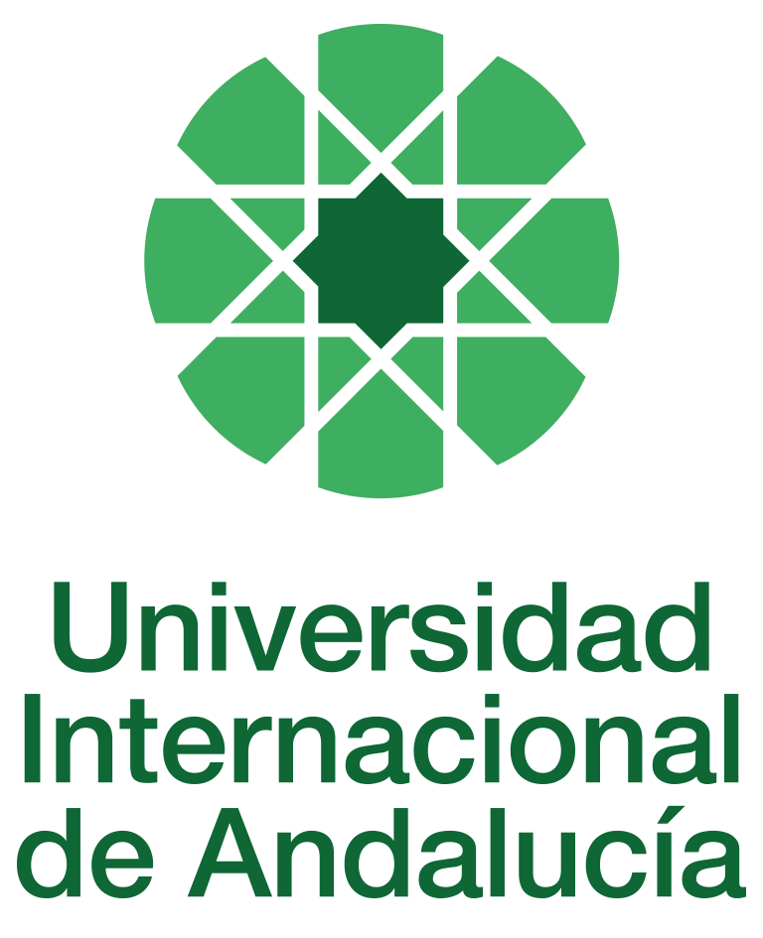

INSTRUCTIONS FOR THE PREPARATION AND PROCESSING OF TEACHING GUIDES FOR COURSES

Type of Training Activity | Master's Degree
Name of the Training Activity | Agroecology: An Approach to the Sustainable Transformation of Agri-Food Systems
Name of the Subject | Sociological Foundations of Agroecology
Module | Module B - Sociological Foundations of Agroecology
Academic | 2024-2025
Type | Compulsory
ECTS | Theory: | 3.00 | Practical: | 0.00 | Total: | 3.00
Teaching method | IN-PERSON
Teaching period | 13 to 17 January 2025
Coordinating university website | https://www.unia.es/estudios-y-acceso/oferta-academica/masteres-oficiales/master-oficial-en-agroecologia-un-enfoque-para-la-sustentabilidad-rural-2
Collaborating university website | https://www.uco.es/estudios/idep/agroecologia / https://www.upo.es/postgrado/Master-Oficial-Agroecologia-Un-Enfoque-de-Transformacion-Sustentable-de-los-Sistemas-Agroalimentarios/
Language(s) of instruction | Spanish

Course coordinator
Name | Email | University | Credits
Ángel Calle Collado | *** | ECOJERTE COOPERATIVE | 0.50

Teaching staff
First name and surname | Email | University | Credits
Ángel Calle Collado | *** | ECOJERTE COOPERATIVE | 0.50
David Gallar Hernández | *** | UNIVERSITY OF CORDOBA | 1.00
María Sagrario Herrero López | *** | GARUA EDUCATIONAL INTERVENTION, S.COOP. MADRID | 0.5
Jessica Milgroom | *** | UNIVERSITY OF CORDOBA | 1.00
TUTORIALS: Schedule and location
Tutorials/seminars:
Wednesday and Thursday afternoons: 5:00 p.m. to 7:30 p.m.
Teaching staff office

RESULTS OF THE TRAINING AND LEARNING PROCESS
Knowledge or content | C01 Understands the principles and scientific basis of agroecology as a tool for the sustainable transformation of agri-food systems.  C02 Understands the sociological and anthropological foundations that enable analysis of the structure and functioning of food systems, as well as the social and participatory dimension of agroecology.  C03 Knows the ecological bases of the functioning of agroecosystems and their application as a basis for the design of sustainable agricultural systems.  C04 Understand the agronomic foundations of the functioning of agroecosystems and their application as a basis for the design of sustainable agricultural systems.  C05 Knows the basic principles of economic analysis applied to agricultural and food activity from the point of view of ecological economics  C06 Understand the fundamentals of the relationship between biodiversity and cultural diversity, applied to the management of agroecosystems and food systems.  C7 Understand the basic principles of political-institutional analysis applied to agricultural and food activities from the perspective of political ecology, with special emphasis on the role of the state and social movements in their regulation  C8 Understand the theoretical proposals and practical tools proposed for the design of the agroecological transition.  C9 Understand the sociological, economic and institutional causes of the global food crisis and the principles that should guide the construction of sustainable agri-food systems.  C10 Understand the different feminist perspectives and their application to the analysis of agri-food systems.
Competencies | COM01 Analyse the content of the readings, synthesise that content to identify key concepts.  COM02 Be able to develop adequate written and oral communication, the orderly presentation of ideas, logical and argumentative justification, as well as relate general concepts to others of a more practical nature.  COM03 Ability to make an ethical commitment to the sustainable transformation of the food system, as advocated by agroecology.  COM04 Integrate social, economic, cultural, agronomic and ecological aspects into the design of the agroecological transition.  COM05 Identify the reproduction of gender inequalities in the agroecological social reality in the field of agri-food systems.  COM06 Reflect self-critically on power relations in research, incorporating critical reflections on authoritarian relations and patriarchy into theoretical considerations and practices.  COM07 Propose and develop community projects for agroecological transformation or maintenance individually, in teams, and through participatory action research.
Skills | HD01 Handles the different theoretical and methodological perspectives and social research techniques applied to agroecology.  HD02 Knows the main methodologies for the economic and environmental analysis of agroecosystems, with special attention to sustainability assessment tools.  HD03 Designs agroecosystems that combine the capacity to produce food and/or other goods and services with a high degree of resilience and autonomy and the maintenance of biodiversity.  HD04 Develops community projects for agroecological transformation or maintenance individually, in teams, in participatory action research, with special attention to sustainable rural development.  HD05 Manages and applies theories and concepts of political ecology, ecological economics, and techniques for stimulating social participation in agro-environmental decision-making.  HD06 Manages feminist methodologies, tools and organisational approaches aimed at eliminating inequalities and building new gender relations; applies a feminist perspective to the analysis of specific agroecological experiences.  HD07 Diagnostics and methodologically solves agroecological problems and prepares reports and forecasts for the implementation of sustainable practices in agroecosystems and agri-food systems.  HD08 Carries out fieldwork in accordance with good design and correct application of participatory action research techniques.

CONTENT DESCRIPTORS
Theoretical classes:
1. From Social Sciences to Agroecology: structure, culture and basic needs; networks, individuals and collective action; power, domination and agencies; nature and society; inequalities and social stratification; socialisation, conflicts and social change.
2.
Basic paradigms of social theory: constructivism, structuralism and functionalism. Conceptual application to natural resource management.
3. Introduction to Ecological Anthropology, Environmental Sociology and Environmental History: towards an Ecology of Difference.
4. The perspective of social change for agroecology. The construction of socio-technical models for an analysis of social transitions towards a sustainable agri-food system. Foundations for social cooperation. Critique of globalisation and consumer society.
5. Introduction to ecofeminism: social foundations for understanding the reproduction of patriarchal hierarchies and how these are present in the agroecological transition.
Practical classes:
1.
Classroom case study: analysis of the agri-food social structure in a specific example of marketing and production. This analysis will be based on one or more of the sociological approaches studied and will lead students to propose a model for researching and evaluating the dynamics of agroecological social change.
Guided activities:
1. Seminar: Sociological analysis of resistance to the globalised agri-food system.
2. Seminar: The state of the art by region

TRAINING ACTIVITIES AND TEACHING METHODOLOGIES
Training activity | Teaching method | Commitment  (hours of independent study) | Dedication  (hours of class work by the student with teacher support)
Lectures and practical activities (face-to-face, synchronous and/or asynchronous) | IN-PERSON | 0 | 25
Academically directed and/or supervised activities | IN-PERSON | 0 | 5
Independent student activities | TO BE DETERMINED | 45 | 0
ASSESSMENT SYSTEM
This face-to-face module will be based on linking the different readings covered in the online module with those specific to this module, which will be sent to students and on which they will be asked to reflect on the elements of this link.
The virtual platform and electronic communication will be used to ensure support for text comprehension, the resolution of doubts, and specific guidance for the development of the master's thesis.
Students may be asked to organise themselves into groups with similar topics for their master's thesis, in order to discuss issues that are of interest to them or that the module coordinators consider appropriate for making the most of the readings.
This will allow the coordinators to delve deeper into the relevant debates in agroecology today on the content of this course, thereby preparing the specific proposals for each master's thesis.
The course will be assessed through an individual reflection and analysis assignment using the readings and content provided in class and on Moodle.
The individual reflection must be submitted before the deadline by uploading a file as an assignment in the corresponding section of the course on Moodle.
Assessment strategies/methodologies |  |  |  | Percentage of total assessment
Cases and practical scenarios |  |  |  | 30%
Long-answer tests |  |  |  | 30
Group work |  |  |  | 40
TEACHING RESOURCES AND MATERIALS
Lecture
Group work and/or group presentations
Case studies
BIBLIOGRAPHY
Alonso, Luis Enrique (2005): La era del consumo (The Age of Consumption), Madrid: Siglo XXI de España Editores.
Beck, Ulrich (2002), The Global Risk Society, Madrid: Siglo Veintiuno de España.
Braudel, Fernand (1984): History and the Social Sciences, Spain, Alianza.
Buckley, Walter (1982): Sociology and Modern Systems Theory, Buenos Aires, Argentina, Amorrortu.
Calle Collado, Ángel; Gallar Hernández, David; Candon Mena, José (2013). Political Agroecology: The Social Transition to Sustainable Agri-Food Systems. Journal of Critical Economics, 15.
Calle Collado, Ángel; Vara Sánchez, Isabel; Gallar Hernández, David (2012). Agri-food disaffection. Citizenship and social networks. Journal: Interface - Journal of Soc Movements, 4, 459-489.
Castells, Manuel (2002): The Information Age Vol. I: The Network Society. Mexico City: Siglo XXI Editores
Castells, Manuel (2001): The Information Age. Vol. II: The Power of Identity, Mexico City, Siglo XXI Editores.
Castells, Manuel (2001): The Information Age Vol. III: End of the Millennium, Mexico City: Siglo XXI Editores. 2001.
Cuéllar, M. Carmen; Calle Collado, Ángel; Gallar Hernández, David (2013). Processes towards food sovereignty. Perspectives and practices from political agroecology. Barcelona: Icaria.
Díaz Méndez, Cecilia and Gómez Benito, Cristóbal (2001): "From food consumption to the sociology of food", Distribution and Consumption No. 60, pp. 5-23.
Escobar, Arturo (2005): Beyond the Third World. Globalisation and Difference, Bogotá, ICANH.
Garrido, Francisco, González de Molina, Manuel, Serrano, José Luis and Solana, José Luis (eds.): The Ecological Paradigm in the Social Sciences, Barcelona, Icaria.
Giner, Salvador (1998): History of Social Thought, Barcelona, Ariel
Godelier, M. (1970) Sur les sociétés précapitalistes (Paris: Editions Sociales)
Godelier, M. , 1981 "From One Mode of Production to Another: Theory of Transition" in Recherches Sociologiques, Vol. XII, 2.
Godelier, M. et. al. (1986) Einaudi Encyclopaedia. V:7. Mode of production, development, underdevelopment (Vila da Maía: Impresa Nacional).
Godelier, M., (1987). "Introduction: the analysis of transition processes". In: Transition processes: anthropological case studies. International Social Science Journal. UNESCO. December. No. 114: 5-15.
Gómez de Benito, Cristóbal (2008): "Approach to the sociology of food", Distribution and Consumption January-February 2008.
Gadgil M. and Guha, R. 1992. This Fisured Land An ecological History of India. Oxford University Press. Delhi. (There is a Spanish version of the key theoretical part of this work, the concept of "Mode of Use of Natural Resources", in M. Gonzalez de Molina and J. Martinez Alier (eds.) Historia y Ecología (History and Ecology) (Madrid: Marcial Pons, 1993: 49-118).
Harris, Marvin (1981): Introduction to General Anthropology, Madrid, Alianza.
Heller, Ágnes (1977), Sociology of Everyday Life, Barcelona, Península.
Hollis, M. (2002): The Philosophy of Social Science: An Introduction, Cambridge; New York, N.Y., Cambridge University Press.
Latour, B. (1992): Science in Action, Barcelona, Labor.
Ploeg, J.D. van der; (2003) The Virtual Farmer. Royal Van Gorcum, Assen.
Ploeg, J. D. van der (2008): The New Peasantries. Struggles for autonomy and sustainability in an era of Empire and Globalisation. London, Earthscan.
Rappaport, Roy A. (1979): Ecology, Meaning and Religion, California, North Atlantic Books.
Redclift, Michael and Woodgate, Graham (2002): Environmental Sociology: An International Perspective
, Malaga, McGraw Hill Spain.
Ritzer, George (2005): Classical Sociological Theory, Madrid, McGraw-Hill/Interamericana de España.
Ritzer, George (2005): Modern Sociological Theory, Madrid, McGraw-Hill/Interamericana de España.
Ritzer, George (2008): The McDonaldisation of Society, Madrid, Editorial Popular.
Rocher, Guy (1978): Introduction to General Sociology, Barcelona, Herder.
Sevilla Guzmán, E. (2006): From Rural Sociology to Agroecology, Barcelona,
Siliprandi and Gloria Patricia Zuloaga (coord.) Gender, Agroecology and Food Sovereignty. Barcelona: Icaria.
Soler Montiel, Marta and Carmen Guerrero Quintero (coordinators) 2010 Cultural Heritage in the New Andalusian Reality, Seville, PH Cuadernos: Andalusian Institute of Artistic Heritage of the Regional Ministry of Culture of the Regional Government of Andalusia.
Sztompka, P. (1995): Sociology of Social Change, Madrid, Alianza Editorial
Tilly, Ch. (1991): Large Structures, Broad Processes and Huge Comparisons, Madrid, Alianza Universidad.
Toledo, V. and González de Molina, M. (2007), "Social metabolism: the relationship between society and nature", in F. Garrido, M. González de Molina, J. L. Serrano and J. L. Solana (eds), The ecological paradigm in the social sciences. Barcelona: Icaria
CONTINGENCY PLAN

In None, 25 April 2024.
Signed: Gallar Hernández, David

In accordance with current legislation on the protection of personal data (Regulation(EU) 2016/679 of 27 April), we inform you that the personal data you have provided will be processed by the INTERNATIONAL UNIVERSITY OF ANDALUSIA as the data controller, with the Academic Management Department (Monasterio Santa María de las Cuevas, C / Américo Vespucio nº2. Isla de La Cartuja - 41092 - Seville), before whom you may exercise your rights of access, rectification, limitation, opposition or portability, specifically indicating the reason for your request and attaching a copy of your identity document. The request may be made in writing on paper or by electronic means.
If you do not receive a response or your request is rejected, you may contact the University's Data Protection Officer (rgpd@unia.es Tel. 954 462299) or lodge a complaint with the Spanish Data Protection Agency using the forms provided for this purpose on its website: https://sedeagpd.gob.es.
As the data controller, the University informs you that it will only process the personal data you provide for the following purposes:
a) Academic and administrative management of:
• Participation in the admission and enrolment processes for official courses (Bachelor's, Master's and Doctorate degrees) or continuing education at the International University of Andalusia.
• Enrolment and/or registration as a student in any of the official degree programmes (bachelor's, master's and doctoral), continuing education or other academic activities offered by the International University of Andalusia.
• Participation in calls for scholarships and study grants from the International University of Andalusia, the General State Administration or the Autonomous Communities and other public or private entities.
• Participation in calls for national or international mobility programmes.
• Obtaining and issuing official degrees, university-specific degrees and other academic qualifications.
b) Management of your participation as a student in national or international internships and training activities in institutions, companies, organisations or other centres.
c) Use of university services such as obtaining a university card, libraries, sports activities, or others.
The University is entitled to process this data as it is necessary for the execution of the legal relationship established between you and the University and for the University to comply with its legal obligations established in Organic Law 6/2001 on Universities.
You are responsible for the accuracy of the personal data you have provided to the University and for keeping it up to date.
The University will communicate the personal data that is essential, and never in any other case, to the following categories of recipients:
• Other public administrations and bodies for the exercise of their own powers and in accordance with the purposes set out above (including, but not limited to, ministries with powers in education and science, other administrations, other universities or equivalent training centres for the management of transfers, and companies for the purpose of work placements).
• To banking institutions for the management of payments and collections.
• To public or private bodies by virtue of collaboration agreements or contracts, in accordance with the provisions of current legislation on data protection.
• To the University's own services that are appropriate for managing the use of the university services offered.
Your personal data will be processed and stored by the University in accordance with current data protection legislation, and will then become part of the University Historical Archive, after being purged, in accordance with the provisions of the legislation on Historical Heritage.
The University only envisages the transfer of data to third countries in the event of your participation as a student in any of the international training programmes or scholarships. The transfer will be carried out in accordance with the guidelines established in this regard by the European Data Protection Regulation and implementing regulations.
The Data Protection Service of the International University of Andalusia has a website that includes legislation, information and models relating to Personal Data Protection, which can be accessed via the following link: https://www.unia.es/protecciondatos

