Agroecology: An Approach to Sustainable Transformation of Agri-Food Systems – Module A – Concepts and Principles of Agroecology

Concept and principles of agroecology

TEACHING GUIDE

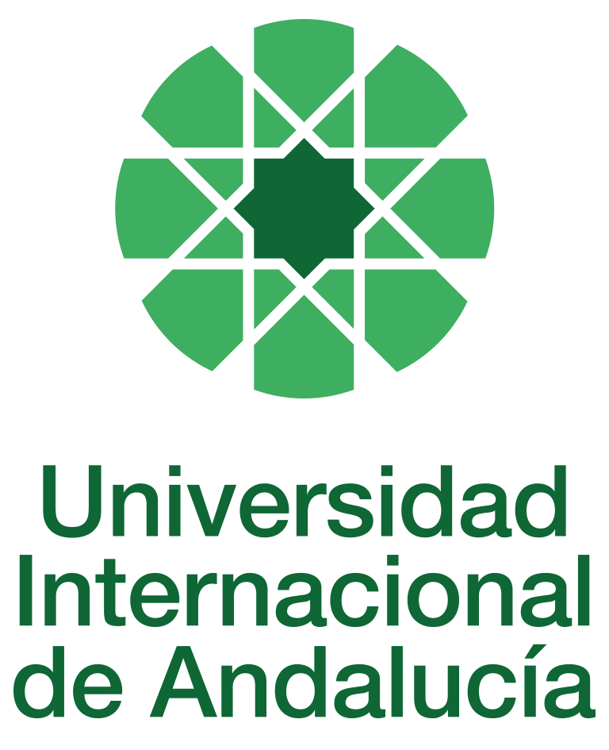

INSTRUCTIONS FOR THE PREPARATION AND PROCESSING OF TEACHING GUIDES FOR COURSES

Type of Training Activity | Master's Degree
Name of the Training Activity | Agroecology: An Approach to the Sustainable Transformation of Agri-Food Systems
Name of the Subject | Concept and Principles of Agroecology
Module | Module A - Concepts and Principles of Agroecology
Academic year | 2024-2025
Type | Compulsory
ECTS | Theory: | 2.50 | Practical: | 2.50 | Total: | 5.00
Teaching method | VIRTUAL
Teaching period | 4 November to 20 December 2024
Coordinating university website | https://www.unia.es/estudios-y-acceso/oferta-academica/masteres-oficiales/master-oficial-en-agroecologia-un-enfoque-para-la-sustentabilidad-rural-2
Collaborating university website | https://www.uco.es/estudios/idep/agroecologia / https://www.upo.es/postgrado/Master-Oficial-Agroecologia-Un-Enfoque-de-Transformacion-Sustentable-de-los-Sistemas-Agroalimentarios/
Language(s) of instruction | Spanish

Course coordinator
Name | Email | University | Credits
David Gallar Hernández | *** | UNIVERSITY OF CORDOBA | 4.00

Teaching staff
First name and surname | Email | University | Credits
Emma Cademartori Siliprandi | *** | FAO (FOOD AND AGRICULTURE ORGANISATION OF THE UNITED NATIONS) | 0.50
David Gallar Hernández | *** | UNIVERSITY OF CORDOBA | 4.00
Gloria Guzmán Casado | *** | PABLO DE OLAVIDE UNIVERSITY | 0.50
TUTORIALS: Schedule and location
Tutorials/seminars: Wednesday and Thursday afternoons: 5pm-7.30pm
Forum and virtual chat

RESULTS OF THE TRAINING AND LEARNING PROCESS
Knowledge or content | C01 Understand the principles and scientific basis of agroecology as a tool for the sustainable transformation of agri-food systems.
Competencies | COM01 Analyse the content of the readings, synthesise this content to identify key concepts.  COM02 Be able to develop written and oral communication skills, present ideas in an orderly manner, provide logical and argumentative justification, and relate general concepts to more practical ones.  COM03 Ability to make an ethical commitment to the sustainable transformation of the food system, as advocated by agroecology.  COM04 Integrate social, economic, cultural, agronomic and ecological aspects into the design of the agroecological transition.  COM05 Identify the reproduction of gender inequalities in the agroecological social reality in the field of agri-food systems.  COM06 Reflect self-critically on power relations in research, incorporating critical reflections on authoritarian relations and patriarchy into theoretical considerations and practices.  COM07 Propose and develop community projects for agroecological transformation or maintenance individually, in teams, and through participatory action research.
Skills | HD01 Handles the different theoretical and methodological perspectives and social research techniques applied to agroecology.  HD07 Diagnostics and methodologically solves agroecological problems and prepares reports and forecasts for the implementation of sustainable practices in agroecosystems and agri-food systems.

CONTENT DESCRIPTORS
Theoretical classes:
• Introduction to organic farming and agroecology from their conceptual foundations.
• From sustainable agriculture to agri-food systems: different dimensions of analysis.
• The social and militant component of agroecology and its historical construction as a social movement.
• The issue of biodiversity and its connection with concepts such as transdisciplinarity and co-evolution.
• The cultural issue of biodiversity
• Indigenous realities.
• The bridges between agroecology and food sovereignty.
• The agroecological transition
Guided activities:
1. Discussion forums. Participation of students in thematic debates proposed by the module coordinators through the virtual platform.

TRAINING ACTIVITIES AND TEACHING METHODOLOGIES
Training activity | Teaching method | Commitment  (hours of independent study) | Dedication  (hours of class work by the student with teacher support)
Lectures and practical activities (face-to-face, synchronous and/or asynchronous) | VIRTUAL | 0 | 10
Academically directed and/or supervised activities | VIRTUAL | 5 | 40
Independent student activities | VIRTUAL | 75 | 0
ASSESSMENT SYSTEM
The course will be assessed based on participation (quantitative and qualitative) in the Moodle discussion forums, as well as individual reflection and analysis assignments on the proposed readings.
These assignments must be submitted by the established deadline by uploading a file as a task in the corresponding section of the course on Moodle.
Assessment strategies/methodologies |  |  |  | Percentage of total assessment
Participation in discussion forums |  |  |  | 40%
Comprehension tests |  |  |  | 30
Writing tests |  |  |  | 30%
TEACHING RESOURCES AND MATERIALS
Lecture
Discussions
Problem solving, exercises and written expression activities
Study and analysis of materials and readings
BIBLIOGRAPHY
The compulsory readings on which the activities in this module are based are as follows (those not referenced are unpublished readings written for the Master's programme):
1.
Guzmán-Casado, Gloria and Morales-Hernández, Jaime 2012. "Agroecology and organic farming. Contributions and synergies to increase agricultural sustainability." In Agroecology, no. 6: pp. 55-62.
2. Gliessman, Stephen, 2002. Agroecology. Ecological processes in sustainable agriculture. Turrialba, C.R.: CATIE: 319-329. Text: From sustainable agriculture to sustainable agri-food systems. 3. Sevilla-Guzmán, Eduardo and Martínez-Alier, Joan: New Rural Social Movements and Agroecology.
4. Vara-Sánchez, Isabel and Cuéllar-Padilla, Mamen 2013. "Cultivated biodiversity: a question of co-evolution and transdisciplinarity." In Ecosistemas Magazine, 22(1): 1–5.
5. Toledo, Víctor: Biodiversity and culture.
6. Calle-Collado, Ángel; Soler-Montiel, Marta. and Rivera-Ferré, Marta. 2013. "Food sovereignty and emerging agroecology: food democracy." In Calle-Collado, Ángel (ed.). Radical Democracy. Between links and utopias. Editorial Icaria, Barcelona.
7. Cuéllar-Padilla, M. and Calle-Collado, A., 2011. "Can we find solutions with people? Participatory Action Research With Small Organic Producers In Andalusia." In Journal of Rural Studies 27, pp. 372–383.
CONTINGENCY PLAN

In None, 25 April 2024.
Signed: Gallar Hernández, David
In accordance with current legislation on the protection of personal data (Regulation(EU) 2016/679, of 27 April), we inform you that the personal data you have provided will be processed by the INTERNATIONAL UNIVERSITY OF ANDALUSIA as the data controller, with the Academic Management Department (Monasterio Santa María de las Cuevas, C / Américo Vespucio nº2. Isla de La Cartuja - 41092 - Seville), before whom you may exercise your rights of access, rectification, limitation, opposition or portability, specifically indicating the reason for your request and attaching a copy of your identity document. The request may be made in writing on paper or by electronic means.
If you do not receive a response or your request is rejected, you may contact the University's Data Protection Officer (rgpd@unia.es Tel. 954 462299) or lodge a complaint with the Spanish Data Protection Agency using the forms provided for this purpose on its website: https://sedeagpd.gob.es.
As the data controller, the University informs you that it will only process the personal data you provide for the following purposes:
a) Academic and administrative management of:
• Participation in the admission and enrolment processes for official courses (Bachelor's, Master's and Doctorate degrees) or continuing education at the International University of Andalusia.
• Enrolment and/or registration as a student in any of the official degree programmes (bachelor's, master's and doctoral), continuing education or other academic activities offered by the International University of Andalusia.
• Participation in calls for scholarships and study grants from the International University of Andalusia, the General State Administration or the Autonomous Communities and other public or private entities.
• Participation in calls for national or international mobility programmes.
• Obtaining and issuing official degrees, university-specific degrees and other academic qualifications.
b) Management of your participation as a student in national or international internships and training activities in institutions, companies, organisations or other centres.
c) Use of university services such as obtaining a university card, libraries, sports activities, or others.
The University is entitled to process this data as it is necessary for the execution of the legal relationship established between you and the University and for the University to comply with its legal obligations established in Organic Law 6/2001 on Universities.
You are responsible for the accuracy of the personal data you have provided to the University and for keeping it up to date.
The University will communicate the personal data that is essential, and never in any other case, to the following categories of recipients:
• Other public administrations and bodies for the exercise of their own powers and in accordance with the purposes set out above (including, but not limited to, ministries with powers in education and science, other administrations, other universities or equivalent training centres for the management of transfers, and companies for the purpose of work placements).
• To banking institutions for the management of payments and collections.
• To public or private bodies by virtue of collaboration agreements or contracts, in accordance with the provisions of current legislation on data protection.
• To the University's own services that are appropriate for managing the use of the university services offered.
Your personal data will be processed and stored by the University in accordance with current data protection legislation, and will then become part of the University Historical Archive, after being purged, in accordance with the provisions of the legislation on Historical Heritage.
The University only envisages the transfer of data to third countries in the event of your participation as a student in any of the international training programmes or scholarships. The transfer will be carried out in accordance with the guidelines established in this regard by the European Data Protection Regulation and implementing regulations.
The Data Protection Service of the International University of Andalusia has a website that includes legislation, information and models relating to Personal Data Protection, which can be accessed via the following link: https://www.unia.es/protecciondatos

