## Notes on methods for studying the adoption of new behaviours among smallholders

Tags: adoption, innovation, nutrition, behaviour change

Date: February 2018

Location: Huancayo, Peru

Event: 2 day Yanapai methods workshops

## 1. Notes on methods and tools

Below are some research methods that emerged during a methods workshop held in Huancayo, Peru in 2017, on studying adoption of new behaviours & technologies. The project in Peru (Yanapai) was particularly interesting in changing nutritional behaviours by changing agricultural practices such as the types of forage crops that were grown and soil management techniques.

As outlined in my presentation on the first day of the workshop, attitudes, beliefs, perceptions, and intentions all interact in a complex way to lead to a particular action.

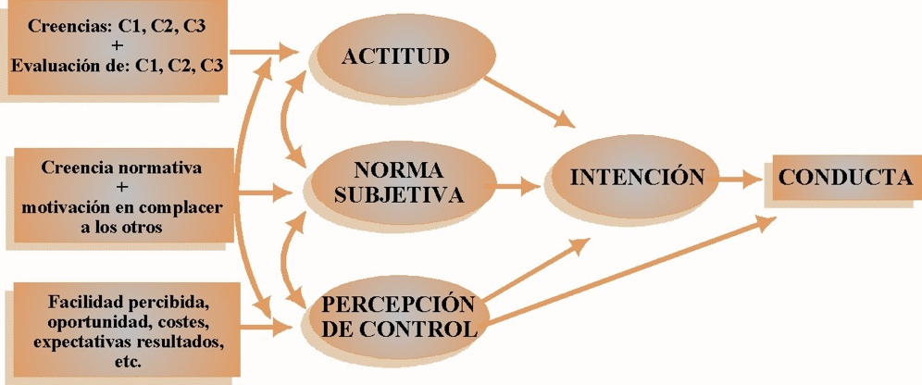

The inside (or *emic*) view

It could be interesting to ask participants directly what they feel would improve the nutrition of their children (if they say the native potato – *papa nativa* – or guinea pig, etc. then you would ask both ‘Why’ and ‘What else’?

Also, further questions about participants own understanding of what could help with nutrition of their children could include:

* Is there any practice that you currently use / could use in future / to improve children's health?
* If not - What are the practices you currently use / could use in future?
* And what others?

Using a family food basket to measure current & future nutritional behaviour

• Participants create a household food basket (before & after an intervention)

This would be similar to the 7-day frequency but take a physical form [For the whole family? Or just children?]. The basket could be for: a recent week, or a week last year. It could also be used to assess future/ideal (the intentions) and then ask about the differences between the different portrayals. Yanapai have developed this and are using it.

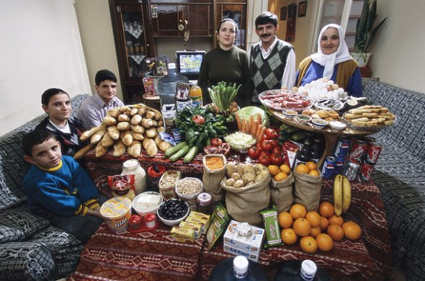

Studying attitudes towards behaviours

Here the idea is to offer examples of people’s behaviour and ask them what they think about these behaviours, as well as indicating which one is closest to theirs. For example:

Person A does x ... Person B does and ... Person C does z ...

* Which is most similar to you?
* What do you think of the other two…?

Studying the efficacy of perceived action

The aim is to determine the percentage of population that believes that behaviour *x* reduces the risk of outcome *y*

For example, one could ask the question: What is the best way to improve child nutrition? And - Is there any other way of achieving this? (other than the promoted way)

(one would expect 100% population to agree ... but maybe 20-30% have other ideas about the best way to improve child nutrition.

Farming ideals and reality

The aim here is to understand the difference between what respondents say they do and what they would ideally like to do. That is, the difference between what they produce/grow and what they would ideally produce on their farm – reality versus their “perfect farm” (and particularly, how much of whatever the intervention is – e.g. forage of a particular kind, crop varieties of a particular kind, etc.. – would there be there?)

This could be done to show a length of time from the past (what the farm was like) to the present and then future.

Researching the factors that influence adoption of new practices/technologies

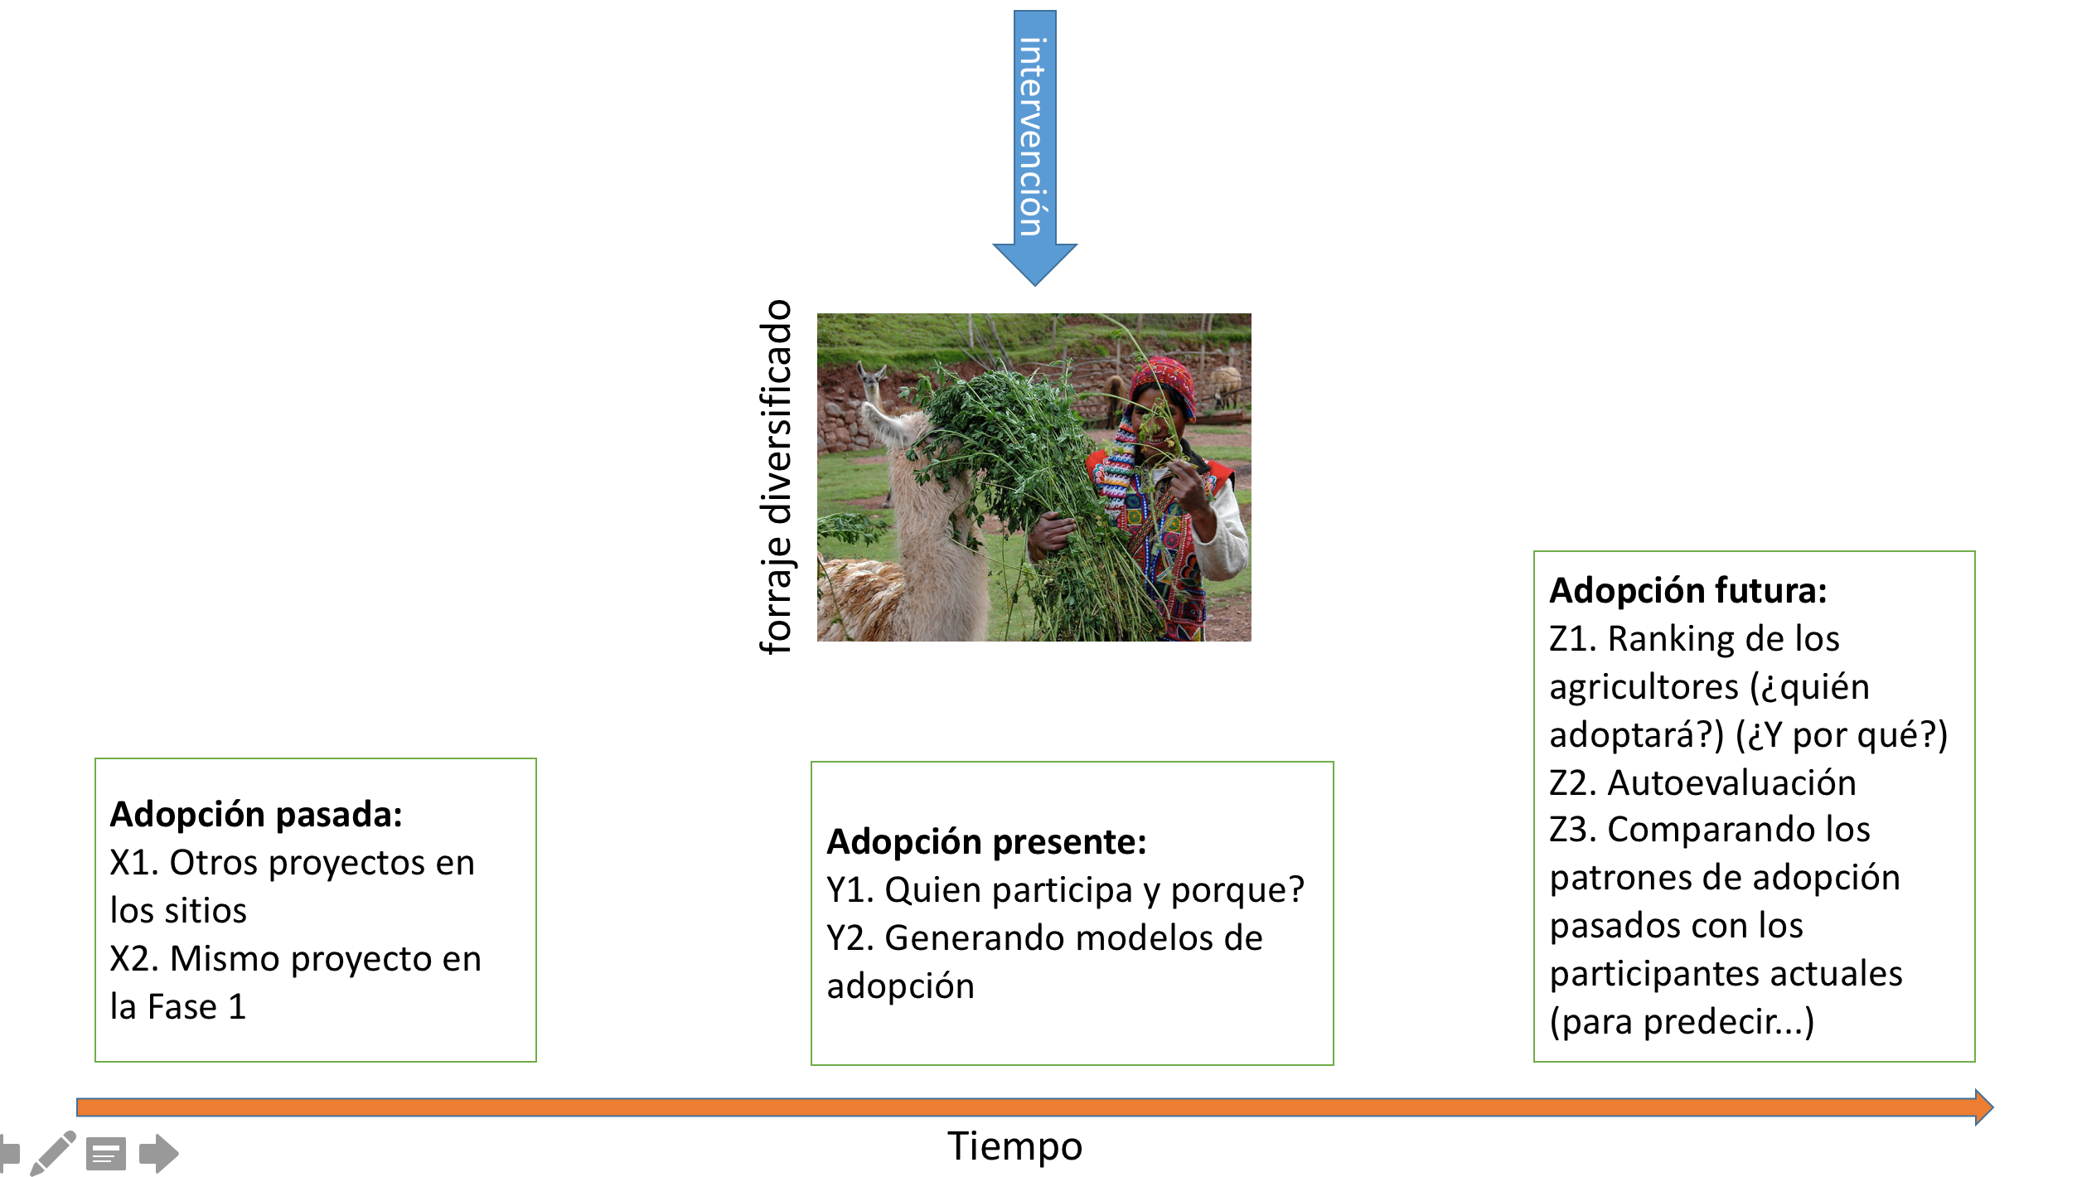

In the case of the Yanapai project, the intervention is to diversify forage crops (with the hope of improving childhood nutrition). When examining adoption of new practices, there are three time periods to be aware of: the past (other projects in the same area, as well as this same project in its first phase); present (including questions such as who is participating and why; as well as generating a model of adoption); and future adoption (who will adopt and why?; as well as examining the patterns of adoption of past adopters compared to current adopters to predict who is likely to adopt in the future).

Who do researchers ask about adoption of these new practice?

* Farmers who have adopted
  + About themselves (and why, what they gained from adoption, etc.)
  + About other farmers that have adopted
  + About the farmers than haven’t adopted
* Farmers who haven’t adopted
  + About themselves (and why they haven’t…)
  + About other farmers that have adopted
  + About other farmers that haven’t adopted.

What questions could researchers ask? They key here is to think about all the ways there are to ask questions about people’s thoughts on themselves but also their thoughts and observations on other people/participants.

* What motivated you to participate? PAST
* What do you think of your plot? Are there differences compared to before? [if they talk about other plots] compared to other plots? PRESENT
* What do you expect from the work that is being done? FUTURE
* [Of the other participants ...] What do you think motivated them to participate? PAST
* What do you think about the plots of the others? PRESENT
* What do the others think of their plots? PRESENT
* Why do not you think the other villagers did not participate? PAST
* What would facilitate adoption / appropriation this practice? (PROBING: polling ...) FUTURE

Similarly, these questions could theoretically be asked of non-participants too:

* Why could you not participate in the trials? PAST
* Have you seen the experimental plots? PRESENT
* What do you think of the plots? ... [re-question] example. 'They are ugly' ... 'Why are they ugly?' PRESENT
* Could you be interested in participating in the future? Why? What do you expect/imagine will happen? FUTURE
* [Of the other participants ...] What do you think motivated them to participate? PAST
* What do the others think of their plots? PRESENT
* Why do you think the other villagers participated? PAST
* What would make it easier for you to adopt / appropriate this practice (in the future)? (PROBING: sounding ...) price, time, plot types/availability..etc .. FUTURE

## 2. Links to books, relevant articles and websites

The adoption problem; or why we still understand so little about technological change in African agriculture (Glover et al. 2016)

Outlook on Agriculture Vol 45, No 1, 2016

<https://journals.sagepub.com/doi/pdf/10.5367/oa.2016.0235>

Conclusion: “We suggest that seriously addressing the adoption problem is just as important as, for example, research on yield gaps, sustainable intensification or climate-smart agriculture. The adoption problem is in every sense an agricultural systems problem, and re-conceptualizing and researching technological change along the lines indicated above will require a concerted, cross-disciplinary effort. Such an effort is long overdue.”

Predicting farmer uptake of new agricultural practices: A tool for research, extension and policy (Kuehne et al. 2017)

Agricultural Systems, Volume 156, September 2017, Pages 115-125

<https://www.sciencedirect.com/science/article/pii/S0308521X16304541>

Highlights

* New tool predicts speed and peak level of adoption by farmers of new practices.
* Based on 22 variables, related to the practice, population of farmers, learning and relative advantage
* Validated successfully for six contrasting Australian farm practices
* Tool being used by R&D funders, extension agents, scientists and policy advisors
* Tool users develop a deeper understanding of the adoption process.